United Nations Development Programme
Country: Morocco
PROJECT DOCUMENT
Project Title: Promoting the development of photovoltaic pumping systems for irrigation
Indicative Output(s):
Output 5.1: The main actors are supported to ensure consistency between the national and sectoral strategies with the National Charter for Environment and Sustainable Development (NCESD).
Output 5.3: Capacities related to development and coordination of strategies and programs of mitigation and adaptation to climate change and management of natural and technological risks are developed and strengthened.
Implementing Partner: National Agency for the Development of Renewable Energy and Energy Efficiency (ADEREE)
Implementing Entity/Responsible Partners: United Nations Development Programme – Morocco
Brief Description: Morocco, a country strongly vulnerable to the effects of climate change (CC), has embarked on an early and voluntary national process to address CC, implementing various activities and programs for the sustainable and low carbon socio-economic development of the Kingdom. The Kingdom has recently submitted its Intended Nationally Determined Contributions (INDCs) to UNFCCC. With international support, Morocco has committed to cutting its GHG emissions by 32% by 2030.
This project falls within the framework of the national strategy of large-scale development of renewables in Morocco which advocates for sustainable energy sources, the industrial integration of clean technologies, and the creation of green jobs. This strategy strives for mitigating GHG emissions associated with the use of fossil energies by reaching a target of 42% installed capacity of renewable in the national grid by 2020. The project is also informed by the objectives of the Green Morocco Plan (GMP) which aims at developing a sustainable agriculture by, inter alia, the rational use of resources and recourse to drip irrigation practices.
The present project aims to promote the take-up of PV-powered drip irrigation pumping systems in Morocco by creating a conducive framework for the implementation of the national programme; strengthening the capacities of the various actors concerned; supporting awareness raising of operators and farmers on the economic and environmental benefits of solar pumping; putting in place financing mechanisms to facilitate the acquisition of PV pumping systems; standardizing solar installations for irrigation; and implementing a monitoring framework to track project impacts as regards GHG emission reductions.
The National Focal Point of the project is the National Agency for the Development of Renewable Energy and Energy Efficiency (ADEREE). The project will be implemented in close cooperation with MEMEE, MAPM, GCAM, MEF and others.
Total resources required $US 73,542,726
Total allocated resources:
  - GEF $US 2,639,726
Other parallel funding (cash/in-kind):
  - ADEREE (cash) $US 7,216,000
  - ADEREE (in-kind) $US 400,000
  - MAPM (cash) $US 30,928,000
  - MAPM (in-kind) $US 200,000
  - MEMEE (cash) $US 3,093,000
  - GCAM&other banks (cash)
$US 28,866,000
  - GCAM &other banks (in kind)
$US 100,000
  - UNDP (cash) $US 100,000

Total Co-Financing: $US 70,903,000

Programme Period: 2014-2017

Atlas Award ID: 00091134
Project ID: 00096531

PIMS # 5284

Start date: August 1, 2016
End Date July 31, 2019

Management Arrangements NIM
PAC Meeting Date June 7, 2016

Agreed by National Agency for the Development of Renewable Energy and Energy Efficiency (ADEREE)
Date/Month/Year

Agreed by UNDP
Date/Month/Year

UNDAF Outcome(s):
UNDAF Outcome 5: The principles of the "National Charter for the Environment for Sustainable Development" are implemented in coherence between sectoral strategies and priorities for the environment, climate change adaptation and risk management and by strengthening territorial convergence in areas and the most vulnerable populations with special attention to gender.
Output 5.1: The main actors are supported to ensure consistency between the national and sectoral strategies with the National Charter for Environment and Sustainable Development (NCESD).
Indicator 5.1.1: Number of strategies produced / reviewed consistently and integrating the principles of ESD charter.
Baseline: 0 plans of capacity development are elaborated and implemented.
Final target: 4 capacity development plans are elaborated and implemented for (i) implementing drip irrigation systems, (ii) manufacturing of PV pumping components and equipments, (iii) design, installation, operation and maintenance of PV pumping systems, (iiii) evaluation of bankable solar pumping projects (finance professionals)
Output 5.3: Capacities related to development and coordination of strategies and programs of mitigation and adaptation to climate change and management of natural and technological risks are developed and strengthened.
Indicator 5.3.1: Number of strategies developed for mitigation and adaptation to CC.
Baseline: 0 RESCO model designed and in place to support implementation of the national program.
Final target: one RESCO model designed and in place to support implementation of the national program.
Indicator 5.3.2: Number of entities that received capacity building in CC and risk management.
Baseline: 0 entity received capacity building on CC aspects related to solar pumping
Final target: At least 10 entity received capacity building in CC (Ministry of Agriculture, Ministry of energy, water users’ associations, service companies and importers / distributors of PV solar pumping equipment, ADEREE, ORMVA, Banks).
It is to know that the project will coincide with the new UNDAF (2017-2021) and contribute to the Outcome 2. Output indicators will be entered in the annual work plans.
Outcome 2 (UNDAF 2017-2021): Public policies and national strategies for industrial development, environment and spatial planning incorporate the principles of sustainable development and inclusive economic growth.
UNDP Strategic Plan Environment and Sustainable Development Primary Outcome:
Outcome 1: Growth and development are inclusive and sustainable, incorporating productive capacities that create employment and livelihoods for the poor and excluded

IRRF Output 1.5: Inclusive and sustainable solutions adapted to achieve increased energy efficiency and/or sustainable energy solutions targeting undiscovered communities/groups and women.
Indicator 1.5.1: Number of new development partnerships with funding for improved energy efficiency and/or sustainable energy solutions targeting underserved communities/groups and women.
Indicator 1.5.2: Number of people with improved access to energy.
Expected CP Outcome(s):
The principles of the "National Charter for the Environment for Sustainable Development" are implemented in coherence between sectoral strategies and priorities for the environment, climate change adaptation and risk management and by strengthening territorial convergence in areas and the most vulnerable populations with special attention to gender.

Table of contents

1 Brief description of the project 9
2 Situation analysis 9
2.1 Legal framework 9
2.2 Morocco and climate change 13
2.3 Irrigation water saving policy in Morocco 14
2.4 Energy situation in Morocco 15
2.4.1 Energy constraints in Morocco 15
2.4.2 Issue of butane use for irrigation in Morocco 15
2.4.3 The Solar Pumping Program in the Irrigation Water Saving Projects 16
2.5 Morocco PV pumping market analysis 16
2.5.1 Supply and demand analysis 16
2.5.2 Stakeholders analysis 18
2.5.3 Stakeholders capacity building needs 19
2.6 Modelling and economic assessment of solar water pumping for irrigation 20
2.6.1 Assessment of economic profitability without investment subsidy 20
2.6.2 Assessment of economic profitability with investment subsidy 23
2.7 Barriers analysis 27
2.7.1 Economic barriers 28
2.7.2 Technical barriers 29
2.7.3 Informational barriers 30
2.7.4 MRV system for assessing climate mitigation impacts 30
3 Strategy 31
3.1 Rational and scope 31
3.2 Project Objectives, Outcomes and Outputs 31
3.3 Environmental management of the project 43
3.4 Expected global, national and local benefits of the project 44
3.5 Project rationale and GEF policy conformity 45
3.6 Country ownership: Country eligibility and country drivenness 45
3.6.1 Country eligibility 45
3.6.2 Country drivenness 45
3.7 Cost-effectiveness 46
3.8 Sustainability 47
3.9 Replicability 47
3.10 International collaboration 47

4 Project Results Framework: 49
5 Total budget and work plan 54
5.1 Total budget 54
5.2 Work plan 59

6 Management Arrangements 63
6.1 Management structure 63
6.2 Project’s Quality Assurance 66
7 Monitoring Framework and Evaluation 66
8 Risks 71
9 Legal and contractual Context 76
9.1 Program Management 76
9.2 Financial management 76
10 Annexes 77
10.1 Annex A:Techno-economical modelling of solar pumping projects 77
10.2 Annex B : Convention de Partenariat entre le Gouvernement et l’ADEREE et le GCAM relative au Programme National de Promotion du Pompage Solaire dans les Projets d’Économie d’Eau en Irrigation 83
10.3 Annex C: Co-financing letters & LoA 90
10.4 Annex D: Terms of reference for PMU Staff 93
10.5 Annex E: Greenhouse gas emission reduction calculation 98
10.6 Annex F: Environmental and Social Safeguards Screening 101

List of acronyms

AC | Alternating Current
ACDI | Agence Canadienne de Développement International  CIDA : Canadian Agency for International Development
ADA | Agricultural Development Agency
ADEREE | National Agency for the Development of Renewable Energy and Energy Efficiency
AMISOLE | Moroccan wind energy and solar industries association
APR | Annual Project Reports
AWP | Annual Work Plan
BDH | billions of Moroccan Dirham
CAM | Crédit Agricole du Maroc
CC | Climate change
CDM | Clean Development Mechanism
C&M | Care and Maintenance
CO₂ | Carbon dioxide
PSC | Project Steering Committee
DC | Direct Current
DGCL | Direction Générale des Collectivités Locales
DH | Moroccan Dirham
EE | Energy efficiency
EHV | Extra High Voltage
FADES | Fonds Arabe pour le Développement Economique et Social
FIRM | Facilitating Implementation and Readiness for Mitigation
GCAM | Groupe Crédit Agricole du Maroc
GDP | Gross Domestic Product
GEF | Global Environmental Facility
GHG | Greenhouse gases
GMP | Green Morocco Plan
GOM  GPBM | Government of Morocco  Professional Association of Moroccan Banks
Ha | Hectare
HV | High Voltage
IEA | International Energy Agency
IMANOR | Moroccan Standards Institute
INDC | Intended Nationally Determined Contribution
Inh. | Inhabitant
kTOE | kilo Tonne of Oil Equivalent (1000 TOE)
kW | Kilo Watt (10³ Watt)
LECB | Low Emissions Capacity Building
LEDS  MAEC | Low Emissions Development Strategy  Ministry of Foreign Affairs and Cooperation
MAPM | Ministry of Agriculture and Marine fishery
MCIEM | Ministry of Industry, Commerce, Investment and Digital Economy
MdE | Delegate Ministry in charge of Environment
MdEau | Delegate Ministry in charge of Water
MDH | Millions of Moroccan Dirham
MEF | Ministry of Economy and Finance
MEMEE | Ministry of Energy, Mines, Water and environment
Mm³ | Millions of m³
MRV | Measurement, Reporting and Verification
MV | Medium Voltage
MW | Mega Watt (10⁶ Watt)
MWp | Mega Watt peak (10⁶ Wattp)
NAMA | Nationally Appropriate Mitigation Actions
NCESD | National Charter for the Environment for Sustainable Development
NIM | National Implementation Mechanism
ORMVA | Regional Office for Agricultural Enhancement
PAR | Project Annual Report
PFD | Program Framework Document
PIF | Project Identification Form
PIR | Project Implementation Reports
PMU | Project Management Unit
PNEEI | National water-saving programme for irrigation
PPG | Project Preparation Grant
PSU | Project Supervision Unit
PV | Photovoltaic
RE | Renewable Energy
RESCO | Renewable Energy Service Company
ROI  SBAA | Return on Investment  Standard Basic Assistance Agreement
SD | Sustainable Development
SWSPP | Support to the Water Solar Pumping Programme
tCO2e | ton of CO2 equivalent
TDH | Total Dynamic Head
TOE | Ton Oil Equivalent
VAT | Value added tax
UNDAF | United Nations Development Action Framework
UNDP | United Nations Development Programme
UNFCCC | United Nations Framework Convention on Climate Change

Exchange rate as at 1/5/2015: 1 US$ equivalent to 9.7 Dh

Brief description of the project
The SWSPP project (Support to the Water Solar Pumping Programme, hereinafter referred to as ‘the Project’) aims at supporting the Moroccan national program of solar pumping –implemented within the framework of a financing agreement established between the ADEREE, the Ministry of Energy, Mines, Water and Environment (MEMEE), the Ministry for Agriculture and the Marine Fishery (MAPM) and the public bank Agricultural credit Group of Morocco (GCAM) – to respond effectively to stakeholders’ collective desire to promote the uptake of PV-powered drip irrigation pumping systems in Morocco.

The proposed components and activities are structured around four sub-objectives, namely:

- to maximize the GEF grant’s impact vis-à-vis pumping systems performance;
- to set up a sustainable implementation framework for the diffusion of solar pumping;
- to strengthen the Solar PV supply chain (equipment standardization, support for RESCOs, etc.) and catalyse demand to encourage the adoption of PV pumping systems; and
- to strengthen stakeholder capacities and to provide them the necessary expertise to properly fulfil their tasks in the program.
The project has various positive environmental impacts, in particular:

- Reduction of direct GHG emissions estimated at 233,940 tCO₂e over the equipment lifetime of technologies supported under the project;
- Water resource conservation through the promotion of water savings (since the program focuses only on farms already equipped with drip irrigation systems).

The implementation of the project will therefore contribute to helping Morocco achieve the Intended Nationally Determined Contribution (INDC) targets and move towards a low-carbon, climate-resilient growth path and a more sustainable development of the agricultural sector.

The Project contributes to sustainable development Goals (SDGs) including the SDG # 7 (Renewable Energy) and the SDG 13 (Climate Action).

Situation analysis

Legal framework
An analysis of the regulatory framework in relation to the Project concerns several laws related to the project activities, which includes:
- Law No. 13-09 on renewable energy (because it is a solar project);
- Law No. 47-09 on energy efficiency that addresses RESCOs as well as performance of energy appliances and equipment;
- Law No. 28-00 relating to waste management and disposal which provides the overall management framework and disposal of equipment which will be replaced by solar pumps;
- Law No. 10-95 on water.

Law No. 13-09 on renewable energy

The law 13-09 on renewable energy was adopted and published officially on 18 March 2010. The law is a centrepiece for the support and achievement of the National Energy Strategy goals for 2030.

This law, which is to develop large-scale renewable energy, introduces four major innovations: i) the opening to private sector competition of renewable electricity generation; ii) access to transport for the renewable electricity via the national grid; iii) ability to export electricity via the national grid and iv) ability for a developer to build their own direct transport line.

It sets goals such as:

- promoting energy production from renewable sources, its marketing, selling and exporting by public or private entities;
- the obligation of energy production facilities from renewable sources to comply with a licensing or declaration procedure; and
- the right of an operator to produce electricity from renewable energy sources on behalf of a consumer or a consumer group connected to the national grid through medium voltage (MT), high voltage (HV) and extra high voltage (EHV) lines, under an agreement by which they undertake to consume the electricity produced exclusively for their own use.

It establishes, in its Articles No. 3 and No. 4, a system of licensing or declaration for the implementation, operation, capacity expansion or modification of the renewable energy production facilities.

Thus, the electricity production facilities with an installed capacity greater than or equal to 2 megawatts are subject to an authorization while those less than 2 megawatts and above 20 kW shall be subject to prior declaration.

Facilities with an installed capacity of less than 20 kilowatts are neither subject to authorization nor prior declaration.

For the Project, pilot plants whose power exceeds 20 kilowatts must therefore be subject to a prior declaration in accordance with this law.

Law No. 47-09 on energy efficiency

Law No. 47-09 is to increase energy efficiency, avoid waste of energy, reduce the burden of energy costs on the national economy and contribute to sustainable development. Its implementation is mainly based on the principles of energy efficiency, energy efficiency requirements, energy impact assessments, mandatory energy audit and technical control.

This law stipulates in Article No. 2 that appliances and equipment running on electricity, natural gas, liquid and gas petroleum products, coal and renewable energy, available for sale on the national territory, must meet minimum energy performance set by regulation.

Consumption and / or energy efficiency shall be stated legibly on appliances and equipment, referred to in the preceding paragraph, as well as their packaging in accordance with the labelling standards.

Law No. 47-09 also defines Energy Services Companies (ESCOs) as a legal entity that is committed toward an institution energy consumer by:

- Performing studies to achieve energy consumption savings;
- Preparing a project that achieves energy savings and ensure its implementation, management, monitoring and possibly its funding;
- Ensuring the project's effectiveness in energy savings.

Article No. 7 of the Law specifies that these companies are authorized by the administration if they meet the following conditions, subject to the provisions of free trade agreements duly ratified by the Kingdom of Morocco:

- be constituted as Moroccan law firm;
- not be in a state of reorganization or liquidation;
- have technical references to energy efficiency as well as human, financial and material means required;
- commit to the terms of a specification which provisions are laid down by regulation;
- have manual procedures, including upgrading energy equipment and systems studied, consistent with the provisions of the specifications referred to above.

The RESCOs targeted by the Project will be recruited among energy services companies, either existing firms or those which are intended to be registered in accordance with the Law.

Law No. 28-00 relating to waste management and disposal

The legal framework on the solid waste management was strengthened in 2006 by the adoption of Law No. 28-00 relating to waste management and disposal which provides the overall framework for the waste sector Morocco and adopts the following rules and the basic principles:

- Preventing harmfulness of waste and reduction of their production;
- The organization of the collection, transport, storage, waste treatment and disposal in an environmentally sound manner;
- The recovery of waste by reuse, recycling or any other operation designed to obtain, from waste, reusable materials or energy;
- National, regional and local planning in the management and disposal of waste;
- Informing the public about the harmful effects of waste on public health and the environment as well as measures to prevent or compensate for their adverse effects; and
- The establishment of a control and repression system of offenses.

Law No. 28-00 defines the different types of waste and includes the obligation to reduce waste at the source, the use of biodegradable raw materials and the sustainable management of products throughout the production chain and use.

In its Article No. 4, the law stipulates that products designed, manufactured and imported by waste generators must have characteristics so that during their life cycle, the amount and toxicity of waste generated by those products are reduced by using the available technology economically viable and appropriate.

Conditions and measures can be imposed on certain products during their production, import or distribution, to reduce their waste amount and toxicity.

Law No. 28-00 prohibits in its Article 5 the use of products derived from waste recycling in the manufacture of products intended to be placed in direct contact with food products. It also states in Article 6 that every person who owns or produces waste in conditions likely to produce harmful effects on soils, flora and fauna, to damage sites or landscapes, to pollute air or water, to cause odours, or in general to harm human health and the environment, is obliged to ensure or make ensure their elimination in order to avoid those effects, and in accordance with the provisions of the Law and its implementing regulations.

The Law also stipulates in Article 24 that inert waste, residual waste, agricultural waste and non-hazardous waste must be deposited by their generators or authorized persons to manage them in places and disposal facilities designated to that end by the Regional Master Plan under the control of municipalities as well as commissioned agents for this purpose.

Moreover, the law allows in Article 25 (at the municipal department responsible) for the management of domestic waste and, where applicable, persons authorized for this purpose, to receive and manage inert waste, agricultural waste and non-hazardous industrial waste for a fee on services rendered.

Agricultural waste and non-hazardous industrial waste cannot be treated as domestic waste only on the basis of a required analysis report, if necessary, by the municipality and developed by an accredited laboratory (Article No. 26). In this case, the waste can be transported and deposited in separate locations within a landfill of household waste.

Law No. 10-95 on water

Law No. 10-95 on water was enacted on August 16, 1995. It aimed for the establishment of a national water policy based on a progressive vision that takes into account both the resource availability and national water needs. It provides legal measures to rationalize the use of water, provide widespread access to water, promote interregional solidarity, and reduce disparities between cities and rural areas in order to ensure water security to the whole national territory.

One of the innovative aspects of the law is the water resource management organized by the hydraulic basin, which is an important innovation for decentralized water management.

The Law No. 10 95 strengthened the existing institutional framework for water management by the creation of basin agencies, public institutions with legal personality and financial autonomy. These agencies are responsible for assessing, planning and managing water resources in the hydraulic basins. They can provide loans, grants and subsidies to anyone engaging in development or water resources conservation investments. Their resources consist of fees collected from water users, loans, grants, donations, etc.

Among the benefits of this law is the improvement of the environmental situation of water resources, since it introduces protection and interdiction perimeters. It also subjects spills releases to declarations, prior authorizations and royalties. However, achieving this objective depends also on the adoption of standards setting liquid waste pollution levels.

Since the publication of the Law in September 1995, thirteen implementing decrees were published. They cover the creation of the Tadla basin agency, composition and functioning of the Superior Council for Water, master plans of water resources integrated development, the National Water Plan, charges for use of water, granting of authorizations, the boundaries of public water, forbidding and protection zones, water quality standards, the inventory of the degree of water pollution and wastewater use.

The implementing regulations for the six hydraulic basins agencies: Moulouya Loukkos Sebou and Bouregreg Chaouia, Tensift and Sous Massa, were adopted by the Government Council of June 20, 2005.

The application of this law depends on the rapid adoption of the implementing decree fixing discharge standards, abstraction and spillage charges values, and the establishment of control structures.

Aware of the shortcomings observed to the law provisions and to its adaptation to the new context of sustainable development of the country, the government has prepared a draft water law currently under discussion and validation. This bill is based, according to Article No. 2, on the following principles:

- The waters are of public domain except those on which duties have been lawfully acquired;
- The right of every citizen to access water and a healthy environment in order to meet their basic needs while respecting fairness and under the conditions laid down by the draft law;
- The right of any legal person of public or private law to use of water resources within the public interest and in compliance with the obligations established by the draft law and its implementing regulations;
- The management of water according to the good governance practices including consultation and participation of governments, local authorities, operators concerned and representatives of the various water users for the management of issues related to the use and protection of water and water management at the level of hydraulic basins at national and local level;
- Integrated and decentralized water management by ensuring spatial solidarity;
- Protection of the environment and promoting sustainable development;
- User pays and polluter-pays principle;
- The gender approach for development and water management.

In practice these laws may have some implementation challenges. The Project can contribute, through the support measures and supervision of activities of the National Solar pumping program, to operationalize some aspects of these laws regarding relevant project interventions, in particular:

- Development of a management chain (recycling and / or disposal) of waste that will be generated by the project;
- Supervision and capacity building of RESCOs for the design, installation and maintenance of solar installations as well as for the management and financing of projects;
- Supporting the ADEREE for the implementation of an accreditation system for RESCOs; and
- Improved use of water resources to avoid any waste that might be created by the solar installations (see risk management of the project).

Morocco and climate change

In Morocco, the effects of climate change are observable for several years with the steady decline in water availability, the irregularity of agricultural production, and the intensification of extreme weather events (droughts, floods, rising sea levels, etc.).

The impacts of climate change are multiple and affect several sensitive sectors such as water resources, agriculture, forests, natural resources, biodiversity, and human health. The impacts are also economic, with high vulnerability on the tourism and infrastructure sectors, and social sectors with increasing poverty and the development of urban migration. These impacts hinder the development of Morocco, particularly in vulnerable areas such as oases, forests, mountains and coastline.

Aware of this problem and in an effort to overcome it, Morocco committed to adopting an integrated, participatory and responsible approach to climate change mitigation. Morocco's strategy is based on two principles, namely the implementation of a greenhouse gas emissions mitigation policy, including the introduction of clean technologies; and the establishment of an adaptation policy that prepares all of its population and its economic actors to face the vulnerability of its territory and its economy to the adverse effects of climate change.

Morocco has recently submitted its Intended Nationally Determined Contribution (INDC) to the UNFCCC. With international support, it commits itself to reduce emissions of greenhouse gases by 32% by 2030. This ambitious goal has earned Morocco the rating "Sufficient" by the Global Climate Tracker placing the country 3rd in the world rankings just after Bhutan and Costa Rica. This ranking confirms that the Kingdom’s s adopted emissions targets are at a level consistent with the global objective of reducing greenhouse gas emissions to limit global warming to a maximum increase of 2°C.

This political will to fight against global warming today is reflected in the Charter on Environment for Sustainable Development, launched by His Majesty the King Mohammed VI at his 2009 and 2010 speeches and that has since been formalized in a Framework Law that has become a benchmark for every new public policy in the Kingdom.

Irrigation water use policy in Morocco

Morocco's water resources are characterized by scarcity and both spatial and temporal irregularity. The potential availability of water resources is steadily declining. Indeed, it decreased from 29 million m³ / year before 1980 to about 22 million m³ / year at present, the equivalent of 730 m³ / capita / year. This water availability per capita is among the lowest in the world and is below the UNDP criterion of 1,000 m³ / capita / year.

The agriculture sector exerts significant pressure on the water resources with the use of 85% of available resources for its needs. The issue of water use in agriculture is caused by traditional irrigation systems that prevailed until recently, and particularly by the gravity system (the most commonly used) that is unconcerned about the water economy.

In this context of water stress, Morocco has been engaged for several years in the improved control of its water resources. The water demand management and its valorisation is one of the pillars of the National Water Strategy, launched in 2009, making water saving a key axis of the water policy in Morocco.

In agriculture, the potential for improved irrigation water saving is estimated at about 2.5 billion m³/year through:

- The conversion to drip irrigation: potential of 2 billion m³/year with a conversion rate of 44,000 ha / year and a target of 920,000 ha in 2030;
- Improved yields of adductions networks to irrigated areas: potential of about 400 million cubic meters per year;
- The adoption of a pricing system based on a volumetric metering;
- Awareness and supervision of farmers on the use of water saving techniques.

Moreover, the agricultural sector in Morocco is changing with the adoption by the Government in 2008 of the Green Morocco Plan (GMP). It aims to make agriculture a pillar of the Moroccan economy, with a focus on increasing levels of production of certain crops (olives, citrus, fruits), in order to reach a GDP of 100 billion dirham by 2020. It also aims to increase the efficiency of agricultural water use through improved irrigation infrastructure and adoption of best practices, as well as promoting high demand, low-water crops.

To support the GMP, the Ministry of Agriculture launched the National Water Saving Irrigation Program (PNEEI) which is in coherence with the National Water Strategy objectives. This program is aimed at a massive conversion to drip irrigation at an average rate of nearly 55,000 ha / year with a total target of 550,000 ha to be achieved by 2020.

The PNEEI has a budget of 37 billion dirham including 30 billion dirham for physical investments and 7 billion dirham for supporting measures, capacity building, etc.

Energy situation in Morocco

Energy constraints in Morocco

The energy demand in Morocco is constantly increasing and is mainly satisfied by fossil fuels. With a very high energy dependency rate, Morocco imports almost all of its energy needs. It therefore remains highly vulnerable to rising international energy prices. Indeed, the energy bill has increased fivefold since the early 2000s to reach 104.3 billion dirham in 2012, due to the combined effect of oil prices and the sustained economic growth recorded in the last decade. Meanwhile, the subsidy for petroleum products, which reached record levels of some 48 billion dirhams, constitutes a heavy burden on public finances. The Moroccan government recently removed subsidies on three petroleum products, namely industrial fuel, gasoline and diesel, but maintained the subsidy for butane gas.

Forecasts predict continuation and acceleration of the upward trend in energy consumption in Morocco over the next two decades.

On the emission of greenhouse gases, the energy sector contributes about 51% of total GHG emissions that were in the order of 97 million tonnes of CO₂ in 2012.

Issue of butane use for irrigation in Morocco
Butane gas is heavily subsidized by the Government with a subsidy that reached about 68% of the final consumer price in 2012. Indeed, the retail consumer price of a bottle of gas is 40 DH, while the Government pays about 84 DH for an actual imported bottle cost of about 124 DH. This policy has been implemented because butane gas is considered both as a social product and as a means to fight against deforestation by decreasing firewood use among rural households.

However, this high subsidy policy has resulted in the development of butane for other uses than those initially targeted by the authorities. In particular, an alarming increase in the use of butane for agricultural irrigation has been observed, because of the large differential between the price of butane gas and that of diesel oil, which results in the accentuation of the public finances deficit. Indeed, demand for this product has undergone strong growth estimated at approximately 7.7% per year, far exceeding the average rate of increase in demand for other petroleum products (about 4.8% per year). The use of butane is mainly observed in small farms for individual irrigation (more than 50% of farms are smaller than 3 ha). These small farms provide subsistence agriculture and are often very vulnerable to higher energy prices, which constitute a more and more important share in the production cost (of up to 40% in some areas).

The Solar Pumping Program in the Irrigation Water Saving Projects
Morocco decided in 2013 to launch the National Solar Pumping Programme in Water Saving Irrigation Projects through the signing of a partnership agreement between the National Agency for the Development of Renewable Energy and Energy Efficiency (ADEREE), the Kingdom of Morocco (represented by the Minister Agriculture, the Minister of Energy, Mines, Water and Environment and the Minister of Economy and Finance) and Crédit Agricole du Maroc (CAM), a state-owned bank for rural and agricultural development.

The objectives of this program are to develop institutional, technical and financial tools to support the installation of solar pumps for agriculture. It thus aims to promote a more sustainable development of Moroccan agriculture by transforming the pumping market for agricultural irrigation to expanded solar use as a competitive alterative to diesel and butane. The program indirectly aims to achieve savings on the butane gas subsidy granted by the compensation fund, by subsidizing small and medium farmers for the purchase of solar pumps under water saving projects.

With a total of 400 MDH mobilized, the program is targeted to provide for each farmer an investment grant of up to 50% of the cost of the system within the limit of 75,000 DH. The grant payment is contingent on the farmer installing a drip irrigation system. The remaining funding would covered by a credit granted by Crédit Agricole du Maroc.

With a total investment of around 750 MDH, the National Solar Pumping Program is aimed to benefit about 8,000 small farmers (with farms smaller than 5 ha) over the 2017-2025 period.

Morocco PV pumping market analysis

Supply and demand analysis
- Supply
The photovoltaic module, as a power generator, is the main focus of supply companies in the solar photovoltaic sector. Several types of photovoltaic systems exist including autonomous photovoltaic pumping systems. The role of these systems is to provide water and may even be equipped with metering pumps for the injection of treatment products into the water.

Solar water pumps are pumps that work with an electric motor whose power comes from photovoltaic cells located on solar panels that capture power from the sun’s light.

The main components of a solar water pumping system are the solar panels, inverter and the motor pump set, which consists of a motor and a pump (see Figure below).
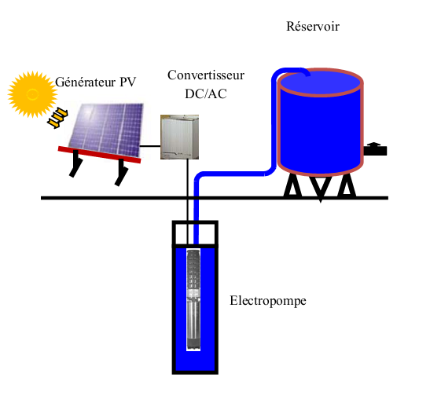
Figure 1: Components of a solar water pumping system

Voltage of the solar pump motors can be AC (alternating current) or DC (direct current). Direct current motors are used for small to medium applications up to about 3 kW rating, and are suitable for applications such as small irrigation projects. If an AC solar pump is used, an inverter is necessary that changes the DC from the solar panels into AC for the pump.

There are three main types of solar water pumps: surface mounted motor pump-set; submersible motor pump set; and floating motor pump set.
- Demand
At present there is not detailed and well-established information on the solar pumping market in Morocco, or on the potential for its development. In general, the use of energy and its mode of consumption in agriculture remain little known in Morocco for several reasons, among others, diffuse mode of consumption; the informal character of the activity; the absence of specific studies on the issue; etc. For example, the Ministry of Agriculture does not have data on the number of wells equipped by a pumping system disaggregated by type of energy used (diesel, electricity and butane).

However, during the preparation of this document, it was possible to estimate the theoretical pumping potential of irrigated area by groundwater (see section 2.6). The total area of ​​private irrigation is estimated about 441,430 Ha with a total of 72,370 farms of various sizes. Typical pump powers, for the main eight groundwater sources that are operated by individual irrigation, range from 0.8 to 6.9 kW/ha. The PV panels powers vary between 1 and 8.6 kWp / ha. The aggregate gross potential of solar pumping is estimated at 1,183 MW in terms of pump power and 1,478 MWp in terms of panel power.

Stakeholders analysis
- Institutional stakeholders

Ministry of Energy, Mines, Water and Environment (MEMEE)

The Department of Energy and Mines within the MEMEE is responsible, among others, to develop and implement government policy relating to energy. Within this Department, the Department of Renewable Energy and Energy Efficiency is responsible for the development and implementation of the national strategy for the development of renewable energy and enhancing energy efficiency. It participates, in collaboration with relevant bodies, in the preparation and implementation of legislation and regulation in this area.

National Agency for the Development of renewable Energy and Energy Efficiency (ADEREE)

ADEREE, established under Law No. 16-09, supports the implementation of the national policy for renewable energy and energy efficiency. ADEREE is responsible for coordinating, implementing and monitoring renewable energy (solar, wind, biomass, etc.) and energy efficiency (transport, buildings, industry, agriculture, public lighting) programs, identifying development areas and renewable energy potentials, developing standards and labels and providing assistance for research and development.

For thirty years ADEREE (ex. CDER) led several nationwide integrated projects for the use of renewable energy, including solar PV (in particular with the installation of the first solar pumps in the 1980s as part of its public service mission or by public-private partnerships). ADEREE has also been the executing agency for a number of RE and EE projects co-financed by international donors (GEF / UNDP, WB, EU, AFD, etc.). ADEREE is under the supervision of MEMEE.

Ministry of Agriculture

The Department of Agriculture within the Ministry of Agriculture is responsible for the development and implementation of the agriculture public policy, where irrigation is a key element given the growing water shortage. Among its tasks, this department oversees the use of irrigation water resources, conducts studies for the development of agriculture, and offers training to farmers.

The management of agricultural irrigation is supervised by the Ministry at a central level and by nine regional departments involved in public irrigation of large areas (regional offices of Agricultural Development, ORMVA).

The National Office of Agricultural Council (created in 2013) is responsible for leading, coordinating and monitoring the implementation of the strategy of the farm advisory nationally (Advise farmers, support professional organizations, Support actions realised by other agricultural development actors, offers training and conducts research and studies).

Agricultural Development Agency (ADA)

ADA was created with the primary mission to implement the GMP. To this end, the ADA is responsible for proposing action plans to the government authorities in two different areas relating to the support of i) agricultural sectors with high added value with a view to improving productivity, and ii) the Agriculture solidarity through the promotion and implementation of economically viable projects, to improve farmers' incomes while meeting the strategic priorities in the GMP. ADA is under the supervision of the Ministry of Agriculture.

The ADA also developed an implementation manual of a project related to the integration of climate change in the GMP implementation. This project aims to build the capacity of farmers as well as public and private institutions in order to integrate climate change adaptation into projects of small farmers in the five targeted regions.
- Private operators
There are several dozen private actors/suppliers in Morocco that operate in the photovoltaic sector. They offer a variety of services ranging from simple equipment supply to technical advice for the design and installation. These operators typically offer services and products related to solar pumping systems.

Most of these operators are grouped in the Moroccan Association of Solar and Wind Industries (AMISOLE) which aims to promote the interests of Moroccan industrials and professionals in the renewable energy sector.
- Farmers
In Morocco, nearly 70% of the agricultural sector consists of small and medium farms with a large majority characterized by their economic vulnerability excluding them from the traditional bank financing scheme. Farmers are relatively aware of the benefits of solar pumping systems, but are hampered by the high investment cost of such systems and their difficulties in accessing bank financing.
- Banks
The Crédit Agricole du Maroc Group (GCAM) was created in partnership with the Government, the Finance Company for Agricultural Development "Tamwil El Fellah", to give access to finance for farmers excluded from the traditional banking system.

However, the banking sector offers no specific credit offer to finance solar pumping systems because the banks are not aware of this emerging market. It is nevertheless expected that, under the National Program for Solar Pumping, the CAM can offer credit for the partial financing of solar pumping systems.

Stakeholders capacity building needs

There is a great need for capacity building among all market players, i.e. institutions, private operators, farmers and banks. More specifically:
- Institutional capacity building, particularly for ADEREE, is necessary for the management of the National Program for Solar Pumping and for the establishment of an accreditation procedure and a skills training system of installers for the design, installation, operation and maintenance of photovoltaic pumping systems.
- Support and capacity building of the national industry for the production of photovoltaic pumping equipment and components.
- Capacity building of farmers for the implementation and management of solar pumping systems.
- Capacity building through training and sensitization of banks to finance solar pumping systems.

Modelling and economic assessment of solar water pumping for irrigation

The use of solar energy for water pumping in not very common in Morocco and there is a lack of studies and publications on the subject. To compensate for this shortcoming, assess the economic rationality of the Project and better define the intended target, a techno-economic analysis was carried out as part of the PPG phase, relating in particular to the following aspects:

- Definition and characterization of the groundwater concerned with the individual irrigation and assessment of the technical potential;
- Profitability analysis of the use of solar PV energy for pumping (comparative cost of provision of m³ of water for the 4 scenarios of pumping and investment returns to the farmer in each case);
- Determination, starting from the results of modelling, of the feasibility of the target of the project according to the duration and the budget allocated.

The modelling was carried out within the framework of the Project sizing related more specifically to eight groundwater tables concerned with the private irrigation of a surface of 354,000 ha; six categories of surface, five types of total heads; and finally based on four different sources of energy: solar PV, diesel, butane, electricity. Thus 960 cases of projects were analysed and evaluated with a view to determine the range and the anticipated results of the implementation of the Project.

The economic evaluation made for each analysed case considered:

- To compare the water provision cost for the 4 pumping modes: diesel, butane, electric and solar PV for each plot category with and without investment subsidy;
- To determine the investment payback for the farmer of adopting a solar PV pumping system versus using butane, diesel or electricity with and without investment subsidy;
- To determine, based on modelling results, the project target according to the budget allocated for subsidies by the national program of solar pumping.

According to the modelling results, the rough potential is estimated at 1,183 MW in terms of pump capacity and to 1,478 MWp in terms of panels capacity, for typical capacity of pumps varying from 0.8 to 6.9 kW/ha and PV panel capacity fluctuating between 1 and 8.6 kWp/ha.

It should be noted that above-mentioned economic modelling was carried out for two cases: with and without investment subsidy of the solar pumping system, whose national budget amount was fixed at 400 MDH within the framework of the Convention for the implementation of the national program of solar pumping, signed in April 2013. The assumptions and the results of modelling analysis are summarized hereafter and detailed in appendix A.

Assessment of economic profitability without investment subsidy
The graph below (Figure 2) presents the pumping costs depending on the type of energy used and the groundwater. As shown in the graph, the cost of PV compared to other pumping modes is the least expensive for all groundwater extraction. The consolidated weighting average costs shows that diesel is the most expensive pumping mode on an operational basis (1.562 DH/m³) followed by butane (0.787 DH/m³) and electricity (0.739 DH/m³). PV is the least expensive pumping mode with a cost of 0.446 DH/m³, i.e. - 71% less than diesel.

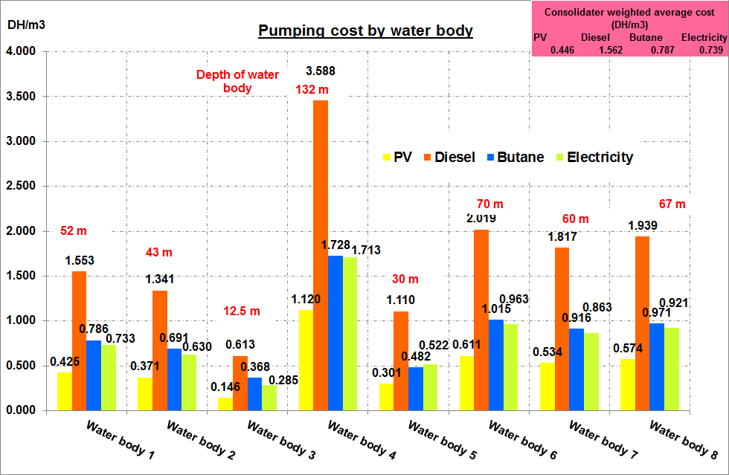
Figure 2: Pumping costs by source of energy and groundwater

As shown in the graph (Figure 3) that presents pumping costs by plot category and by source of energy used, PV still remains the least expensive pumping mode compared to other sources of energy regardless of the plot category. It is also shown that PV pumping costs are lower for larger areas. The consolidated weighting average costs show that diesel still remains the most expensive pumping mode (1.587 DH/m3) followed by butane (0.790 DH/m³), electricity (0.739 DH/m³) and PV (0.498 DH/m³, i.e. - 69% less than diesel).

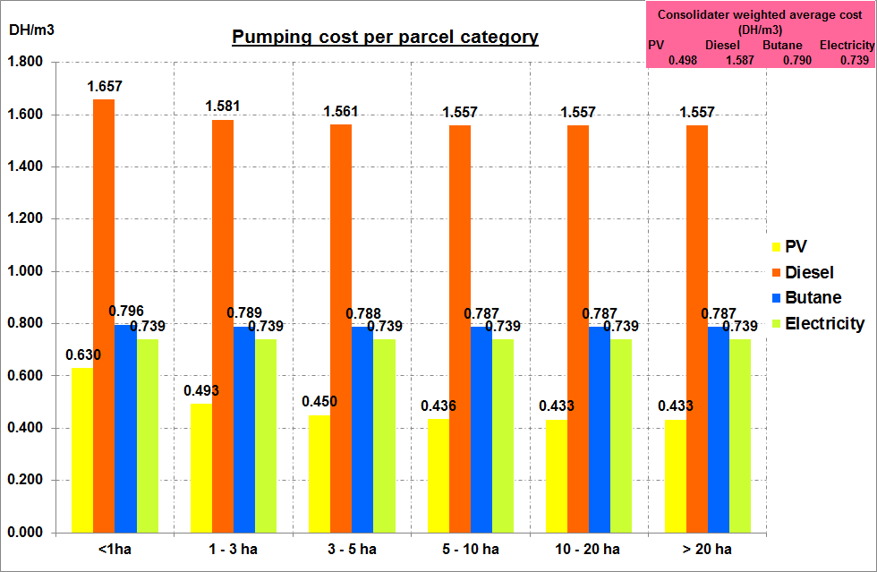
Pumping cost per plot category
Figure 3: Pumping cost by plot category and energy source

The graph below (Figure 4) presents the return on investment (ROI) depending on the plot category and the source of energy used. As shown in the graph, the weighted ROI of PV is 3.4 years compared to diesel, 8.3 years compared to butane and 9.2 years compared to electricity. It is also shown that smallest plots categories have the higher ROI, with an ROI higher than 10 years compared to butane and electricity with plots categories smallest than 1 ha.

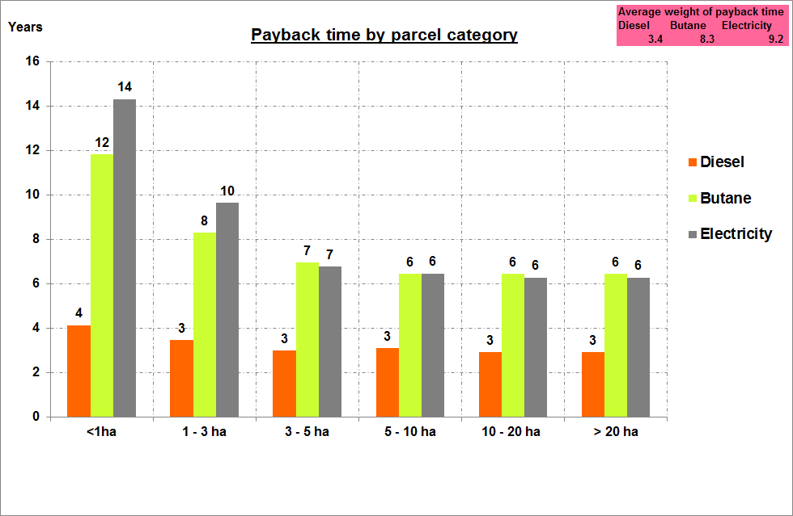
Payback time per plot category
Figure 4: Payback time by plot category and energy source

Assessment of economic profitability with investment subsidy
Considering an investment subsidy of about 50% of the installation cost (within the limit of 75,000 DH by project, 15,000 DH/ha & kit, and 15,000 DH / kWp installed) the weighted pumping cost of PV technology by groundwater is 0.366 DH/m³; that is 77% cheaper than diesel, 53% cheaper than butane and 50% cheaper than electricity (Figure 5).
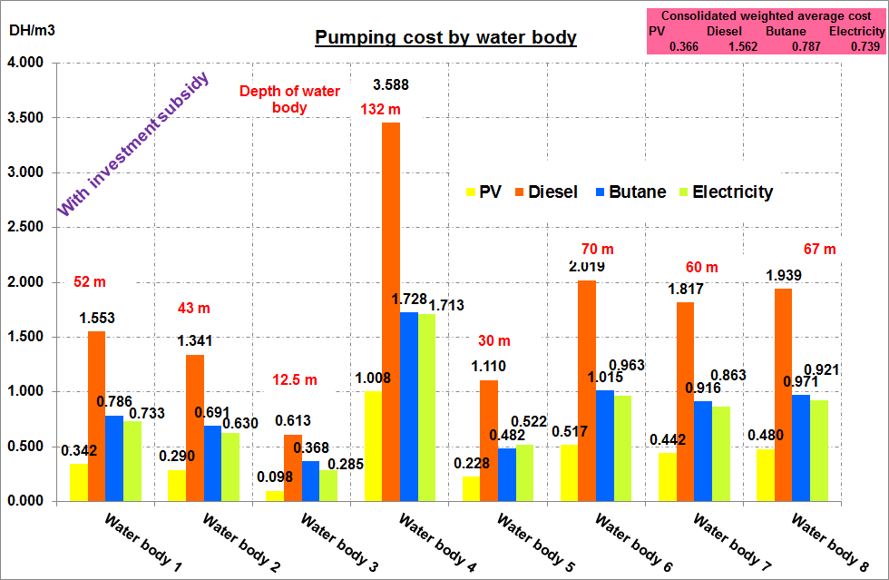
Figure 5: Pumping cost by groundwater and energy source (with investment subsidy)

The weighted cost by plot category of PV technology with investment subsidy is 0.334 DH/m³ i.e. 79% cheaper than diesel, 58% cheaper than butane and 55% cheaper than electricity (Figure 6).
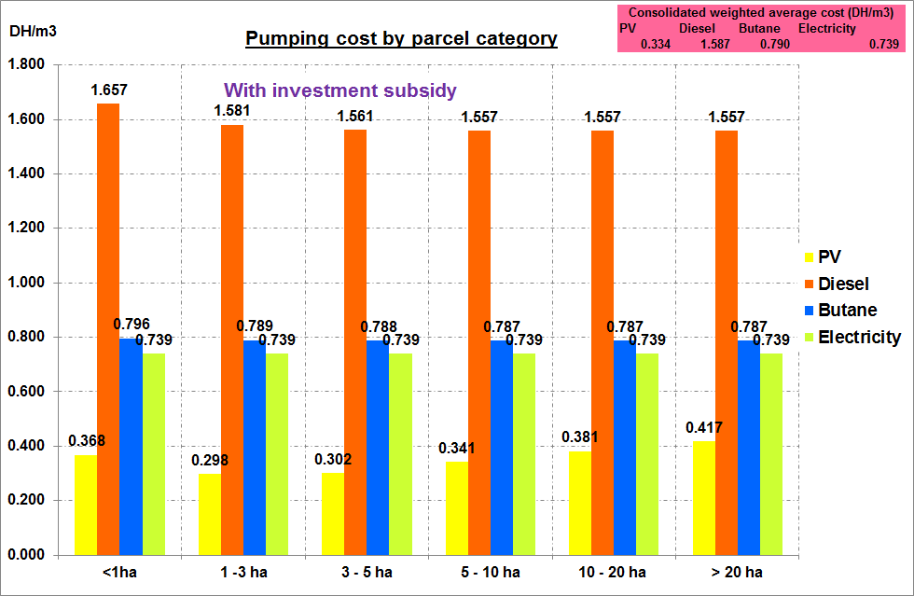
Pumping cost per plot category
Figure 6: Pumping cost by plot category and by energy source (with investment subsidy)

By comparing the cost by plot category, it should be noted that the subsidy mainly impacts the small plots and reduced slightly the pumping cost of PV system for the large plots as illustrated in the following table:

Table 1: Comparison of PV pumping cost by plot category with and without subsidy (in DH/m³)
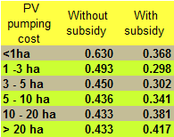

As regards the ROI, solar PV is (on average) about 2 years compared to diesel, 3.9 years compared to butane and 4.2 years compared to electricity. The subsidy mainly impacted the small plots and reduced slightly the ROI for the large farms (Figure 7).

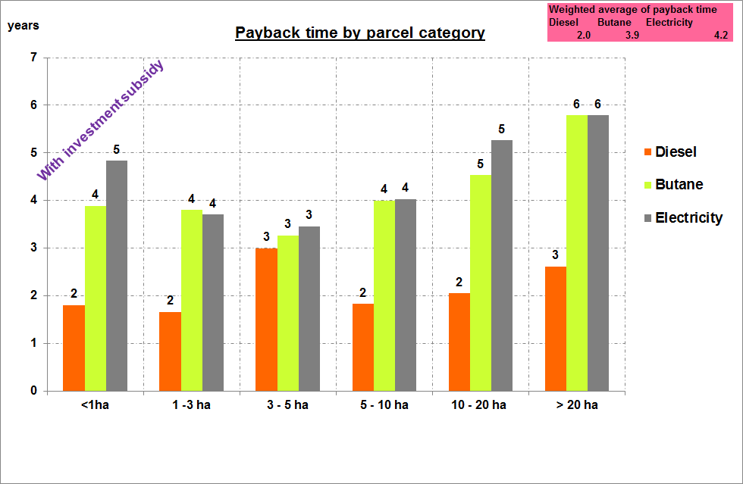
Payback time per plot category
Figure 7: Payback time per plot category and energy source (with investment subsidy)

By groundwater and energy source, the PV ROI is now less than 3 years compared to diesel and for all groundwater. The weighted average of PV ROI is 2.3 years compared to diesel, 4.6 years compared to butane and 4.8 years compared to electricity (Figure 8).
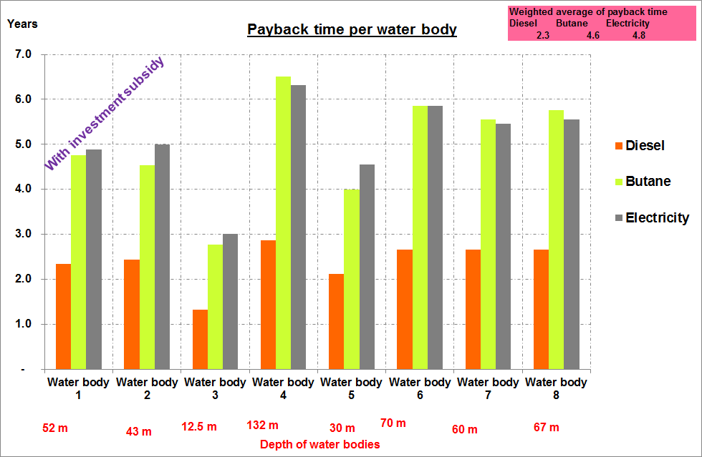
Figure 8: Payback time by groundwater and energy source (with subsidy)

Ultimately the investment subsidy is shown to be instrumental in improving the profitability of the small solar pumping projects to the benefit of the small farmers that are targeted primarily by the national program of solar pumping. Therefore the Project will support the development of the targeted small solar PV systems and ensure their positive impact on the incomes of farmers benefiting from the Project activities.

Barriers analysis
The "National Programme of solar pumping " agreement signed in April 2013 between the ADEREE, Ministry of Energy, Mines, Water and Environment (MEMEE), Ministry of Agriculture and the state-owned agricultural bank Agricultural credit of Morocco Group (GCAM), is considered as a baseline co-finance for the Project.
This program, although conceived to promote solar pumping, does not address the full range of associated barriers and opportunities and is hindered by a number of shortcomings which can inhibit the successful achievement of its objectives.
Indeed, four families of barriers were identified, and were taken into account when designing the Project as a means to overcome them:

Economic barriers
- Poor competitiveness compared with conventional solutions
Taking into account the subsidized tariffs of conventional electricity and butane in Morocco, the solar pumping solution remains relatively unattractive from the financial point of view for most farmers without an accompanying incentive/subsidy to have a level playing field. Indeed, the weighted payback time of PV in a BAU scenario compared to diesel is 3.4 years, 8.3 years compared to butane and 9.2 years compared to electricity, with a downward trend for large areas farms.
For the small plots, payback times of return are even higher than 10 years compared to butane and electricity for farms of less than 1 ha.
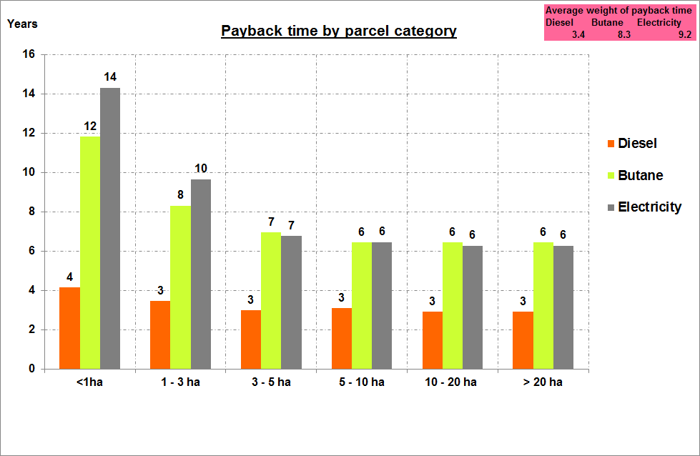
Figure 9: Payback time by plot category and by energy source
- Capital cost beyond small-scale farmers capacity
Affording the high upfront capital cost of solar pumping systems is beyond the financial capacity of the small farmers who constitute the great majority of irrigation users in Morocco, i.e. those working in 44 % of the total irrigated area of the country.

Indeed, as shown in the table below based on discussions with some local suppliers of solar systems, the current initial cost of a solar pumping system is respectively 2.6 and 5.5 times more expensive than BAU diesel and butane / electric system for system of 2 kW, and respectively 2.4 and 4.5 times higher for systems of 5 kW.

Table 2: Cost of pumping systems per type of system and per pump capacity
(in Dirhams)

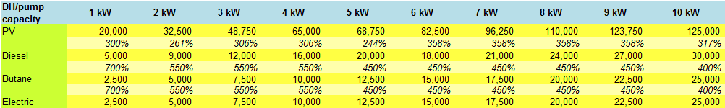
Source: data based on unit costs per kW collected from local suppliers
- Difficulty of funding this type of investment
The capital cost constraint is intensified by the fact that many farmers have limited or no access to term credit for the financing of these types of investment. This is mainly due to the absence of a specific offer of credit because the banks are not aware of this emerging market, and on the other hand because of land tenure security and precarious economic conditions of farms, over-indebtedness of farmers, and their exclusion from the banking system, etc.

In addition, although it offers an alternative financing platform for poor and vulnerable farmers, the interest rate proposed by the Finance company "Tamwil El Fellah" (subsidiary of the GCAM) remains relatively high in comparison with the traditional financing of the GCAM (around 8% instead of 5.5%), owing to the fact that the target population is considered high-risk borrowers.

In addition, at present the private sector seems to have a limited role in the program of the government, limited at present to a supplier of PV equipment. Indeed, in spite of the explicit acknowledgement by the Green Morocco Plan and the National Energy Strategy of the important role of the private sector as an engine of growth and sustained investment in the energy and agriculture sectors, its role remains limited in this program. There is no provision for catalysing private sector expertise or investment or for enhancing the private-sector credit environment for small-scale farmers.
- Subsidy announced, but not yet operational
The Ministry of Agriculture announced, in the context of the launch of the national programme of solar pumping during the agriculture conference in April 2013 in Meknès, a new grant of 50% for the installation cost of PV pumps with a ceiling of 75,000 DH per system to help Moroccan farmers to afford the purchase of solar water pumps.

However, although announced since 2013, this grant has not come into effect, which has led many farmers to defer their solar system purchase decisions in order to be able to profit from this (as yet operational) financial incentive.

Technical barriers
- Lack of tailored products
Under the National Promotion Programme for Solar Irrigation Water Pumping as it is constituted in the baseline, there is no provision to provide assistance to farmers on site surveys, equipment selection, maintenance or training. Small-scale (and largely unsophisticated) farmers who qualify for a state grant will be thus required to select, install and operate PV equipment of their own choosing. PV pump irrigation equipment which, it should be noted, is not off-the-shelf, may be inappropriate, expensive, inefficient or short-lived without customized support. Moreover, opportunities to maximize solar efficiencies through bespoke, site-specific designs will be lost.
- Weak development of a structured national offer
Although there are competent installers able to carry out PV installations in accordance with best practices and safety rules, the national offer is still insufficient to foster a rapid and large-scale development of demand. Indeed, the following conditions have been noted:

- Lack of skilled technicians having in-depth knowledge of solar pumping technology to ensure the development of a mass market;
- Lack of tailored solutions for farmers;
- A low domestic production capacity of equipment and components related to PV pumping systems.
- Lack of quality control and absence of certification
Although the Ministry of Agriculture ensures the quality control of drip irrigation equipment through supplier accreditation, files inspecting and field monitoring, the marketed solar pumping equipment are not currently monitored across the value chain which can impact the quality of systems installed and the viability of installations.

Moreover, aside from PV panels, there is no certification system and national standards for the solar pumping components (pumps, controllers and equipment associated).

Informational barriers
Solar pumping systems were introduced since the 1980s in Morocco through CDER-USAID, DGCL-FADES and DGCL - ACDI initiatives. These programs made it possible to install approximately 350 systems of which 50% are today out of service, mainly due to maintenance reasons. In spite of these initiatives, PV pumping technology is still today largely unknown by most Moroccan farmers, especially in absence of information and targeted public awareness campaigns. Intense campaigns of sensitization and information awareness will be thus necessary to facilitate the accelerated uptake of this technology.

MRV system for assessing climate mitigation impacts
The baseline Programme contains no provisions or mechanisms for assessment of the success of the initiative (e.g. in terms of hours of usage of the PV pumps, frequency of break-downs and other technical problems) or monitoring of the amount of greenhouse gas avoided (i.e. no planned assessment of baseline fuel types/usage, the displacement of fuel consumption by PV or energy efficiency savings). Nor does the baseline project contain any provisions for the avoidance of leakage – i.e. on-selling of old fossil fuel pumps by farmers adopting PV pumps. Such omissions also prevent the Programme, as constituted in the baseline, from potentially tapping into sources of climate finance such as NAMAs or being accurately counted under as part of INDC tracking.

Strategy

Rational and scope

Without GEF support, it is clear that the baseline scenario:

- is heavily reliant on grants and state-supplied loans for its support to PV pumping systems;
- runs a high risk of failure without additional support (lack of equipment quality assurance, untrained farmers, no maintenance and support regimes in place); and
- fails to comprehensively track climate change mitigation impacts from technology uptake of solar PV pumping systems in terms of monitoring, reporting and verification.

The Project will offer tailored support to the baseline National Promotion Programme for Solar Irrigation Water Pumping while also addressing the identified weaknesses in the Programme.

In this respect, the Project was sized for the categories of plots for which the use of solar PV pumping is sufficiently profitable for the small-scale farmers, the main target of the national program of solar pumping. In more concrete terms, the regions targeted by the project are those where the payback time of PV compared to diesel and butane is below or equal to 3 years.

Based on modelling results, during its implementation period (2017-2019) the Project will benefit at least 3,750 farms covering a total area of 19,000 ha. The total corresponding pump capacity is about 23.6 MW, for a total aggregate investment cost of about 280 MDH.

It is important to note that the Project will support the first phase of implementation of the national program of solar pumping over the period 2017-2019. Beyond the type of the projects selected for SWSPP sizing, the proposed activities will benefit all projects of the National Promotion Programme for Solar Irrigation Water Pumping.

Project Objectives, Outcomes and Outputs
The GEF project is designed to offer pragmatic and customized incremental support to the baseline National Promotion Programme for Solar Irrigation Water Pumping while also addressing the identified weaknesses in the Programme.

The Project will primarily target fruit plantations and legume crops grown by small and medium private operators through gravity irrigation. Given Morocco's vulnerability to climate change and the impact of rainfall variability on the economy (particularly in the agriculture sector), the Project will allow water saving by converting gravity irrigation to drip irrigation. It will thus contribute to improving plantation productivity, adaptation to climate change and contributing to the strategic objective of the Green Morocco Plan to strengthen the food security of Morocco.

The project will also support the low-carbon and climate-resilient development of Morocco, notably through:

- Reinforcement of the institutional capacities which are necessary for the management of the program, and of other stakeholders in terms of development, implementation and management of solar pumping and drip irrigation systems. These capacities could then lead to extend the program to medium and large farms and the promotion of other activities of renewable energies and/or energy efficiency in agriculture sector (those that are difficult to implement on a large scale without innovative support mechanisms, as those proposed within the framework of the Project);
- Contribution to the emergence of a national policy concerning the decentralized small-scale RE generation;
- Support and reinforce the national capacity of production of PV pumping equipment and components that will allow local industry to benefit from the technology and to create jobs;
- Creation of a structured local supply industry of solar pumping equipment and installation and maintenance services. The development of such an offer will in turn cater for increasing demand and lowering of installation prices thanks to competition, which will in turn strengthen the market expansion and consequently will contribute to the low-carbon and climate-resilient development of Morocco; and
- Creation of long-term high quality market on the basis of sound and balanced public private partnership by putting in place a management system within the program, through an equipment standards system, operator certification, skills training for installers and equipment labelling.

It is to mention that the project will carry out a detailed gender analysis at its beginning.

The Project has four Outcomes:

Outcome 1: PV pump units covering a range of configurations designed, assessed, installed and under implementation

GEF funding: US$959,025
Co-financing: US$25,000,000 (ADEREE: $2,500,000; MEMEE: $1,000,000; Ministry of Agriculture: $11,000,000; GCAM and other banks: $10,500,000)

This outcome seeks to enhance the baseline project, namely the National Promotion Programme for Solar Irrigation Water Pumping, in order to maximize the impact of subsidies and to enhance pumping system performance, notably through the following outputs:

- Output 1.1 3,750 small-scale off-grid PV pumps installed in a diverse range of geographical locations, facilitated by system configuration, siting and maintenance protocols

GEF funds will not be directly used as investment in the financing of the targeted systems (that will be done by the Program co-finance). Rather the mobilization of the financial resources for farmers will be ensured by the signatory organizations of April 2013 agreement under the National Program and by the farmers concerned, as illustrated in the graph below.

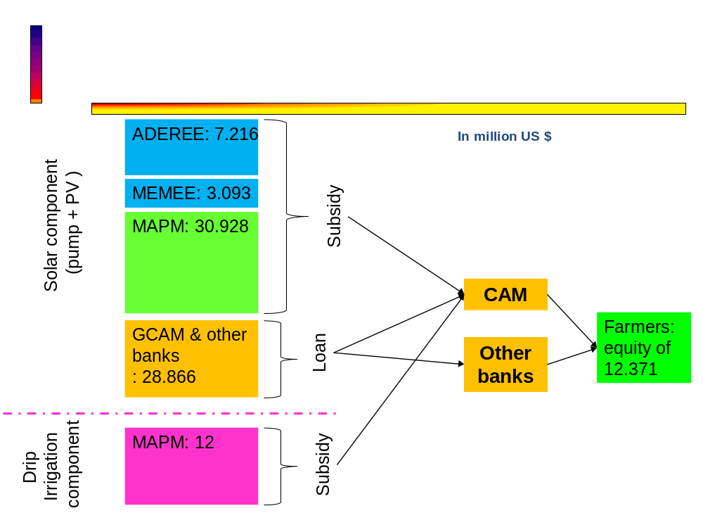
* the contributions of farmers and banks are evaluated on the basis of a contribution of 30% equity and 70% in loans of the investment amount required after grant.

Figure 10: Financing scheme of the national program of solar pumping

Instead GEF funds will be used for technical assistance in combination with the investment facilitated under the National Program. It should be noted that the Project supports the national programme of solar pumping during its first implementation phase, namely the 2017-2019 period. During this period, the project will leverage US$ 25.8 million in co-financing or 35% of its overall budget.

The Project’s input will consist in maximizing the impact of the public subsidies from the national Programme, notably through:

- Developing guidelines and tools for optimizing the sizing, siting and orientation of PV panels supported under the National Programme;
- Designing a modular configuration of standardized components that can be ‘mixed and matched’ according to site characteristics, farm requirements and the farmer’s budget;
- Amending the design of the National Promotion Programme so that the subsidies only apply to systems that: (a) meet the hardware certification criteria developed under Component 2, and (b) which are channelled through the Renewable Energy Service Companies (RESCOs) established under Outcome 2.

The work of the Project in conjunction with tailored financial products offered by Moroccan banks (see Outcome 3) to cover at least some of the remaining unsubsidised PV system costs and in conjunction with state subsidies available through the National Agricultural Development Fund to cover the costs of drip irrigation equipment.
Development of guidelines and tools for optimizing the sizing, siting and orientation of PV panels

Two types of literature will be developed: simple literature will be developed for farmers and farmer associations who choose to directly access the grant funds provided by the National Promotion Programme for Solar Irrigation Water Pumping. More sophisticated literature and tools (including a software tool based on a GIS/GPS platform) will be developed for the Renewable Energy Service Companies (RESCOs) supported by the Project (see below).

Designing a modular configuration of standardized components that can be ‘mixed and matched’ according to site characteristics, farm requirements and the farmer’s budget

The four standard elements of a PV irrigation pumping system – the PV panels, the pump, the controller and the electric motor – will be augmented by optional components such as adjustable mounts, solar tracking systems, batteries, etc. Certification criteria for each of these components will be developed under Outcome 2 to ensure minimum performance standards in the Moroccan context.

To ensure a continuous monitoring of pumping system operation and as part of monitoring, reporting and verification of the national program of solar pumping, a remote monitoring system will be adapted to all pumping stations to be installed. Such system would facilitate the MRV of the projects and allow farmers to remotely follow by Internet, phones or PC the performance of their solar pumping systems (flow, volume pumped per day, stock of in the basin, etc.). The software and equipment will be tested within the framework of the pilot installations of the project (see output 1.2).

In order to increase the efficiency of solar pumping system, the following potential options will be considered, according to the results, their relevance in the national context, and technical feasibility:

  - replacement of panels;
  - use of hydrophilic coatings to enhance panel self-cleaning;
  - performance monitoring;
  - preventive and curative maintenance;
  - anticipation of energy generation;
  - etc.
As theft and vandalism can be potential risks for rural PV projects, the system configuration guidance/tool will also incorporate security considerations – for example, guidance on how to enclose equipment; on how to mount PV modules in such a way that they would have to be physically damaged to be removed, thereby limiting their re-use/re-sale value; on how to mount equipment at such a height that it is inaccessible to casual intruders; etc.

The possibility of linking PV systems to cell-phone SMS systems, integrating built-in GPS trackers, etc. will also be considered.

- Output 1.2 Ten larger-scale demonstration PV pump units installed to demonstrate the potential of solar energy for larger farms
The Project will provide GEF funding for 50% cost subsidies to 10 large solar pumping units (between 20 and 30 kW) for average and large farms. These larger-scale systems will be used for assessment, sizing, monitoring and training purposes, and represent a unique opportunity to leverage the institutional and technical architecture of the baseline National Promotion Programme to extend the benefits of PV pumping to the larger-scale irrigated farm sector.

The GEF grant will be used to subsidize the ten pilot pumping PV systems selected on the basis of criteria established by the Project’s steering committee. The grant scheme will be operated by the Agriculture development fund (FDA) in close collaboration with Crédit Agricole under the oversight of ADEREE. It is worth noting that the FDA and Crédit Agricole both have extensive past operational experience channeling subsidies to farmers including those provided within the framework of the National Irrigation Water Efficiency Plan (subsidies for the purchase of drip irrigation systems).

The transfer of any GEF funds for equipment subsidies to the FDA will be conditional on the signature of an agreement between ADEREE, FDA and Crédit Agricole that specifies all requisite fiduciary and legal conditions and ensures the appropriate disbursement and monitoring of the GEF grant according to its intended use. The project will itself not manage the fund or disburse the grants to beneficiaries but rather transfer the equipment funds to ADEREE for on-granting to FDA; however, the project will ensure compliance of fund operations with steering committee procedures and UNDP/GEF guidelines.

- Output 1.3 Pump scrapping and recycling scheme studied and a programme contract with the Ministry in charge of environment is proposed to avoid GHG leakage effects associated with the project
The diesel/butane pumps which will be replaced by the solar systems within the framework of the program are likely to be re-used. In order to offset this potential risk, a collection scheme for recycling or disposal will be studied and proposed. In this context, a contract of collaboration between the project and ministry in charge of environment will be proposed for implementing this scheme.

This will serve to avoid potential greenhouse gas (GHG) leakage effects whereby farmers sell on their old pump units to other farmers, thereby undermining the mitigation benefits of the Programme.

•  Output 1.4 Monitoring systems and indicators designed and operationalized to reliably track energy consumption and GHG emission reductions

This MRV system will allow, inter alia, to effectively monitor the program effects on GHG emissions (fossil energy substitution by renewable energy, energy efficiency, irrigation system, leakage, etc) and therefore to quantify the emissions reductions associated with the implementation of the national program of solar pumping and other benefits which allow the program to qualify to international finance as a National Appropriate Mitigation Action (NAMA) or under the form of other mitigation mechanisms.

Outcome 1 | Output | Activities
PV pump units covering a range of configurations designed, assessed, installed and under implementation | - 3,750 small-scale off-grid PV pumps installed in a diverse range of geographical locations, facilitated by system configuration, siting and maintenance protocols | - Development of guidelines and tools for optimizing the sizing and performance of PV panels  - Designing a decision-tree tool and a modular configuration of standardized components that can be ‘mixed and matched’ according to site characteristics, farm requirements and the farmer’s budget;  - Definition of programme accession criteria for project, such that the subsidies only apply to systems that meet the hardware certification criteria developed under Component 2, and which are channelled through the Renewable Energy Service Companies (RESCOs)
 | - Ten larger-scale demonstration PV pump units installed to demonstrate the potential of solar energy for larger farms | - Site selection for demonstration projects on the basis of criteria to be defined;  - Engineering design of pumping systems and analysis of business model for units servicing;  - Installation and commissioning of pumping units;  - Training of beneficiaries on servicing and maintenance of equipment
 | - Pump scrapping and recycling scheme studied and a programme contract with the Ministry in charge of environment is proposed to avoid GHG leakage effects associated with the project | - Design of a pump scrapping and recycling programme (definition of partners and their roles, design of a financing scheme, establishment of a procedural manual, etc)  - Establishment of a programme contract between the project and the ministry in charge of environment
 | - Monitoring systems and indicators designed and operationalized to reliably track energy consumption and GHG emission reductions | - Designing of a monitoring systems and indicators to reliably track GHG emission, climate funds and co-benefits  - Implementation of a software tool for monitoring and management of emission reduction associated with pumping systems installed under the Project

Outcome 2: Conducive implementation framework and quality standards in place

GEF funding: US$540,000
Co-financing: US$100,000 (ADEREE: $40,000; Ministry of agriculture: $40,000; GCAM and other banks: $20,000)

The second expected outcome of the project is the implementation of a sustainable framework for the diffusion of solar pumping through, in particular:

- Output 2.1 Renewable Energy Service Company (RESCO) model designed and in place to support implementation of the National Promotion Programme for Solar Irrigation Water Pumping
As noted above, in the BAU baseline the choice of pumping systems, purchase, operation and maintenance are left to the responsibility of the small farmers whose knowledge in this field is extremely limited, which could compromise the sustainability of the program in the long term.

To overcome such barriers, the Project will support the development of RESCOs within the framework of the program. These establishments will have a central role to play in the management of the program since they will ensure the quality and the performance of the systems to be installed and will be the primary interface with the farmers to facilitate their access to investment grants of the national program and to bank commercial loans (see outcome 3).

These entities will operate on a commercial basis and will offer services tailored to the farmer needs. These services will include support for PV pumping feasibility studies for farmers, site visits to design optimal system positioning/configuration, and innovative business models to reduce costs and/or displace risks for farmers and also of the after-sale, care and maintenance services.

Although the specific business model of the RESCOs intervention for pumping is not yet fully elaborated and must be coordinated with ADEREE and Ministry for agriculture, the experience of Morocco in the leasing sector for vehicles, property and industrial equipment has shown that such a model is already well anchored in the commercial practices of Moroccan firms and could be duplicated in agriculture sector. The principle would be to purchase an appropriate pumping system tailored to farmer needs and to lease it to farmer within the framework of an irrevocable commitment over a given period. At the end of this period, the farmer has the option of relinquishing the asset or to buy back the asset at price which takes account payments made during the leasing period. The RESCO will be commit to guaranteeing the performance of pumping equipment by ensuring all the necessary operations of servicing and maintenance. This is only one possible model to be explored; a full analysis of various RESCO-models will be done as part of this output.

As part of the development of the RESCO business model supported under the project, criteria will be established for the types of RESCOs that will benefit from Project support. One of the criteria (to be monitored by the Project) will be that the RESCOs do not engage in excessive profiteering in selling pumping systems to unsophisticated farmers. Additionally, only Solar pumping equipment and systems that are approved on the basis of standards for PV pumping developed under Result 2 of the project, can benefit from the support of the Project.

- Output 2.2 A system of quality control is designed and set up

In order to secure the potential energy and mitigation benefits of the programme and, importantly, to ensure that any negative experiences of early adopters (e.g. system breakdowns, poor power output) do not deter later waves of farmers from taking up PV systems, it is imperative that the equipment funded and installed under the Programme meets minimum quality criteria.

In this context, the Project will support ADEREE to develop certification criteria for the full range of hardware components of PV pumping systems; to strengthen ADEREE’s existing certification laboratory and other test benches to be identified to allow it to test and certify such components; and to design and implement a certification monitoring and enforcement scheme to ensure that all equipment procured using Programme funds is certified and complies with international standards.

- Output 2.3 Fertigation management tool developed to inform farmers of the optimal fertilizer regime under drip-irrigation; and development of a cost-savings calculator to demonstrate to farmers the immediate financial benefits of switching to an optimal fertigation regime
The coupling of solar pump acquisition with water saving projects under the national program of solar pumping will induce – in addition to fuel savings and water resource conservation – an uptake in reduced fertigation practices (the application of water-dissolved fertilizers) and consequently an additional GHG mitigation benefits in the form of reduced N₂O emissions.

The Project will support the farmers in fertigation management by the development of a fertigation management tool to inform farmers of the optimum fertilizer amount, type and frequency of application so as to avoid over-application as well as a basic cost-savings calculator to demonstrate to farmers the immediate financial benefits of switching from a business-as-usual to an optimal fertigation regime.

- Output 2.4 NAMA concept updated and operationalized in support of the PV pump installation programme
The solar irrigation program will reduce GHG emissions while contributing to the sustainable development of Morocco. It has potential to be eligible for international support within the framework of a NAMA instrument.

A NAMA concept related to the solar pumping program was developed by the Department of Energy as part of the FIRM project activities. The Project will update the concept of the NAMA and adapt it to the project objectives and the MRV system for monitoring its activities.

The Project will ensure the coherence of the NAMA with the objectives of the national solar pumping program for drip irrigation. It will thus contribute to the creation of the favourable framework for the NAMA submission to UNFCCC, its registration and operational implementation.

Outcome2 | Outputs | Activities
Sustainable implementation framework and standards for solar pumping and drip-irrigation fertigation practices developed | 2.1 Renewable Energy Service Company (RESCO) model designed and in place to support implementation of the National Promotion Programme for Solar Irrigation Water Pumping | - Examination and definition of RESCOs operation business model  - Elaboration and set up of a RESCO accreditation system on the basis of specifications established in consultation with all the stakeholders  - Assisting RESCOs in their first projects
 | 2.2 A system of quality control is designed and set up | - Development of technical standards for equipment  - Strengthening of certification laboratory and test benches to be defined and putting in place of labelling and standardization procedures for the main components of solar pumping systems  - Definition of program eligibility criteria for equipment of solar pumping systems on the basis of established standards and labelling system to be implemented  - Elaboration and set up of suppliers and installer accreditation system on the basis of specifications established in consultation with all the stakeholders  - Definition of quality control procedures for facilities acceptance
 | 2.3 Fertigation management tool developed to inform farmers of the optimal fertilizer regime under drip-irrigation; and development of a cost-savings calculator to demonstrate to farmers the immediate financial benefits of switching to an optimal fertigation regime | - Development of a fertigation management tool to inform farmers of the optimum fertilizer amount, type and frequency of application so as to avoid over-application  - Development of a basic cost-savings calculator to demonstrate to farmers the immediate financial benefits of switching from business-as-usual practice to an optimal fertigation regime.
 | 2.4 NAMA concept updated and operationalized in support of the PV pump installation programme | - Update of the NAMA concept and content  - Calculation update of the NAMA and baseline emissions  - Update of costs and financing needs for the NAMA  - Consistency analysis of the MRV system with respect to the monitoring system of the emissions reduction associated with the project activities  - Submission of NAMA concept to Ministry in charge of environment for validation

Outcome 3: Supportive financing mechanisms and incentive schemes identified, designed and proposed to the MEF for implementation
GEF funding: US$342,000
Co-financing: US$120,000 (ADEREE: $40,000; GCAM and other banks: $80,000)

In addition to the activities strengthening the supply side, the Project will support demand development to encourage the adoption of PV pumping systems, through the following outputs:

- Output 3.1 Local private sector banks enabled to design and offer tailored financial products to farmers to support PV pump take-up

The project will work with local banks and financial institutions to design and offer tailored financial products to farmers to support PV pump take-up. By explicitly involving and supporting such institutions in the Programme, the Project can address a key deficiency in the baseline project, which places overreliance on state-funded grants and soft loans which are, by their very nature, limited and non-sustainable. Local banks will be enabled – through capacity development and involvement in Programme design – to develop tailored leasing, risk capital and credit products to enable farmers to acquire PV pump systems.

With the Project support, the National Promotion Programme will explicitly address banks’ lending risks (and thereby allow full involvement in the project by local banks) by putting in place a number of risk mitigation mechanisms:

- Only drip irrigation or supplemental irrigation systems – i.e. highly water-efficient irrigation techniques – will be eligible for support. This will have the effect of reducing farmers’ recurring water consumption costs, thereby generating savings for other purposes;
- Lending to farmers in the framework of the Programme will be limited to those farmers using quality-certified equipment and RESCO services for siting, installation or maintenance of the PV pump units;
- Farmers and banks will benefit from capacity development support, assisting farmers to understand and utilize PV pumping and banks to screen bankable projects;
- The MRV systems put in place primarily for GHG mitigation purposes will also serve as early-warning systems if particular types of PV system begin to fail or difficulties are encountered with operating the installed systems (thereby allowing solutions to be deployed rapidly and the value of farmers’ investments preserved).

- Output 3.2 Smart incentives/tax benefits enhancing farmers’ willingness to acquire PV technology designed in collaboration with Ministry of Economy and Finance

The Project will work with partners, particularly the Ministry for the Economy and Finance, to design and implement targeted tax incentives to enhance farmers’ willingness to acquire PV technology. This will cover inter alia tax and depreciation rules currently unfavourable to leasing and the value-added tax (VAT) and import tariff regime on PV technology. The analytical work underlying fiscal incentive design will be informed by a detailed system dynamics modelling (SDM) exercise to model economic costs and benefits and cross-sectoral spill-over effects of a range of potential fiscal adjustments to promote PV pump take-up and low-carbon development in the agricultural sector.

- Output 3.3 Options for better alignment of fertilizer subsidies with sustainable fertigation practices under drip irrigation analysed and recommended to the Ministry of Agriculture and the Ministry of Economy & Finance

Besides working on tax incentives, the Project will also assist the Ministry of Agriculture and the Ministry of Economy & Finance to explore options for better alignment of fertilizer subsidies with sustainable fertigation practices under drip irrigation.

Outcome 3 | Outputs | Activities
Supportive financing mechanisms and incentive schemes identified, designed and proposed in collaboration with the MEF for implementation | 3.1 Local private sector banks enabled to design and offer tailored financial products to farmers to support PV pump take-up | - Supporting Government partners preparing and signing an agreement with partner banks;  - Capacity strengthening of banks;  - Development of tailored financial products to farmers
 | 3.2 Smart incentives/tax benefits enhancing farmers’ willingness to acquire PV technology designed in collaboration with Ministry of Economy and Finance | - Feasibility study conducted (dynamic modelling of economic costs and benefits and cross-sectoral spill-over effects) and consultation with main stakeholders on tax benefits to adopt to enhance farmers’ willingness to acquire PV technology  - Definition of tax incentives and instruments to be adopted  - Establishment of an action plan for the implementation of adopted tax incentives and instruments
 | 3.3 Options for better alignment of fertilizer subsidies with sustainable fertigation practices under drip irrigation analysed and recommended to the Ministry of Agriculture and the Ministry of Economy & Finance | - Analysis and consultation with main stakeholders on options for better alignment of fertilizer subsidies with sustainable fertigation practices under drip irrigation;  - Validation of selected options by line relevant ministries  - Drafting of a decree on operationalization of alignment of fertilizer subsidies with sustainable fertigation practices under drip irrigation

Outcome 4: Capacities enhanced in developing, implementing and managing solar pumping and associated drip irrigation systems
GEF funding: US$673,000
Co-financing: US$260,000 (ADEREE: $140,000; Ministry of agriculture: $120,000)

A comprehensive program of communication, training and technical assistance tailored to specific needs of the baseline programme will be developed and undertaken within the framework of the Project. The aim of the program is to strengthen the capacities of the actors and to provide them the necessary expertise to help them to effectively fulfil their tasks within the national program.

Provision of technical support in this regard will entail support to:

- ADEREE in terms of standardization, test and equipment labelling, and operation of large-scale grid-connected demonstration PV pump units;
- RESCOs in order to allow them to recommend systems adapted to farmer needs and to provide them with continuous technical assistance;
- Local banks to allow them to examine and evaluate the projects of solar pumping;
- Farmers, associations of water users, regional agencies of agricultural development, RESCOs and banks to understand, recommend and optimize the practices of fertigation; and
- The local manufacturers, who will profit from technical support for the manufacturing of quality PV pumping system components, meeting the standards and the labelling criteria to be set up, and for the after-sales care of this equipment.

Outcome 4 | Outputs | Activities
Capacities enhanced in developing, implementing and managing solar pumping and associated drip irrigation systems | 4.1 Capacities of selected stakeholders enhanced to build local awareness and technical capability in solar pumping technology, business planning, life-cycle costing, quality assurance, maintenance, procurement and marketing | - Design of an awareness raising and communications program  - Design of a training program for building the capacities of ADEREE, Ministries in charge of Energy and Agriculture, agricultural water users’ associations, ORMVA, service companies and importers/distributers of PV equipment, and individual  - Implementation of awareness-raising activities  - Conducting training sessions to each category of stakeholders
 | 4.2 Capacity for national manufacturing of equipment and components built through strengthening of local private sector fabrication facilities | - Technical assistance to local private sector manufacturers for producing certification-quality PV system components and for providing after-sales maintenance support.
 | 4.3 Technicians trained for designing, installing, operating and maintaining PV pumping systems | - Establishment of a training program on design, installation, operation and maintenance of PV pumping systems for installers in order to enable them to be accredited under the programme  - Organization of skills training for technicians
 | 4.4. Finance professionals trained on the evaluation of bankable solar pumping projects | - Design of a training programme on evaluation of bankable solar pumping projects  - Specific trainings for banks
 | 4.5 Capacities in the application of optimal fertigation practices strengthened among farmers, water user associations, Regional Agricultural Development Agencies, RESCOs and banks | - Design of a training programme application of optimal fertigation practices for farmers, water user associations, Regional Agricultural Development Agencies, RESCOs and banks  - Conduction of training sessions to each category of stakeholders

Environmental management of the project

The proposed program for the development of solar irrigation reduces emissions of greenhouse gases while contributing to the sustainable development of Morocco. The project has positive environmental impacts including:

- A saving of 6,750 TOE/year of fossil fuels (gasoil and butane) and 4,050 TOE/year (applying a 60% GEF causality factor to baseline);
- A direct reduction in GHG emissions, through the use of renewable energy, estimated at 233,940 tCO₂e applying a 60% GEF causality factor, during the equipment lifetime period of 20 years;
- Further indirect (bottom-up) emissions reduction of 935,760 tCO2e during the solar pumping life period (see annex E);
- Preservation of water resources since the program is only for farms equipped with drip irrigation systems;
- The reduction of N₂O emissions thanks to an optimal fertigation system (to be calculated during project implementation).

The following table summarizes the GEF contribution to emissions abatement costs as detailed in Annex E, taking into account both direct and indirect emissions reductions resulting from the Project’s activities.

Description | Unit | Direct emissions reduction | Indirect emissions reduction  (bottom-up) | Total emissions reduction
Emissions reduction | tCO2 | 233,940 | 935,760 | 1,169,700
GEF Contribution | US$ | 2,639,726
Abatement cost | US$/tCO2 | 11.28 | 2.82 | 2.26

Considering the GEF financial contribution of $2,639,726 the Project’s emissions reduction will translate in a GEF direct emissions abatement cost of US$ 11.28 per tCO₂. Taking into account the Project’s total estimated global emissions reduction (direct and indirect) the abatement cost is US$ 2.26 per tCO₂.

The environmental and social screening of the project has categorized the project as a low risk project (See Annex F).

The project could present some environmental risks associated with:

- The generation of waste from diesel and butane pump systems that must be eliminated;
- The potential increase of the water amount pumped by solar systems.

However, these environmental risks are manageable because regarding waste generation the project includes a system for recycling and disposal of replaced pumping systems (see Outcome 1). Furthermore, the amount of water to be pumped is also controlled since farmers who will benefit from the program must have a permit to pump water from their wells. This authorization is issued by the corresponding Water Basin Agency (ABH). This authorization is issued with respect to a threshold volume of water to be pumped. Solar pumping systems will be designed to meet this threshold.

Expected global, national and local benefits of the project

Global benefits

The global benefits of the project are related to the reduction of GHG emissions that result from fossil fuel savings due to solar pumping systems use. The calculation details of the emissions reduction of the Project are presented in Annex E and already mentioned in Section 3.3 (above).

At the global level, the program targets direct GHG emissions estimated at 389,900 tCO₂ during the equipment lifetime of 20 years. Since in the baseline scenario, solar pumping program is planned without the support of the UNDP-GEF, a 60% causality factor may be applied to estimating emissions that can be attributed to support for the GEF project. Applying this causal factor, reduction of GHG emissions is estimated at 233,940 tCO₂ on the 20-year lifetime of the equipment.

The Project will also result in indirect emissions reduction. These have been evaluated according to a top down and a bottom up approaches (see Annex E). The bottom up approach is considered more conservative. Accordingly, the Project activities will result in a further 935,760 tCO₂ indirect emission reductions.

National benefits

At the national level, the project will have a positive impact on the country's energy bill. Indeed, the use of renewable energy will limit fuel imports given that almost all of Morocco's energy needs are imported and that the energy bill remains dependent on international energy prices.

The program will also have a positive impact by reducing the level of butane gas subsidization by the Moroccan Government. The program would therefore contribute to reducing the compensation system burden on government budget by developing solar pumping market for agricultural irrigation and reducing use of diesel and butane.

On the social level, the implementation of this solar pumping program will create jobs for the equipment, installation and maintenance of solar pumping systems.

Local benefits

Locally, the program's implementation will have a significant impact on targeted farmers' incomes via decreased expenditures on fossil fuels. The solar pump systems will reduce energy costs for pumping related to the production cost of farmers with the use of renewable energy. It is important to remember that small farms in Morocco provide subsistence agriculture and are often vulnerable to increases in energy prices, especially diesel, which constitutes a more and more important share in the production cost.

Project rationale and GEF policy conformity

The program will result in a significant reduction of GHG emissions through the use of renewable energy technologies and a reduced use of fossil energy sources. Specifically, the program will enable technical and institutional capacity building of stakeholders and will establish investment mechanisms for the deployment and diffusion of renewable energy technologies.

The Project is fully consistent with the Green Morocco Plan objectives of sustainable agriculture with low-carbon emissions and on the other hand, with the national strategy for the development of renewable energy and efficiency energy. It will contribute to achieving the goal recently set by Morocco under its INDC to reduce GHG emissions by 32% by 2030 compared to the no action scenario.

In this respect, the Project is in line with GEF policy and focal area strategies on climate change and in particular with the objective 3 which is to promote investment in renewable energy technologies. A key element of the GEF strategy on climate change has always been the funding of renewable energy technologies as well as supporting the removal of barriers to the adoption of these technologies.

Country ownership: Country eligibility and country drivenness

Country eligibility
According to the Instrument for the Establishment of the Restructured GEF, Morocco qualifies for GEF funding for the following reasons:

- It ratified the UNFCCC in December 1995;
- It is a Non-Annex I Party to the UNFCCC.
In addition, the UNDP has recognized experience and is one of the key agencies supporting emissions reductions in Morocco. In this context the UNDP has supported the following projects in Morocco:
- CDM capacity building project;
- Preparation of the Second National Communication project;
- Preparation of the Third National Communication project;
- Low Emissions Capacity Building (LECB) Project;
- Development of a building energy efficiency code project;
- Integration project of climate change in the National Logistics Strategy.

Country drivenness

By ratifying the UNFCCC in December 1995 and the Kyoto Protocol in 2002, Morocco engaged in the global process of fighting against global warming by limiting greenhouse gas emissions and implementing adaptation and mitigation strategies consistent with its sustainable development policy. The Solar Pumping Programme is in line with the goals already mentioned under the Second National Communication submitted to the UNFCCC in 2010. More recently, the program was integrated into the national project portfolio, illustrating Morocco's commitment to green growth and the fight against climate change through its INDC.

The Project is in full compliance with the policies and strategies of Morocco and comes in support of the Solar Pumping Programme initiated by the signing of a partnership agreement between the Government, ADEREE and Groupe Crédit Agricole du Maroc (see section 2.4.3). This program is consistent with two major strategies of Morocco: The National Strategy for Energy and the Green Morocco Plan.

Indeed, the Energy Strategy adopted in 2010, is based among others on the diversification of its energy mix, controlling energy demand and developing renewable energies.

The Green Morocco Plan, launched in 2009, aims to modernize the agricultural sector in Morocco in order to reduce poverty in rural areas. It also aims to safeguard natural resources for the sustainability of agriculture. As such, its action plan includes actions on adaptation to climate change, the fight against desertification, energy saving, water resources saving and the use of renewable energy for irrigation.

Moreover, by encouraging farms with a drip system, the Project is also in line with the National Water Saving Irrigation Program (PNEEI) whose objective is the promotion of water savings through implementation of drip irrigation systems in farms.

The UNDAF, through its Joint Action Plan for 2012-2016, reflects the commitment of the Moroccan government and UN agencies in Morocco to strengthening the reforms put in place and intensifying their cooperation in order to address GHG emissions mitigation and the integration of climate change into national strategies, including those relating to agriculture, water and energy. The project is also in line with the UNDAF's Outcome 5 on Environment and Sustainable Development, which includes four outputs:

- Output 5.1: The main actors are supported to ensure consistency between national and sectoral strategies and the national charter of environment and sustainable development (CNEDD);
- Output 5.2: Regional development plans and projects in the zones targeted are implemented bearing in mind the provisions of the CNEDD;
- Output 5.3: Capacities in terms of the development and coordination of 1) climate change mitigation and adaptation programs and strategies and the management of natural and 2) technological risks, are developed and strengthened;
- Output 5.4: the capacity of key actors to access funds is enhanced as a way of supporting the operationalization of the CNEDD.

Cost-effectiveness

In absence of the GEF support, the national solar pumping program for drip irrigation may not achieve its objective of mobilization of private farmers to adopt solar pumping systems and of ensuring the required supervision for the dissemination of quality solar systems. The capacity-building and accreditation activities of RESCOs to ensure quality service and establish the confidence of private farmers to adopt technology that is new to them are not planned by the national program. Similarly, the mobilization of financial operators and awareness to the benefits of solar pumping is essential to expand the complementary financing offers to the state grants and thus be able to overcome the major constraints to the development of solar systems, namely the initial investment. Under these conditions it is clear that in the absence of the Project activities, the national program accomplishments would be limited and in all cases, delayed.

The GEF funding, of an amount of US$ 2,639,726 dollars, will leverage an additional investment in co-financing of US$ 25,800,000 during project lifetime and an additional US$ 45,103,000 beyond 2019, which is a leverage of 26 times. The Project will build the enabling environment in terms of capacity building and technical leadership for the support of the National pumping program and ensure its feasibility. A total of US$ 412,025 from GEF funding will be devoted to partial finance 10 large facilities with a capacity of 20 to 30 kW as demonstration projects. The objective is to demonstrate the technical, economic and financial viability of large systems and enable to switch to a larger scale solar pumping market.

Further information on the financing and cost-sharing arrangements of the project can be found from section 5. In converting budgets made in Moroccan Dirhams to US dollars, an exchange rate of USD 1 = MAD 9.7 has been used.

Sustainability

The implementation of a quality management system within the program, through an accreditation system of operators, and standardization and certification of equipment will ensure an adequate and highly qualified range of services including systems installation. In addition, the integration of the private sector through the development of energy service companies will help provide a quality service offering by creating a structured local supply chain of solar pumping equipment, as well as maintenance and installation services. The development of such an offer will in turn stimulate demand and lower prices for installations through competition, which in turn will strengthen market expansion. This will result in the creation of a sustainable market in the long term. The market will also benefit from the GEF support as part of this project through pilot demonstration projects that will be used to demonstrate the feasibility of such solar pumping systems for larger farms. The market is therefore not limited to small scale farms.

The Project in Morocco will also help develop appropriate and sustainable financial mechanisms for the financing of solar pumping projects by farmers regardless of the subsidies (which are limited).

Furthermore, the institutional capacity building of ADEREE for the standardization and certification of equipment, and other stakeholders in terms of financing, development, implementation and management of solar pumping systems will enhance the sustainability of the national solar pumping program, once the GEF support is completed.

Finally, the development of a NAMA concept specific to solar pumping in Morocco will also ensure the sustainability of the program well beyond the GEF support. Indeed, a NAMA will establish robust monitoring, reporting and verification mechanisms of the program results on an ongoing basis. The NAMA will also bring potentially new climate finance funding opportunities to the national program for solar pumping and maintain a strict management system to ensure the sustainable success of this program.

Replicability

Replicability of the Project will be ensured by several approaches that are part of the project components, namely capacity building, implementation of demonstration projects and the development of a NAMA.

Capacity building and training of persons and institutions will help to ensure dissemination of the program results.

A focus on larger size farms will help replicate the results of the Program to larger sizes farms that were not initially targeted. The development of a NAMA will further increase the possibilities for replication.

International Collaboration

It is worth mentioning that Sudan will implement a similar UNDP/GEF project on Promoting the use of electric water pumps for irrigation in Northern State of Sudan. The project comprises four components: i) the development of pilot projects as a demonstration of the viability of the technology and an accompanying financing mechanism for continued finance of projects; ii) development of standards and guidelines to promote quality and sustainability of water pumping; iii) development of a NAMA to support solar water pumping; and iv) developing a supporting environment to encourage scaling up and further replication.

As it can be seen from above, the two projects have similar objectives. They both aim at the establishment of a favourable environment for the development in their respective countries, of solar pumping for irrigation. The difference in national contexts can be a source of a valuable experience exchange between the two countries on the projects’ operational barriers and the lessons learned overcoming them. To this end, the Project’s team will collaborate through UNDP/GEF with the Sudan project’s PMU to maintain a regular exchange on operational experience gained and potential synergies between the two projects.

This is an excellent example of South-South cooperation that can be extended to other African countries as part of the capitalization of knowledge and exchange of experiences.

Project Results Framework:
This project will contribute to achieving the following Country program Outcome: The principles of the "National Charter for the Environment for Sustainable Development" are implemented in coherence between sectoral strategies and priorities for the environment, climate change adaptation and risk management and by strengthening territorial convergence in areas and the most vulnerable populations with special attention to gender.
Country Program Outcome Indicators:
Indicator 5.1.1: Number of strategies produced / reviewed consistently and the principles of ESD charter integrated.
Indicator 5.3.1: Number of strategies developed for mitigation and adaptation to CC.
Indicator 5.3.2: Number of entities that have received capacity building in CC and risk management

Primary applicable Key Environment and Sustainable Development Key Result Area: 1. Mainstreaming environment and energy OR 2. Catalysing environmental finance OR 3. Promote climate change adaptation OR 4. Expanding access to environmental and energy services for the poor.
Applicable GEF Focal Area Objective:
CCM 3 - “Promote investment in renewable energy technology”
 | Indicator | Baseline | Targets  End of Project | Source of verification | Risks and Assumptions
Project Objective:  To promote the take-up of PV-powered drip irrigation pumping systems in Morocco. | Additional amount of tons of CO₂ emissions reduced per year (above baseline and attributed to the project) | 0 | 11,697 tCO₂/year  Total of 233,940 tCO₂ over the 20 years lifetime of all pumps | Quarterly progress monitoring reports (these reports will include a section dedicated to emission reduction monitoring). This section will be informed by the information system for the calculation and monitoring of emission reduction. | Assumption: Direct emission reduction on an annualized basis, applying a 60% GEF causality factor.  Risk : leakage associated to the reuse of substituted fuel pumps
 | - Number of solar pumps installed (cumulative)  - Fuel saved (TOE/year) | 1,500  2,700 TOE/year | 3,750  4,050 TOE/year  (942,020 MWh lifetime) | Quarterly progress monitoring report | Assumption: applying a 60% GEF causality factor.  Risk: refer to section 8.0 on risks of delay in implementing operational modalities of subsidy granting and in implementing solar pumping projects
 | Number of new RESCOs partnerships fostered for provision of improved energy efficiency and/or sustainable energy solutions targeting underserved communities/groups and women. | 0 | 5 RESCOs created or assisted | Quarterly progress monitoring report  List of RESCOs which benefited from the Project capacity building and technical assistance  Statistics and activity reports of partner banks | Assumption: The project’s interventions will successfully catalyse private sector RESCO interest in solar pump products and market opportunities
 | Number of people (Man and woman) benefiting from improved access to sustainable energy platforms | 0 | 18,750 (3,750 solar pumping systems benefiting to 3,750 rural households composed on average of 5 persons each) | Quarterly progress monitoring report | Assumes installed solar pump target is met
Outcome 1:  PV pump units covering a range of configurations designed, assessed, installed and under implementation | Cumulative capacity of installed solar pumps– kW | 9,560 kW | 23,900 kW | Quarterly progress monitoring report | Assumption: applying a 60% GEF causality factor  Risk: refer to section 8.0 on risks of delay in implementing operational modalities of subsidy granting and in implementing solar pumping projects
 | Number of large scale demonstration PV pump units  Installed / (Man and woman) | 0 | 10 | Quarterly progress monitoring report
 | Availability of an MRV system | None: Absence of procedures and monitoring & assessment system of emissions and programme impacts | Yes: MRV system designed and operationalized to  reliably track project progress and GHG emission reductions | Design report of MRV system,  Quarterly progress monitoring report | Assuming good cooperation between farmers targeted for reporting of operational information on installed solar systems
Outcome 2 :  Sustainable implementation framework and standards for solar pumping and drip-irrigation fertigation practices developed | Number of RESCOs created or assisted | 0 | 5 | Quarterly progress monitoring report which will capture list of RESCOs which benefited from the Project capacity building and technical assistance activities
 | Existence of Standardization and equipment labelling procedures (Yes/No) | None: Absence of standardization and labelling procedures of main solar pumping components | Yes: Standardization and labelling procedures adopted, tested and in place for main solar pumping components | Quarterly progress monitoring report, ADEREE activity reports
 | Existence of a quality audit and evaluation system for installations (Yes/No) | None: Absence of PV pumping systems control | Yes: Quality audit and evaluation system for PV pumping systems developed | Quarterly progress monitoring report
 | Existence of an information tool on optimal  fertilizer regime  under drip irrigation and cost-savings  calculation for farmers (Yes/No) | None: Absence of information for farmers on optimal fertigation management and associated financial benefits | Yes: Information tool on optimal fertilizer regime  under drip irrigation and cost-savings calculation for farmers designed and developed | Design report of fertigation information tool,  Quarterly progress monitoring report | Active participation of regional agriculture ministry services in farmers’ awareness raising on the interest of optimizing fertigation
 | Existence of an updated NAMA concept  in support of the PV  pump installation  programme (Yes/No) | No: Absence of an updated NAMA concept in support of the national solar pumping system | Yes: NAMA concept updated and validated for submission to UNFCCC NAMA registry | NAMA document,  Quarterly progress monitoring report | Government commitment to adopt, support, monitor and verify the proposed NAMA.
Outcome 3: Supportive financing mechanisms and incentive schemes identified, designed and proposed in collaboration with the MEF for implementation | Number of banks involved in the programme | 0: Local private banks are not involved in  the program financing | 4: Full involvement in  program financing by 4 local private banks | Quarterly progress monitoring report  Statistics and activity reports of partner banks | Assuming positive bank perception of this market segment
 | Availability of fiscal incentives to solar pumping (Yes/No) | No: Absence of fiscal incentives for solar pumping | Yes: Relevant tax incentives/instrument designed in collaboration with the ministry of finance for adoption | Analytical work and dynamic modelling report  Quarterly progress monitoring report | Ministry of finance commitment to the modelling approach and its endorsement for the approval of proposed instruments
 | Alignment of fertilizer subsidies with sustainable fertigation  practices under  drip irrigation (Yes/No) | No: Absence of an alignment of the fertilizer subsidies with sustainable fertigation  practices under  drip irrigation | Yes: Options for an  alignment of fertilizer  subsidies with sustainable fertigation  practices under drip irrigation analysed | Report on options analysis  Quarterly progress monitoring report | Ministry of agriculture and ministry of finance commitment to the analysis
Outcome 4:  Capacities enhanced in developing, implementing and managing solar pumping and associated drip irrigation systems | Number of actors whose technical capabilities are enhanced for PV technology, maintenance and marketing | 0 | 400 | Training reports, project reports, rapport de communication and awareness-raising report, minutes of project steering committee
 | Number of trained technicians (Man and woman) specialized in the design, installation, operation and maintenance of solar pumping systems | 0 | 30 | Training reports,  Quarterly progress monitoring report | Vocational training organizations commitment
 | Number of financial professionals whose evaluation pumping capacity projects are reinforced (Man and woman) | 0 | 40 | Training reports,  Quarterly progress monitoring report | Commercial banks commitment to the project
 | Number of actors whose capabilities are enhanced for optimal control of fertigation practices  (Farmers, associations of water users, regional agencies for agricultural development, RESCO and banks) | 0 | 160 | Training reports,  Outils de communication et de formation  Quarterly progress monitoring report | Agricultural Development Agency and Ministry of Agriculture commitment

Project Outputs and Related Target(s)/Sub-target(s), as applicable
Outcome 1  PV pump units covering a range of configurations designed, assessed, installed and under implementation | Outcome 2  Sustainable implementation framework and standards for solar pumping and drip-irrigation fertigation practices developed | Outcome 3  Supportive financing mechanisms and incentive schemes identified, designed and proposed in collaboration with the MEF for implementation | Outcome 4  Capacities enhanced in developing, implementing and managing solar pumping and associated drip irrigation systems
Output 1.1  More than 3,700 small-scale off-grid PV pumps installed in a diverse range of geographical locations, facilitated by system configuration, siting and maintenance protocols | Output 2.1  Renewable Energy Service Company (RESCO) model designed and in place to support implementation of the National Promotion Programme for Solar Irrigation Water Pumping | Output 3.1  Local private sector banks enabled to design and offer tailored financial products to farmers to support PV pump take-up | Output 4.1  Capacities of selected stakeholders enhanced to build local awareness and technical  capability in solar pumping  technology, business  planning, life-cycle costing,  quality assurance, maintenance,  procurement and  marketing
Output 1.2  Ten larger-scale demonstration PV pump units installed to demonstrate the potential of solar energy for larger farms | Output 2.2  A system of quality control is designed and set up | Output 3.2  Smart incentives/tax benefits enhancing farmers’ willingness to acquire PV technology designed in collaboration with Ministry of Economy and Finance | Output 4.2  Capacity for national manufacturing of equipment and  components built through  strengthening of local private  sector fabrication facilities
Output 1.3  Pump scrapping and recycling scheme studied and a programme contract with the Ministry in charge of environment is proposed to avoid GHG leakage effects associated with the project | Output 2.3  Fertigation management tool developed to inform farmers of the optimal fertilizer regime under drip-irrigation; and development of a cost-savings calculator to demonstrate to farmers the immediate financial benefits of switching to an optimal fertigation regime | Output 3.3  Options for better alignment of fertilizer subsidies with sustainable fertigation practices under drip irrigation analysed and recommended to the Ministry of Agriculture and the Ministry of Economy & Finance | Output 4.3  Technicians trained for designing,  installing, operating and  maintaining PV pumping systems
Output 1.4  Monitoring systems and indicators designed and operationalized to reliably track energy consumption and GHG emission reductions | Output 2.4  NAMA concept updated and operationalized in support of the PV pump installation programme |  | Output 4.4  Finance professionals trained on the evaluation of bankable solar pumping projects
Output 4.5
Capacities in the application of optimal fertigation practices
strengthened among farmers,
water user associations, Regional Agricultural Development Agencies,
RESCOs and banks

Total budget and work plan

Total budget

Award ID: | 00091134 | Project ID(s): | 00096531
AwardTitle: | Promoting the development of photovoltaic pumping systems for irrigation
Business Unit: | MOR10
Project Title: | Promoting the development of photovoltaic pumping systems for irrigation
PIMS no. | 5284
Implementing Partner (Executing Agency) | National Agency for the Development of Renewable Energy and Energy Efficiency (ADEREE)

GEF Outcome/Atlas Activity | Responsible Party/ Implementing Agent | Fund ID | Donor Name | Atlas Budgetary Account Code | ATLAS Budget Description | Amount  Year 1  (USD) | Amount  Year 2  (USD) | Amount  Year 3  (USD) | Amount  Year 4  (USD) | Total (USD) | See Budget Note:
Outcome 1. PV pump units covering a range of configurations designed, assessed, installed and under implementation | ADEREE | 62000 | GEF | 71200 | Int. Consultants | 30,000 | 60,000 | 30,000 | 20,000 | 140,000 | 1
 |  |  |  | 71300 | Local Consultants | 10,000 | 40,000 | 10,000 | 10,000 | 70,000 | 2
 |  |  |  | 71400 | Contract services Ind | 20,000 | 20,000 | 20,000 | 20,000 | 80,000 | 3
 |  |  |  | 72600 | Grants for equipment | 0 | 105,000 | 254,025 | 53,000 | 412,025 | 4
 |  |  |  | 72100 | Contract Services Comp | 10,000 | 10,000 | 10,000 | 10,000 | 40,000 | 5
 |  |  |  | 72500 | Supplies | 5,000 | 5,000 | 5,000 | 5,000 | 20,000 | 6
 |  |  |  | 75700 | Workshops and meetings | 5,000 | 5,000 | 5,000 | 5,000 | 20,000 | 7
 |  |  |  | 71600 | Travel | 30,000 | 30,000 | 10,000 | 10,000 | 80,000 | 8
 |  |  |  | 72200 | Equipment & Furniture | 60,000 | 15,000 | 5,000 | 5,000 | 85,000 | 9
 |  |  |  | 74500 | Miscellaneous | 5,000 | 1,000 | 1,000 | 5,000 | 12,000
 |  |  |  |  | Total outcome 1 | 175,000 | 291,000 | 350,025 | 143,000 | 959,025

Outcome 2. sustainable implementation framework and standards for solar pumping and drip-irrigation fertigation practices developed | ADEREE | 62000 | GEF | 71200 | Int. Consultants | 30,000 | 30,000 | 10,000 | 10,000 | 80,000 | 10
 |  |  |  | 71300 | Local Consultants | 25,000 | 20,000 | 15,000 | 10,000 | 70,000 | 11
 |  |  |  | 71400 | Contract services Ind | 20,000 | 20,000 | 20,000 | 20,000 | 80,000 | 3
 |  |  |  | 72100 | Contract Services Comp | 10,000 | 30,000 | 30,000 | 10,000 | 80,000 | 12
 |  |  |  | 72200 | Equipment & Furniture | 15,000 | 50,000 | 50,000 | 10,000 | 125,000 | 13
 |  |  |  | 72500 | Supplies | 5,000 | 5,000 | 5,000 | 5,000 | 20,000 | 6
 |  |  |  | 75700 | Workshops and meetings | 10,000 | 10,000 | 10,000 | 10,000 | 40,000 | 7
 |  |  |  | 71600 | Travel | 10,000 | 10,000 | 10,000 | 10,000 | 40,000 | 8
 |  |  |  | 74500 | Miscellaneous | 1,000 | 1,000 | 1,000 | 2,000 | 5,000
 |  |  |  |  | Total outcome 2 | 126,000 | 176,000 | 151,000 | 87,000 | 540,000
Outcome 3. supportive financing mechanisms and incentive schemes identified, designed and implemented | ADEREE | 62000 | GEF | 75700 | Workshops and meetings | 2,000 | 5,000 | 2,000 | 5,000 | 14,000 | 14
 |  |  |  | 71200 | Int. Consultants | 50,000 | 50,000 | 30,000 | 30,000 | 160,000 | 15
 |  |  |  | 71300 | Local Consultants | 20,000 | 20,000 | 20,000 | 20,000 | 80,000 | 16
 |  |  |  | 72100 | Contract Services Comp | 0 | 20,000 | 20,000 | 20,000 | 60,000 | 17
 |  |  |  | 71600 | Travel | 5,000 | 5,000 | 5,000 | 5,000 | 20,000 | 8
 |  |  |  | 74500 | Miscellaneous | 2,000 | 2,000 | 2,000 | 2,000 | 8,000
 |  |  |  |  | Total outcome 3 | 79,000 | 102,000 | 79,000 | 82,000 | 342,000
Outcome 4. capacities enhanced in developing, implementing and managing solar pumping and associated drip irrigation systems | ADEREE | 62000 | GEF | 75700 | Workshops and meetings | 5,000 | 5,000 | 10,000 | 15,000 | 35,000 | 7
 |  |  |  | 71200 | Int. Consultants | 20,000 | 20,000 | 20,000 | 20,000 | 80,000 | 18
 |  |  |  | 71300 | Local Consultants | 10,000 | 10,000 | 10,000 | 10,000 | 40,000 | 19
 |  |  |  | 71400 | Contract services Ind | 20,000 | 20,000 | 20,000 | 20,000 | 80,000 | 3
 |  |  |  | 72100 | Contract Services Comp | 0 | 30,000 | 100,000 | 50,000 | 180,000 | 20
 |  |  |  | 72200 | Equipment & Furniture | 2,000 | 2,000 | 2,000 | 2,000 | 8,000 | 21
 |  |  |  | 74200 | Audio-visual production costs | 0 | 0 | 70,000 | 70,000 | 140,000 | 22
 |  |  |  | 72500 | Supplies | 5,000 | 5,000 | 5,000 | 5,000 | 20,000 | 6
 |  |  |  | 71600 | Travel | 10,000 | 20,000 | 30,000 | 30,000 | 90,000 | 8
 |  |  |  |  | Total outcome 4 | 72,000 | 112,000 | 267,000 | 222,000 | 673,000

Project management | ADEREE | 62000 | GEF | 71400 | Contr.Services Indiv | 10,000 | 11,000 | 11,000 | 11,000 | 43,000 | 3
 |  |  |  | 72100 | Contract Services Comp | 0 | 20,000 | 0 | 40,000 | 60,000 | 23
 |  |  |  | 74598 | DPC | 6,500 | 6,500 | 5,000 | 4,701 | 22,701 | 24
 |  |  |  |  | Sub total PM- GEF | 16,500 | 37,500 | 16,000 | 55,701 | 125,701
Project management | ADEREE | 4000 | PNUD | 71400 | Contr.Services Indiv | 15,000 | 15,000 | 15,000 | 15,000 | 60,000 | 3
 |  |  |  | 74100 | Audit fees | 10,000 | 10,000 | 10,000 | 10,000 | 40,000 | 25
 |  |  |  |  | Subtotal PM - UNDP | 25,000 | 25,000 | 25,000 | 25,000 | 100,000
Project management | ADEREE |  |  |  | Total Project Management | 41,500 | 62,500 | 41,000 | 80,701 | 225,701 | 26
 |  |  |  |  | PROJECT TOTAL GEF | 468,500 | 718,500 | 863,025 | 589,701 | 2,639,726
 |  |  |  |  | PROJECT TOTAL UNDP | 25,000 | 25,000 | 25,000 | 25,000 | 100,000
 |  |  |  |  | PROJECT TOTAL GEF & UNDP | 493,500 | 743,500 | 888,025 | 614,701 | 2,739,726

Budget Notes:
No. | Note
1 | International consultants in sizing and implementing PV pumping units, monitoring GHG emissions and in assessing emission reductions associated with these units
2 | Local consultants to support international consultant; 1) conduct surveys, data-gathering and field work to the extent possible; 2) consultant to work on waste management and recycling & valorisation of industrial waste; and 3) communication consultant
3 | Long term local consultant / project lead team (consisting of the project manager and technical staff)
4 | GEF funding for partial cost subsidy for equipment for 10 pilot solar pumping projects, each with a capacity of 20 to 30 kW. The use of grants and transfer of funds from the project for the grants will be subject to the UNDP micro-capital grant policy.
5 | Service companies to work on training, awareness raising, communication and supporting field implementation of projects
6 | Publishing and printing of training documents; knowledge-sharing and communication activities
7 | Workshops and trainings to support the implementation of solar pumping projects; capacity-building to raise awareness on solar pumping and on monitoring GHG emissions and associated emissions reduction
8 | Travel costs of project stakeholders and partners to attend workshops and project activities. Note that some project implementation activities may be conducted at the regional level. Travel costs to Project Management Unit members to ensure the follow up of project activities at local level.
9 | Software, computers and IT tools for the GHG emissions management and monitoring
10 | International consultants for the design of RESCO business plan; development and enabling of NAMA; design and enabling of MRV system; and assessment of GHG mitigation potentials
11 | Local consultants to support international consultant in RESCOs, NAMAs and MRV enabling, surveys and data-gathering; development of equipment quality standards, inventory of suppliers, accreditation system of suppliers and PV pumping equipment; programme on fertigation optimization according to the type of cultivation

12 | Service companies for the definition of quality standard control procedures; development of a fertigation management tool; and design of communication media on standards, fertigation and NAMA
13 | Equipment and supplies for the strengthening of laboratories and certification test installations for RESCOs; for the establishment of a fertigation management system and for the monitoring tests of the project's emissions reductions as part of NAMA MRV system
14 | Workshops and training sessions to support the implementation of solar pumping projects; Capacity building to raise stakeholder awareness on economic calculation of solar pumping projects and on associated financial mechanism and tools
15 | International consultants to provide technical assistance on financial and tax incentives for solar PV pumping
16 | National consultants to assist in economic analyses, identifying appropriate tax incentives and negotiations with the MEF
17 | Design and production of guides and training materials for training and communication on financial support mechanisms and incentives
18 | International consultants to assist in defining project training programme, training of trainers, validation of training material
19 | Local consultants to assist in defining training programme, designing training material and workshop facilitation
20 | Design and development of training and communication materials
21 | Acquisition of software, computers and IT tools for the project team
22 | Diffusion of audio-visual materials and radio and television spots
23 | Mid-term review, final evaluation of project
24 | Direct Project Costs – see attached LoA
25 | Annual audits fees; organization of the inception and final workshops
26 | ADEREE and MAPM will also contribute to the project management budget with annual amounts of respectively $ 45,000 and $ 10,000 in kind over the life of the project (2017-2019), or total contributions of $ 180,000 and $ 40,000 respectively.

Summary of funds:

Source of funding | Amount (USD)  Year 1 | Amount (USD)  Year 2 | Amount (USD)  Year 3 | Amount (USD)  Year 4 | Amount (USD)  Total
GEF | 468,500 | 718,500 | 863,025 | 589,701 | 2,639,726
ADEREE (grant) | 1,804,000 | 1,804,000 | 1,804,000 | 1,804,000 | 7,216,000
ADEREE (in-kind) | 100,000 | 100,000 | 100,000 | 100,000 | 400,000
MAPM | 7,732,000 | 7,732,000 | 7,732,000 | 7,732,000 | 30,928,000
MAPM (in kind) | 60,000 | 60,000 | 40,000 | 40,000 | 200,000
MEMEE | 773,250 | 773,250 | 773,250 | 773,250 | 3,093,000
UNDP (grant) | 25,000 | 25,000 | 25,000 | 25,000 | 100,000
GCAM & other banks | 7,216,500 | 7,216,500 | 7,216,500 | 7,216,500 | 28,866,000
GCAM & other banks (in kind) | 30,000 | 30,000 | 20,000 | 20,000 | 100,000
TOTAL | 18,209,250 | 18,459,250 | 18,573,775 | 18,300,451 | 73,542,726

Work plan

 | 2017 |  |  |  | 2018 |  |  |  | 2019 |  |  |  | 2020
 | Q1 | Q2 | Q3 | Q4 | Q1 | Q2 | Q3 | Q4 | Q1 | Q2 | Q3 | Q4 | Q1 | Q2 | Q3 | Q4
OUTCOME 1. PV PUMP UNITS COVERING A RANGE OF CONFIGURATIONS DESIGNED, ASSESSED, INSTALLED AND UNDER IMPLEMENTATION
Output 1.1: 3,750 small-scale off-grid PV pumps installed in a diverse range of geographical locations, facilitated by system configuration, siting and maintenance protocols

Output 1.2: Ten larger-scale demonstration PV pump units installed to demonstrate the potential of solar energy for larger farms

Output 1.3: Pump scrapping and recycling scheme studied and a programme contract with the Ministry in charge of environment is proposed to avoid GHG leakage effects associated with the project

Output 1.4: Monitoring systems and indicators designed and operationalized to reliably track energy consumption and GHG emission reductions

OUTCOME 2. SUSTAINABLE IMPLEMENTATION FRAMEWORK AND STANDARDS FOR SOLAR PUMPING AND DRIP-IRRIGATION FERTIGATION PRACTICES DEVELOPED
Output 2.1: RESCO model designed and in place to support implementation of the National Promotion Programme for Solar Irrigation Water Pumping

Output 2.2: A system of quality control is designed and set up

Output 2.3: Fertigation management tool developed to inform farmers of the optimal fertilizer regime under drip-irrigation; and development of a cost-savings calculator to demonstrate to farmers the immediate financial benefits of switching to an optimal fertigation regime

Output 2.4: NAMA concept updated and operationalized in support of the PV pump installation programme

OUTCOME 3. SUPPORTIVE FINANCING MECHANISMS AND INCENTIVE SCHEMES IDENTIFIED, DESIGNED AND PROPOSED IN COLLABORATION WITH THE MEF FOR IMPLEMENTATION
Output 3.1: Local private sector banks enabled to design and offer tailored financial products to farmers to support PV pump take-up

Output 3.2: Smart incentives/tax benefits enhancing farmers’ willingness to acquire PV technology designed in collaboration with Ministry of Economy and Finance

Output 3.3: Options for better alignment of fertilizer subsidies with sustainable fertigation practices under drip irrigation analysed and recommended to the Ministry of Agriculture and the Ministry of Economy & Finance

OUTCOME 4. CAPACITIES ENHANCED IN DEVELOPING, IMPLEMENTING AND MANAGING SOLAR PUMPING AND ASSOCIATED DRIP IRRIGATION SYSTEMS
Output 4.1: Capacities of selected stakeholders enhanced to build local awareness and technical
capability in solar pumping
technology, business
planning, life-cycle costing,
quality assurance, maintenance,
procurement and
marketing

Output 4.2: Capacity for national manufacturing of equipment and
components built through
strengthening of local private
sector fabrication facilities

Output 4.3: Technicians trained
for designing, installing, operating and maintaining PV pumping systems

Output 4.4: Finance professionals trained on the evaluation of bankable solar pumping projects

Output 4.5: Capacities in the application of optimal fertigation practices
strengthened among farmers,
water user associations, Regional Agricultural Development Agencies,
RESCOs and banks

 | 2017 |  |  |  | 2018 |  |  |  | 2019 |  |  |  | 2020
 | Q1 | Q2 | Q3 | Q4 | Q1 | Q2 | Q3 | Q4 | Q1 | Q2 | Q3 | Q4 | Q1 | Q2 | Q3 | Q4
PROJECT MANAGEMENT
Steering Committee meetings and reviews
Quarterly reporting
Annual reporting
Project closure reporting

Management Arrangements

The project will be implemented according to the UNDP procedures “National Implementation by the Government – NIM”; the partner for the implementation of the project is ADEREE. UNDP will ensure quality assurance throughout the project.

UNDP will maintain the oversight and management of the overall project budget. It will be responsible for monitoring project implementation, timely reporting of the progress to the UNDP Regional Centre and the GEF, as well as organizing mandatory and possible complementary reviews and evaluations on an as-needed basis. It will also support the executing agency in the procurement of the required expert services and other project inputs and administer the required contracts. Furthermore, it will support the coordination and networking with other related initiatives and institutions in the country.

Management structure

A Project Management Unit (PMU) will be established at ADEREE (see diagram). The PMU will be responsible for the management of the project under the direct supervision of the ADEREE Head of Renewable Energy and Energy Efficiency Pole and the National Project Director.

The Steering Committee is responsible of decisions relating to the strategic direction of the project. The steering Committee of the project consists of the following institutions:

- The National Agency for the Development of Renewable Energy and Energy Efficiency (ADEREE);
- UNDP;
- The Ministry of Agriculture and Maritime Fishing (MAPM);
- The Ministry of Energy, Mines, Water and Environment (MEMEE);
- The Ministry of Economy and Finance;
- The Ministry of Foreign Affairs and Cooperation;
- The Ministry delegated for Water;
- The Crédit Agricole du Maroc Group (GCAM).

Figure 11: Institutional scheme proposed for the Project management
Experts – Consultants and Trainers

UNDP
Quality assurance

STEERING COMMITTEE
Members: ADEREE-UNDP-MEMEE-MAPM-MEF-MdE--MdEau, MAEC, GCAM and other institutions if necessary

National Project Director: ADEREE

Monitoring
ADEREE, UNDP, MEMEE/MDE, MAPM and PMU

Director of Renewable Energy and Energy Efficiency Pole

Project Management Unit (PMU)
National Project Coordinator
Technical Support - Administrative and Financial Assistance

UNDAF STEERING COMMITTEE
OG5 ENVIRONMENT AND SD
a. Steering Committee

The Steering Committee will meet at least twice a year or as needed. Its missions will be to:

- Approve the annual work plan and the reports prepared by the management and technical Committee;
- Monitor and evaluate project performance in terms of results and financial disbursements;
- Monitor the progress of discontinued operations;
- Review and validate the progress reports and results;
- Recommend actions and activities that meet the needs and policy;
- Coordinate inter-institutional relations in connection with the project and help remove any difficulties that may arise in its implementation.
Develop and approve an exit strategy in the previous semester to project closure.

The responsibilities of the Steering Committee are:

- At the launch of the project: steering committee, in consultation with partners, will meet at the start of the project and on the basis of the project document, it will study the project, the risks and potential partnerships;

- Annual reviews: the steering committee will meet every end of the year in the cycle of the project to:
  - Evaluate the annual results of the project;
  - Ensure coordination and harmonization of the approach and methodology agreed;
  - Identify enlargement modalities of experience and the perimeter of the database if necessary;
  - Validate the planning of the following year.

- At the end of the project: the steering committee will meet at the end of the project (end of 2019) to assess the final results of the project and validate the expected outputs, to learn and validate an implementation plan of the recommendations of the project’s final evaluation.

Any matter related to the implementation, or any changes to the design or the scope of the project, should to be discussed by the steering committee.
b. Project Management Unit (PMU)
The PMU consists of a National coordinator responsible of the project’s operational management. The National Coordinator will be hired as full-time Renewable Energy expert. He will be assisted by one or more technical assistant hired full time for the project.

The National Coordinator is responsible for managing the project on a daily basis. Its main responsibility is the outcomes expected from the project and described in the project document results, depending on the required quality standards, and taking into account the specificities and constraints of time and costs outsourced. The coordinator works under the direct supervision of the ADEREE Head of Renewable Energy and Energy Efficiency Pole and the National Project Director, and under the authority of the Steering Committee, according to standards established by the committee.

ADEREE and UNDP will hire the national coordinator according to specific terms of references (see appendix D).

PMU will be supported by international and national experts for the implementation of specific activities within the framework of a technical assistance to the project.
c. Monitoring Committee
The Monitoring Committee is responsible for monitoring the implementation of project activities, the evaluation and approval of the planning prepared by the PMU, the assessment of the progress of the project in relation to the work plan provided, the assessment of any changes in the design, the extent or duration of the project, the validation of any revisions and for making recommendations and proposals to ensure the good progress of the project.

The project includes INV funding for a limited amount of grants (Output 1.2). The Project will provide GEF funding for 50% cost subsidies to 10 large solar pumping units (between 20 and 30 kW) for average and large farms. The GEF grant will be used to subsidize these ten pilot pumping PV systems which will be selected on the basis of transparent and competitive selection criteria established by the Project’s steering committee. The grant scheme will be operated by the Agriculture development fund (FDA) in close collaboration with Crédit Agricole under the oversight of (and by delegation of) ADEREE and the project steering committee. It is worth noting that the FDA and Crédit Agricole both have extensive past operational experience channeling subsidies to farmers including those provided within the framework of the National Irrigation Water Efficiency Plan (subsidies for the purchase of drip irrigation systems).
The transfer of any GEF funds for equipment subsidies to the FDA will be conditional on the signature of an agreement between ADEREE, FDA and Crédit Agricole that specifies all requisite fiduciary and legal conditions and ensures the appropriate disbursement and monitoring of the GEF grant according to its intended use and in compliance with UNDP’s micro-capital grant policy. The selection procedures and eligibility for how the targeted beneficiaries can access grant subsidies by FDA will be done according to transparent and pre-defined criteria established under year 1 of the project and codified as part of the agreement mentioned above. A standard UNDP grant agreement will be provided and will be modified to suit the project circumstances. The contribution of GEF funds (for subsidies) is likely to be in tranches, based on performance. The funds may either be directed to the FDA (at the request and formal delegation of ADEREE) and will then be disbursed or advanced against the eligible purchase of individual pumping units and then reconciled on a regular (e.g. quarterly basis) following certification by the PSC that proper procedures were followed for selection of beneficiaries. Alternatively, a dedicated bank account for the grant subsidies will be set up at UNDP Morocco country office and then the funds could be advanced or disbursed to ADEREE (or FDA on their delegation) following the same procedures and rules. In the former case the transfer of any GEF funds for equipment subsidies to FDA will only happen upon the provision of proof that all requisite fiduciary and legal conditions are in place to ensure appropriate disbursement and monitoring of the GEF funds by the fund vehicle according to its intended use. In that case the project will itself not manage the fund but will ensure compliance of fund operations with UNDP/GEF guidelines.
Moreover, it is recommended that an Independent Review Mechanism be established by the project for Outcome 1 (within the project and ring-fenced) that will review and endorse the selection of all grant recipients under the grant component (1.2) and regularly assess the performance of these beneficiaries in managing the assets subsidized by the grants over the course of the project. This mechanism will be established during the first six months of the project and will be condition precedent for the disbursement of any GEF funds for grants. Finally, an exit strategy will be prepared during the last year of the project that will ensure the continued monitoring of asset utilization by beneficiaries of grants funded by the project.

Project’s Quality Assurance

The Quality Assurance Project function is a responsibility delegated by the Steering Committee of the project to the UNDP because this function supports the Project Steering Committee in performing objective and independent monitoring and control functions. During the implementation process of a project, this function ensures the management and implementation of appropriate milestones.

This function will be under the responsibility of UNDP, who will ensure the smooth running and quality of the project and will support and advise the project by making available its United Nations expertise networks.

In the case of this project, the Project Assurance will be supported by an UNDP program Officer, with the following specific tasks:

- Check that the funds are made available to the project;
- Check that the project progresses towards the desired results;
- Carry out regular monitoring activities, such as periodic visits to field and random checks;
- Ensure that resources entrusted to UNDP are used properly;

- Seizure of the information contained in the quarterly report submitted by the national coordinator in Atlas at the end of each quarter;
- Ensure that financial reports are submitted to UNDP at the end of each quarter and the CDRs are prepared and submitted to the National Coordinator;
- Logs’ risks and problems update in Atlas at the end of each quarter, based on information from the quarterly report submitted by the national coordinator;
Monitoring plan will be updated regularly in Atlas to record the actions of major monitoring.

Monitoring Framework and Evaluation
The project results as outlined in the project results framework will be monitored annually and evaluated periodically during project implementation to ensure the project effectively achieves these results.

Project-level monitoring and evaluation will be undertaken in compliance with standard UNDP requirements as outlined in the UNDP POPP and UNDP Evaluation Policy. Though these UNDP requirements are not detailed in the project document, the UNDP Country Office will ensure UNDP M&E requirements are met in a timely fashion and to high quality standards. The additional and mandatory GEF-specific M&E requirements as outlined in this section will be undertaken in accordance with the GEF M&E policy and GEF guidance materials. In addition to these mandatory UNDP and GEF M&E requirements, other M&E activities deemed necessary to support project-level adaptive management, and the exact role of project target groups and other stakeholders in project M&E activities, will be finalized during the Inception Workshop and will be detailed in the Inception Report.

Oversight and monitoring responsibilities:
The primary responsibility for day-to-day project implementation and regular monitoring rests with the Project Manager. The Project Manager will develop annual work plans based on the multi-year work plan included in the annexes, including annual targets at the output level to ensure the efficient implementation of the project. The Project Manager will ensure that the standard UNDP and GEF M&E requirements are fulfilled to the highest quality. This includes, but is not limited to, ensuring the results framework indicators are monitored annually in time for reporting (i.e. GEF PIR), and reporting to the Project Board at least once a year on project progress. The Project Manager will inform the Project Board and the UNDP Morocco Country Office of any delays or difficulties as they arise during implementation, including the implementation of the M&E plan, so that the appropriate support and corrective measures can be adopted. The Project Manager will also ensure that all project staff maintain a high level of transparency, responsibility and accountability in monitoring and reporting project results.

The UNDP Country Office will support the Project Manager as needed, including through annual supervision missions. The UNDP Country Office is responsible for complying with all UNDP project-level M&E requirements as outlined in the UNDP POPP. This includes ensuring the UNDP Quality Assurance Assessment during implementation is undertaken annually; that annual targets at the output level are developed, and monitored and reported using UNDP corporate systems; and, updating the UNDP gender marker on an annual basis based on progress reported in the GEF PIR and UNDP ROAR reporting. Any quality concerns flagged by the process must be addressed by project management. Additional M&E and implementation quality assurance and troubleshooting support will be provided by the UNDP-GEF Regional Technical Advisor and the UNDP-GEF Unit as needed. The project target groups and stakeholders including the GEF Operational Focal Point will be involved as much as possible in project-level M&E.

Audit Clause: The project will be audited according to UNDP Financial Regulations and Rules and applicable audit policies on NIM implemented projects.

Additional GEF monitoring and reporting requirements:

Budget Revision and Tolerance: As per the UNDP requirements outlined in the UNDP POPP, the project board can agree on a budget tolerance level for each plan under the overall annual work plan allowing the project manager to expend up to the tolerance level beyond the approved project budget amount for the year without requiring a revision from the project board. Should the following deviations occur, the Project Manager and UNDP Country Office will seek the approval of the UNDP-GEF team as these are considered major amendments by the GEF: a) budget re-allocations among components in the project with amounts involving 10% of the total project grant or more; b) introduction of new budget items/or components that exceed 5% of original GEF allocation.
Inception Workshop and Report: A project inception workshop will be held after the project document has been signed by all relevant parties to: a) re-orient project stakeholders to the project strategy and discuss any changes in the overall context that influence project implementation; b) discuss the roles and responsibilities of the project team, including reporting and communication lines and conflict resolution mechanisms; c) review the results framework and discuss reporting, monitoring and evaluation roles and responsibilities and finalize the M&E plan; d) review financial reporting procedures and mandatory requirements, and agree on the arrangements for the annual audit; e) plan and schedule Project Board meetings and finalize the first year annual work plan. The Project Manager will prepare the inception report no later than one month after the inception workshop. The final inception report will be cleared by the UNDP Morocco Country Office and the UNDP-GEF Regional Technical Adviser, and will be approved by the Project Board.

Discuss financial reporting procedures and obligations, and arrangements for annual audit. Propose implementation and financial arrangement for grant component under Outcome 1 and prepare execution of required agreements or delegation of responsible parties. Prepare roadmap for establishment of an Independent Review Mechanism that will review and endorse the selection of all grant recipients funded by GEF and regularly assess the performance of these beneficiaries in managing the assets subsidized by the grants over the course of the project

GEF Project Implementation Report (PIR): The Project Manager, the UNDP Country Office, and the UNDP-GEF Regional Technical Advisor will provide objective input to the annual GEF PIR covering the reporting period July (previous year) to June (current year) for each year of project implementation. The Project Manager will ensure that the indicators included in the project results framework are monitored annually well in advance of the PIR submission deadline and are reported on accordingly in the PIR. The PIR that is submitted to the GEF each year must also be submitted in English and shared with the Project Board. The UNDP Morocco Country Office will coordinate the input of the GEF Operational Focal Point and other stakeholders to the PIR. The quality rating of the previous year’s PIR will be used to inform the preparation of the subsequent PIR. The project’s terminal PIR along with the terminal evaluation (TE) report and corresponding management response will serve as the final project report package. The final project report package shall be discussed with the Project Board during an end-of-project review meeting to discuss lesson learned and opportunities for scaling up.

GEF Focal Area Tracking Tools: In line with its objective and the corresponding GEF Focal Areas/ Programs, this project has prepared the following GEF Tracking Tool(s): Climate Change Mitigation Tracking Tool. The baseline/CEO Endorsement GEF Focal Area Tracking Tool(s) –attached to the project document – will be updated by the Project Manager/Team and shared with the mid-term review consultants and terminal evaluation consultants before the required review/evaluation missions take place. The updated GEF Tracking Tool(s) will be submitted to the GEF along with the completed Mid-term Review report and Terminal Evaluation report.

Mid-term Review (MTR): An independent mid-term review process will begin after the second PIR has been submitted to the GEF, and the final MTR report will be submitted to the GEF in the same year as the 3rd PIR. The MTR findings and responses outlined in the management response will be incorporated as recommendations for enhanced implementation during the final half of the project’s duration. The terms of reference, the review process and the final MTR report will follow the standard templates and guidance available on the UNDP Evaluation Resource Center (ERC). Additional quality assurance support is available from the UNDP-GEF Directorate. The final MTR report will be available in English and will be cleared by the UNDP Country Office and the UNDP-GEF Regional Technical Adviser, and approved by the Project Board.

Terminal Evaluation (TE): An independent terminal evaluation (TE) will take place before operational closure of the project. The Project Manager will remain on contract until the TE report and management response have been finalized. The terms of reference, the evaluation process and the final TE report will follow the standard templates and guidance available on the UNDP Evaluation Resource Center. Additional quality assurance support is available from the UNDP-GEF Directorate. The final TE report will be cleared by the UNDP Country Office and the UNDP-GEF Regional Technical Adviser, and will be approved by the Project Board. The TE report will be publically available in English on the UNDP ERC.

The UNDP Morocco Country Office will include the planned project terminal evaluation in the UNDP Country Office evaluation plan, and will upload the final terminal evaluation report in English and the corresponding management response to the UNDP Evaluation Resource Centre (ERC). Once uploaded to the ERC, the UNDP Independent Evaluation Office will undertake a quality assessment and validate the findings and ratings in the TE report, and rate the quality of the TE report. The UNDP IEO assessment report will be sent to the GEF Independent Evaluation Office along with the project terminal evaluation report.

The UNDP Morocco Country Office will retain all M&E records for this project for up to seven years after project financial closure in order to support ex-post evaluations undertaken by the UNDP Independent Evaluation Office and/or the GEF Independent Evaluation Office.

Awareness and knowledge management:

The results generated by the project will be disseminated within and outside the project’s intervention area through sharing information and using networks and forums at sub-national, national, regional and global levels. The project will identify, analyse, and share lessons learned that might be beneficial in the implementation of other projects with similar focus areas. There will be a two-way exchange of information between this project and other similar ones (such as the Sudan project).
The M&E budget is as follows:
Table 3 :Monitoring & Evaluation Work Plan and Budget

Type of M&E activities | Responsible Parties | Budget US$  Excluding project team staff time | Time frame
Inception Workshop | - PMU  - UNDP | Indicative Cost: 10,000 $ | Within first two months of project start up
Initial Report | - PMU  - UNDP | None | Right after inception workshop
PMU /Quality assurance UNDP Meetings | - PMU  - Quality assurance UNDP | None | Once a month
Monitoring Committee meetings: review of project progress | - PMU  - Quality assurance UNDP | None | Quarterly
Quarterly reports | - PMU | None | Quarterly
Mid-Term and annual Review | - PMU  - Quality assurance UNDP | None | Mid-term review on May/June  Annual review on October/November of each year
ARR/PIR | - PMU  - UNDP | None | Annually
Annual reports | - PMU | None | Annually
Steering Committee meetings | - ADEREE  - UNDP | None | Twice a year
Mid-term evaluation | - PMU  - UNDP  - External Consultants (i.e. review team) | Indicative cost: $20,000 | Between 2nd and 3rd PIR.
Final Evaluation | - PMU  - UNDP  - External Consultants (i.e. evaluation team) | Indicative cost: $40,000 | At least three months before operational closure  As required. GEF will only accept reports in English.
Final project report | - PMU | None | At least three months before the end of the project
Audit | - PMU  - UNDP | 5,000 $ | Annually (Total $20,000)
HACT : Micro evaluation | - PMU  - UNDP | None | Once
HACT spot check Missions | - PMU  - UNDP | None | Once a year
Site visits | - UNDP  - Representatives of Government members of the Steering committee | None | Annually
Project final workshop | - PMU  - UNDP | Indicative Cost: 10,000 $ | End of project activities
TOTAL indicative COST  Excluding project team and UNDP staff time and travel expenses |  | US$ 100,000

Risks
The principal risks identified relating to the successful implementation of the project include:

- Delay in the national program of solar pumping implementation
There is a shared consensus between the institutional partners’ signatories of the Agreement (ADEREE, MAPM, MEMEE, GCAM, MEF) to implement the national program of solar pumping. The operationalization of the Agreement has thus far been delayed due to the fact that the institutional partners wished to further expand the program and are currently seeking additional financial resources to considerably increase the program budget. Although announced in 2013, this incentive grant has not yet been operationalized which has led many farmers to defer their solar system purchase decision in order to be able to profit from this financial incentive for drip system in combination with purchase of a solar PV pump. This has had an adverse effect of slowing down market activity in the solar pumping market in the near term. However the subsidy grant scheme is expected to become operationalized in the next 2-3 months and the initial funding is already confirmed as noted by the co-finance letters. The Project is designed to establish a conducive framework for rolling out the national program of solar pumping and to strengthen the capacities of the actors concerned by solar pumping. In cases of delayed operationalization of the Agreement, these activities can still be implemented pending initiation of the grants program (which has been confirmed by Government).

- Risks of climate change
Morocco is highly vulnerable to climate change. There is consensus among climate models that in coming decades Morocco's climate will be warmer and drier, with declines in average precipitation of 20-30% in the 2030s projected. This will exacerbate the growing water scarcity problems in some areas of Morocco. Rain-fed agriculture is expected to particularly suffer, with declines in productivity of over 30% possible in selected areas.

The Project will primarily target fruit plantations and vegetable crops grown by small and medium private operators who are generally using traditional gravity irrigation. Given Morocco's vulnerability to climate change and the impact of rainfall variability on the economy and especially the agriculture sector, the Project will allow water saving by converting gravity irrigation to more efficient drip irrigation. It will therefore contribute to improving plantation productivity, adaptation to climate change and the fulfilment of the strategic objective of the Green Morocco Plan to strengthen the food security of Morocco.

In promoting a switch from traditional to drip irrigation techniques, the project is clearly aligned with the needs imposed on Morocco by anticipated climate change. The solar resource being promoted by the project will be unaffected (or will even improve given reduced precipitation) by climate change (unlike hydro-power, which is likely to experience declines in coming years due to reduced rainfall and greater siltation of dams). This issue is addressed in the SESP.

- Environmental risks
The proposed program for the development of the solar irrigation reduces GHG emissions while contributing to water resource conservation via the promotion of water saving as the program is linked to farms already equipped with localized irrigation systems (or drip systems).

Projects funded under the National Solar Pumping Programme in Water Saving Irrigation Projects (SWSPP - to which this project is linked) must have wells authorized by Hydraulic Basin Agencies in order to control pumping flow rates. In addition, as shown in the technical and economic analysis in the Prodoc (Section 2.6), there is a very large difference in pumping costs according to the depth of the wells (0.2 to 2 Dh / m³). It is clear that projects that will be carried out as part of SWSPP (2017-2020) will have lower costs and will be located in areas where water is available at shallow depths. Concerning maintenance, the area equipped for irrigation are about 1.4 million hectares of which 50% will be converted to drip irrigation as part of the National Water Saving Irrigation Program (PNEEI)

As regards water resource supply, the amount of water to be pumped is already known and State-controlled as farmers who will benefit from the program will be required to have a permit to pump water from their wells. This authorization is issued by the corresponding Water Basin Agency (ABH) and is issued with respect to a threshold volume of water to be pumped. Solar pumping systems will be designed to meet this threshold.

The project has some minor environmental risks primarily associated with waste generation from the replacement of diesel and butane pump systems which must be disposed. However, these environmental risks can be controlled. With regards to waste generation, the project includes a pump scrapping and recycling scheme.

- Financial risks
In addition to the risk of non-payment, commercial lending to farmers is further constrained by a conservative regulatory environment (lending activities are legally required to pass through only establishments licensed by the central bank) and by the presence of an interest rate cap (approximately 14%) imposed by the central bank on bank loans, rendering some forms of lending – particularly unsecured lending to small-scale farmers – problematic (from the perspective of banks) as the risks are considered excessive. Although the regulatory environment is conservative, the sector does provide a complete range of financial products, ranging from bank credit, micro-finance, leasing, and agricultural insurance.

The Project will explicitly address banks' lending risks by putting in place a number of risk mitigation mechanisms such as ensuring that farmers use certified equipment and the services of accredited RESCOs while only drip irrigation or supplemental irrigation systems – i.e. highly water-efficient irrigation techniques – will be eligible for support. This will have the effect of reducing farmers’ recurring BAU water consumption costs, thereby freeing up income for other purposes (such as loan repayment). Farmers and banks will benefit from capacity development support, assisting farmers to understand and utilize PV pumping and allowing banks to accurately screen and assess bankable projects. The MRV systems put in place (primarily for GHG mitigation purposes) will also serve as early-warning systems if particular types of PV system begin to fail or difficulties are encountered with operating the installed systems (thereby allowing solutions to be deployed rapidly and the value of farmers' investments protected before technical risks result in loan defaults). Component #3 was specifically developed to deal with financial risks.

- Institutional risks
This type of risk is essentially linked to a weak adherence of the key institutional partners of the project, in particular Ministry of Economy and Finance and Ministry of Agriculture. However, their strong and systematic involvement in the project steering committee will reduce this risk, because they will be informed and made aware of solar PV development for the irrigation.
In addition, social risks were considered insignificant and do not require specific mitigation measures. Indeed, the social acceptability of the project is very high in Morocco because it is specifically aimed at stimulating job creation and addressing the needs of the most vulnerable farmers. In addition, the practice of the solar pumps for the irrigation already exists in Morocco and so the technology is not altogether new, although its current is still limited.
Moreover, the project is an integral part of two flagship policies of the Government covering the agriculture and energy sectors: The National Energy Strategy and Morocco Green Plan.
Finally, by targeting mainly small scale farms and vulnerable farmers, and by creating green local jobs by the installation and maintenance of the solar pumping systems, the Project also contributes to the establishment of an inclusive agricultural sector which aims at combating poverty by significantly increasing the agricultural income of the country’s most vulnerable farmers.

# | Description | Date Identified | Type | Impact &  Probability | Countermeasures / Mngt response | Owner | Submitted, updated by | Last Update | Status
1 | Delay in the operationalization of the national program of solar pumping implementation | PFD | Institutional/ Organizational | Delayed operationalization of the Agreement  P= 2  I = 1 | The operationalization of the National Program is supposed to happen in the next 2-3 months and has the full support of Govt. Many of the project activities can still be validly implemented, pending initiation of the grants program and operationalization of the national program. | Project steering committee |  | N/A | N/A
2. | Risks of climate change  – Morocco vulnerability to climate change | PPG | Climate Change | Morocco's climate risks becoming warmer and drier, with declines in average precipitation of 20-30% in the 2030s projected in certain areas  Worsening of the growing water scarcity problems in some areas of Morocco  Decline in rain-fed agriculture productivity  P = 2  I = 2 | The Project is aligned with the needs imposed on Morocco to adapt and prepare for the anticipated climate change effects and will be climate-proofed in line with the latest climate data  The solar resource being promoted by the project will be unaffected (or will even improve given reduced precipitation) by climate change (unlike hydro-power, which is likely to experience declines in coming years due to reduced rainfall and greater siltation of dams). This issue is addressed in the SESP. |  |  | N/A | N/A
3 | Environmental risks  Waste generation associated with the replacement of used diesel and butane pump systems which must be disposed  Possible increase in the quantity of water pumped by the solar installations | PIF | Environmental | P = 3  I = 1 | As regards water resource supply, the amount of water to be pumped is already known and State-controlled as farmers who will benefit from the program will be required to have a permit to pump water from their wells. This authorization is issued by the corresponding Water Basin Agency (ABH) and is issued with respect to a threshold volume of water to be pumped.  The solar pumping systems will be sized in such a way as to respect the threshold of the water abstraction permit.  The Project includes a pump scrapping and recycling scheme to address any negative waste impacts | PMU |  | N/A | N/A
4 | Financial risks  Risk of credit non-payment by farmers | PIF | Financial | Commercial lending to farmers is further constrained by a conservative regulatory environment (lending activities are legally required to pass through only establishments licensed by the central bank) and by the presence of an interest rate cap (approximately 14%) imposed by the central bank on bank loans, rendering some forms of lending – particularly unsecured lending to small-scale farmers – problematic as the risks cannot be covered.  P = 2  I = 2 | The project will put in place a number of risk mitigation mechanisms as noted | PMU |  | N/A | N/A
5 | Institutional risks  Weak adherence of the key institutional partners of the project, in particular Ministry of Economy and Finance and Ministry of Agriculture | PFD | Institutional | P = 1  I = 3 | Strong and systematic involvement of these organizations as evidenced by their co-finance letters and participation in the project steering committee  Information and awareness rising of these organizations on issues of solar PV development for the irrigation. | Project steering committee |  | N/A | N/A

Legal and contractual Context
The UN System's Development Assistance Framework in Morocco (UNDAF) developed and signed by the Moroccan Government and the UNS, is a binding legal agreement covering the UNDP's five-year program of activities in Morocco.

At the project level, the planning and implementation reference document consists of the Annual Work Plan (AWP) signed by the Implementing Partner for one calendar year. Therefore, for a more effective measure of performance, the project's expected outcomes have been included in the wider framework of the UNDAF Outcome.

The Government of the Kingdom of Morocco (hereinafter "the Government") and the United Nations Development Program (hereinafter the "UNDP") concluded a basic agreement to manage UNDP assistance to the country which was signed by the two parties on May 13, 1982. According to Article 1, paragraph 2 of the SBAA (Standard Basic Assistance Agreement), the assistance provided by the UNDP to the Government will be made available to the Government and shall be furnished and received in line with the relevant and applicable resolutions and decisions of the competent UNDP bodies, and subject to the availability of the necessary funds to the UNDP. In particular, decision 2005/1 of January 28, 2005 of the UNDP Executive Board approved the new financial regulations and rules as well as the new definitions of the terms "execution" and "implementation", enabling the UNDP to fully implement the Common Country Program Procedures resulting from the simplification and harmonization initiative of the United Nations Development Group ("UNDG"). In light of this decision, the UNDAF and the AWP constitute together a project document as referred to in the basic agreement (SBAA).

Program Management
In line with the Resolution 47/199 of the General Assembly who reiterated that the national execution modality should be the norm for programs and projects funded by the United Nations system, taking into account the needs and capacities of beneficiary countries, national implementation procedures (NIM) will be monitored and enforced.

The NIM is considered as the standard as it is expected to contribute effectively to:
- A greater national autonomy through effective use and strengthening of management capabilities, and technical expertise of national institutions and individuals through learning from practicing.
- Better sustainable development programs and development projects by increasing national ownership and commitment to development activities.
- Reduction of workload and integration with national programs through greater use of appropriate national systems and procedures.

Financial management
Among the different kinds of transfer arrangements able to manage finances in the NIM framework, Direct Payment system may be applicable in the context of this project: The implementing partner ensures delivery but requests UNDP to make the payment.

Annexes

Annex A: Techno-economical modelling of solar pumping projects

- Scope of the analysis
Modelling covered in total 960 cases characterized as follows:
- 8 groundwater tables concerned by private irrigation, totalling 354,000 ha extrapolated to 441,430 ha.

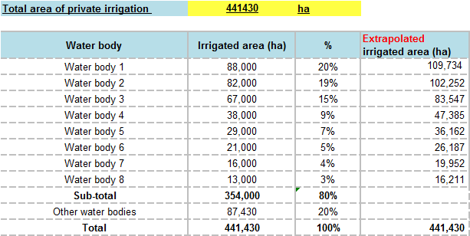

Source : M. Belghiti, l’agriculture irriguée au Maroc ; enjeux et marges de progrès
- 6 plot categories: < 1ha, 1 to 3 ha, 3 to 5 ha, 5 to 10 ha, 10 to 20 ha, > 20 ha
- 5 Total Dynamic Head (TDH) values : TDH, TDH -20%, TDH-10%, TDH+10%, TDH+20%
- 4 pumping technologies: PV, diesel, butane, electrical.

- Analysis outputs

For each examined case, modelling outputs are mainly the following:

- Determining the required hydraulic energy and pump & PV panel capacities;
- Assessment of the m³ pumping cost for the four considered technologies according to the levelized cost method, defined as follows:
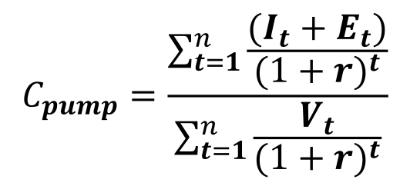

Where :
C_{pump} | Levelized cost of pumping
I_{t} | Investment costs in year t
E_{t} | Operations and maintenance costs in year t
V_{t} | Volume of water pumped in year t
r | Discount factor
n | Project /equipment lifetime

- Determining the farmer payback period of solar PV versus butane, diesel and electricity, defined as the year which nullify the discounted benefit of the project : Aggregation of differences between discounted annual expenditure of PV vs conventional energy (diesel, butane or electricity)

It is important to note that the above-mentioned economical modelling was undertaken for two cases:
- Considering an investment subsidy for solar pumping system, the amount of which is defined by the Agreement signed in April 2013
- Without an investment subsidy

- Output example

The tables below present an example of modelling output for a plot of less than 1 ha located in Souss water body, and considering an average TDH value.

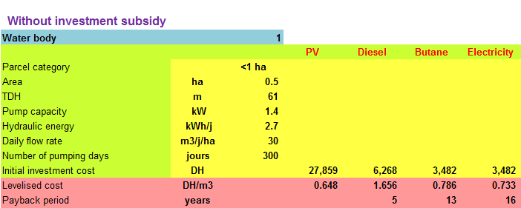

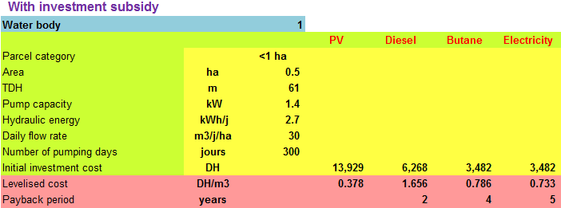

- Assumptions and inputs
The necessary inputs for the techno-economical modelling include inter alia the following elements:
- Irrigated areas and their distribution according to size and localization (region/water body/ hydraulic basin) ;
- Distribution of individual irrigated plots by size, TDH level and localization;
- Typical water consumption rates in individual irrigated plots in the region;
- Installed pumping systems in irrigated areas;
- Typical energy consumptions in individual irrigated plots;
- Investment cost of different pumping systems.
Because of data unavailability due to the absence of statistics and specific studies on the issue, the following assumptions were adopted based on the consultant’s knowledge of the sector and of other projects and interviews with the main actors (suppliers, farmers, managers of the ministry of agriculture, etc.).

- Technical assumptions

- Distribution of plot categories : the distribution of individual irrigated area in terms of number and area by plot category was performed for each water body on the basis of national plot distribution of the 1996 General Agricultural Census .
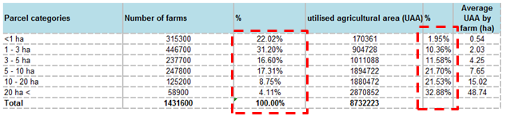

- Water needs : 30 m³/ha/day
- Motor pump efficiency ->Solar : 30%, butane : 17%, diesel: 17%, electrical: 59%
- Pump lifetime -> solar : 7 years, butane : 3 years, diesel: 5 years, electrical: 5 years

- Economic assumptions

- Discount rate: 8%
- Bank interest rate: 7 %
- Investment cost:
    - Solar (DH/kW pump)

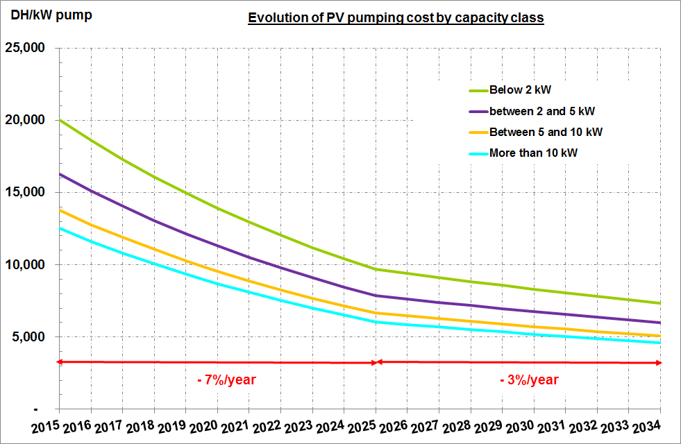

The estimated decrease in solar pumping system costs over the next 20 years is based on estimates that a PV panel price would drop according to IEA from 0.8 USD/Wp in 2012 to 0.3-0.4 USD/Wp in 2035, i.e. a total decrease of 70% and an annual decrease of 4.2% over the same period.

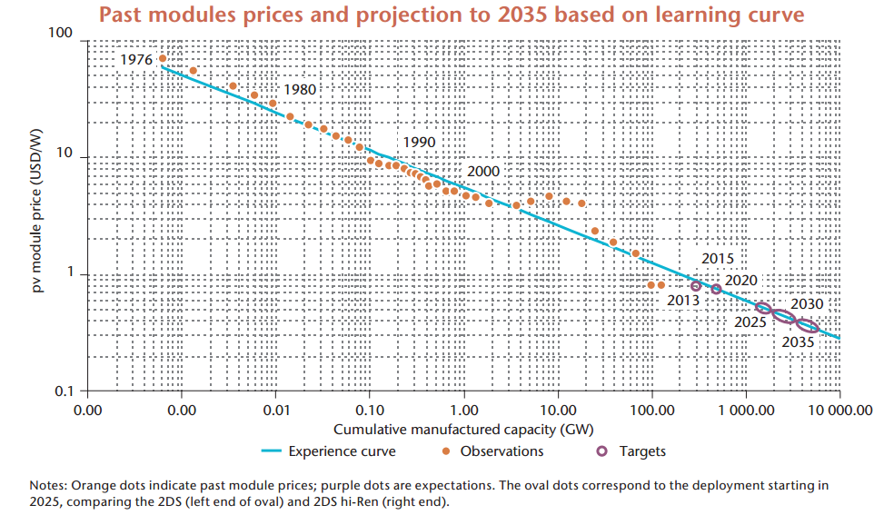
    - Diesel(DH/kW pump):
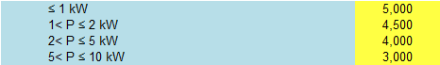
    - Butane (DH/kW pump):2 500
    - Electrical(DH/kW pump):2 500

- Operating costs:
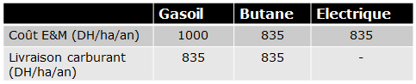
- Evolution of energy prices:

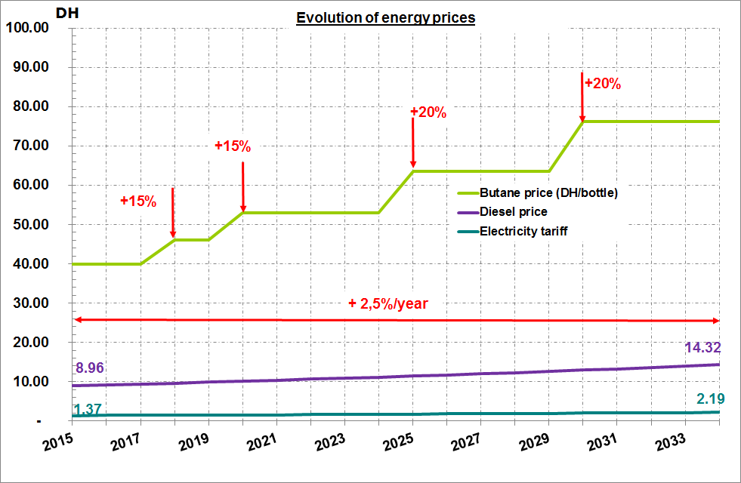

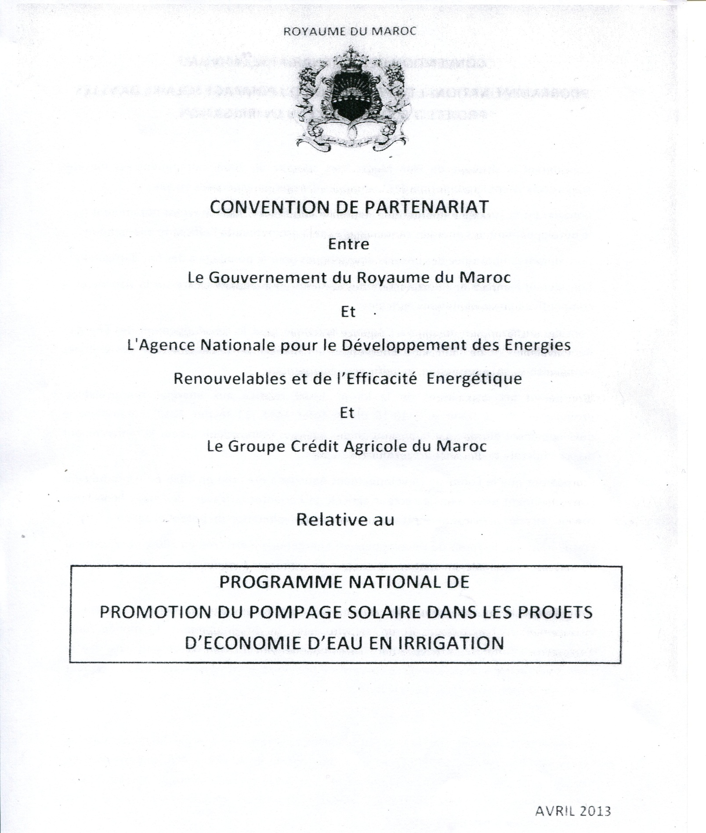
Annex B: Partnership Agreement between the GoM, ADEREE and GCAM on the Promotion of National Solar Pumping Programme in Water Saving Irrigation Projects

Annex C: Co-financing letters

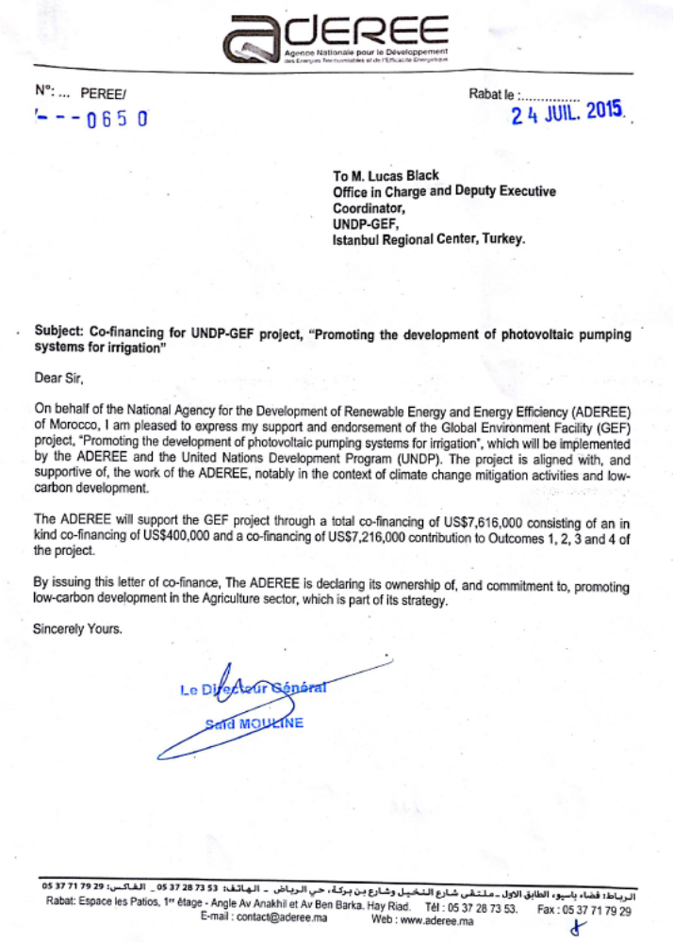

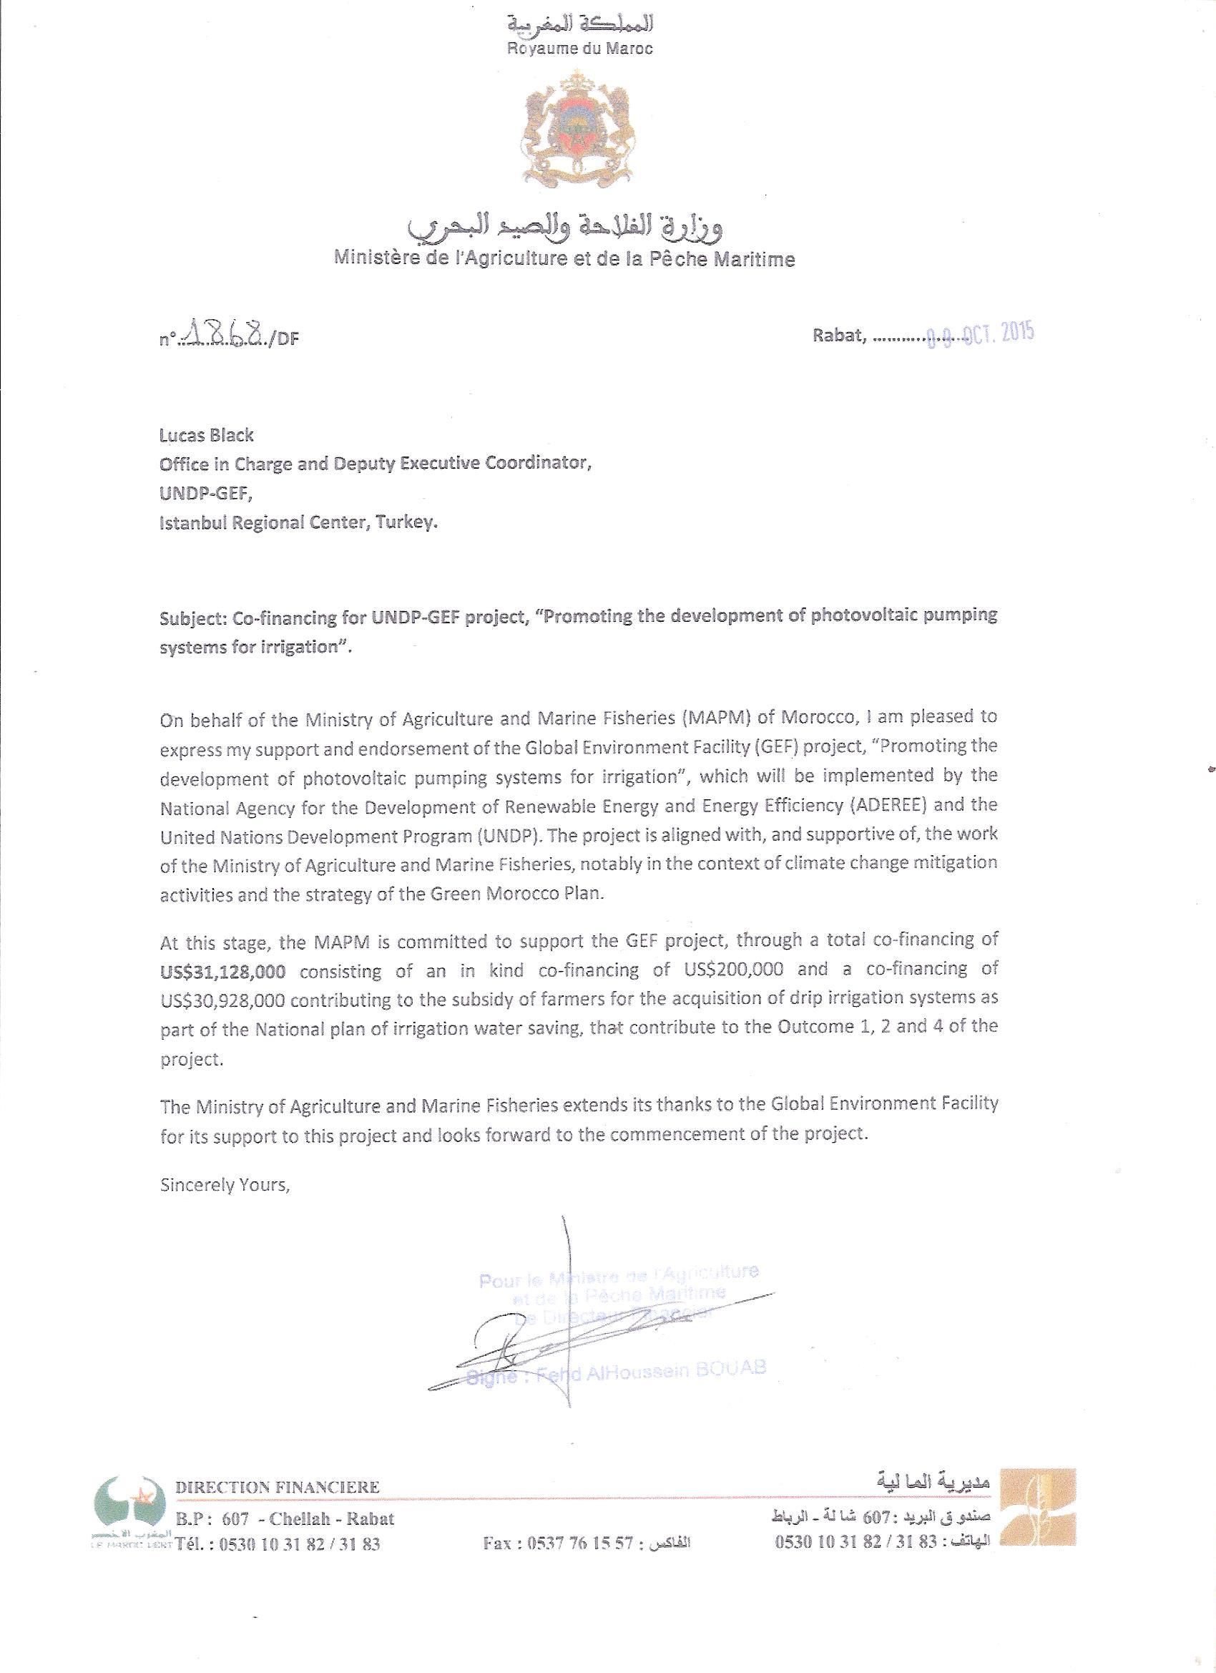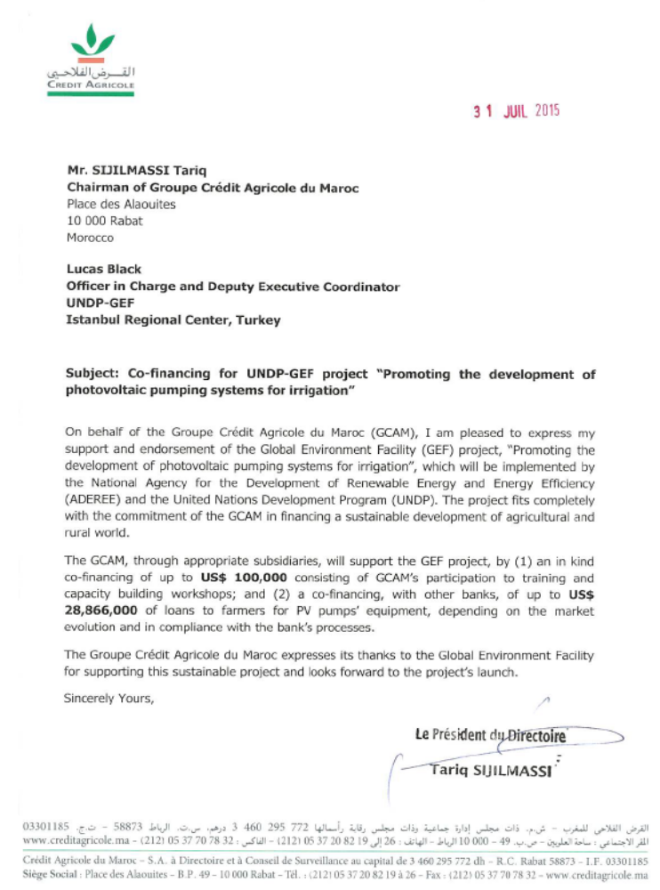
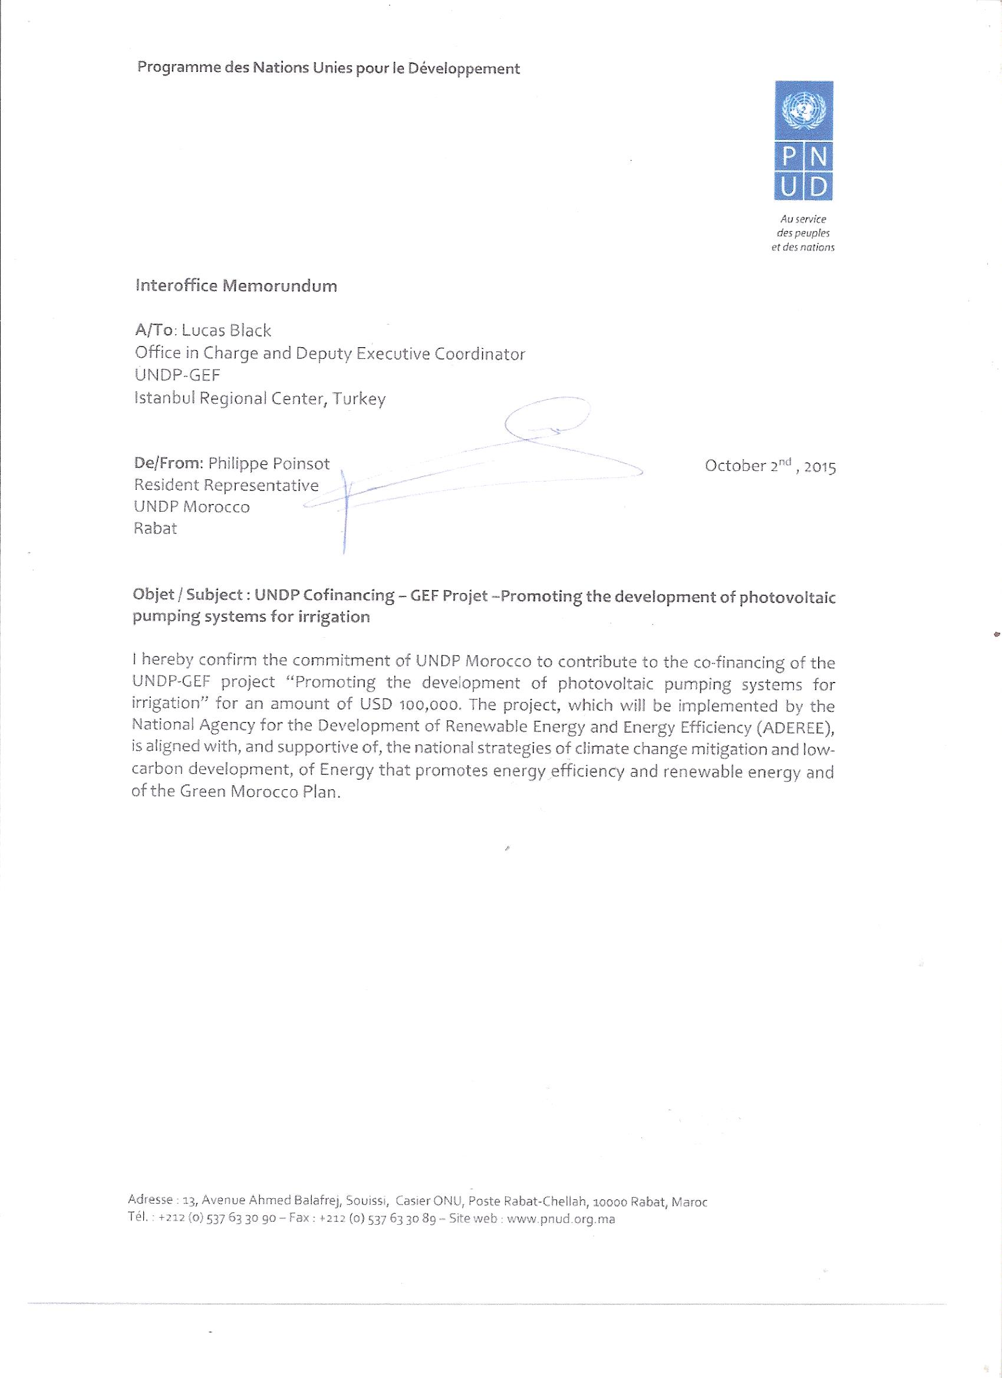

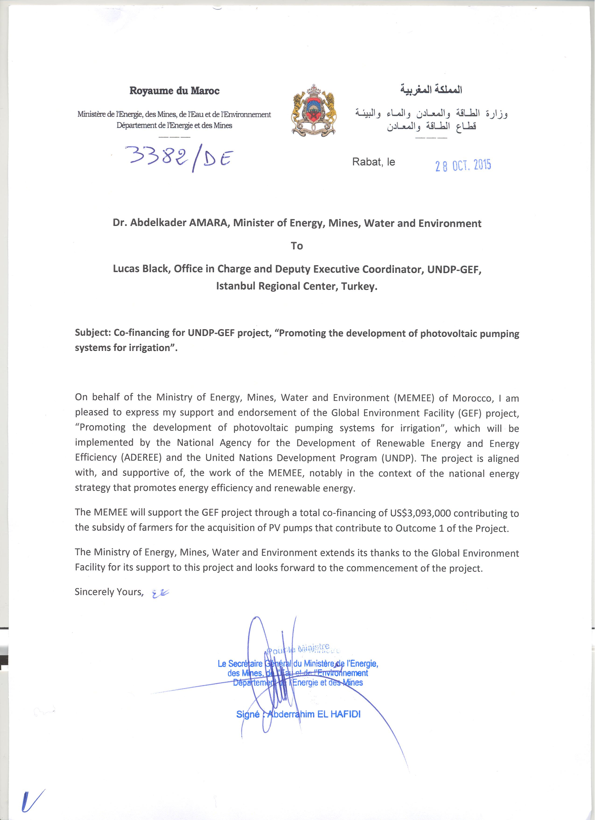

LETTRE D’ACCORD TYPE ENTRE LE PNUD ET LE GOUVERNEMENT
POUR LA FOURNITURE DE SERVICES D’APPUI
COMMENT UTILISER LA PRÉSENTE LETTRE D’ACCORD

- Le présent accord a pour but de conférer une protection juridique appropriée lorsque le bureau de pays du PNUD fournit des services d’appui dans le cadre d’une gestion nationale.
- Le présent accord doit être signé par une autorité gouvernementale ou un représentant officiel habilité à conférer une protection juridique intégrale au PNUD (Il s’agit généralement du ministre des affaires étrangères, du Premier ministre et/ou du chef de l’État). Le bureau de pays du PNUD doit vérifier que le signataire de l’Accord au nom du gouvernement est dûment habilité à conférer privilèges et immunités.
- Copie de la lettre d’accord type signée est jointe à chaque descriptif de projet nécessitant ces services d’appui. Parallèlement, le bureau de pays du PNUD complète le tableau présenté dans l’appendice à la lettre type pour présenter la nature et la portée des services à fournir et les responsabilités des parties intéressées.
- Le bureau de pays du PNUD établit la lettre d’accord et consulte le bureau régional si l’une ou l’autre des parties souhaite modifier le texte.
- Après la signature de l’accord par l’autorité habilitée à conférer des privilèges et immunités au PNUD, le gouvernement conserve un original de la lettre et le bureau de pays du PNUD l’autre. Copie de l’accord doit être communiquée au siège du PNUD (BOM/LSO) et au bureau régional.

TERMINOLOGIE

- Le présent Accord emploie la terminologie harmonisée conforme à la version révisée des Règlement financier et règles de gestion financière du PNUD (Financial regulations and rules (FRR)) qui introduisent des termes nouveaux ou redéfinis comme suit :
a. Le terme « exécution » se rapporte à l’appropriation et à la responsabilité générales des résultats des programmes du PNUD au niveau du pays, qui sont exercées par le gouvernement, via l’organe gouvernemental de coordination, qui approuve et signe le plan d’action pour la mise en œuvre des programmes de pays (CPAP) avec le PNUD. Toutes les activités relevant du CPAP sont donc exécutées à l’échelon national.
b. Le terme « réalisation » se rapporte à la gestion et la production d’activités de programme visant à obtenir des résultats spécifiques, et plus particulièrement la mobilisation des contributions du PNUD et leur utilisation pour la production de résultats qui contribueront aux réalisations sur le plan du développement, tels que définis dans les plans de travail annuels (AWP).

Ces deux termes sont explicités dans la rubrique Cadre légal de la section Programme and Project Management Section des POPP (Règles et procédures des programmes et opérations).

- Il importe de noter qu’au niveau de la gestion des projets, les termes « exécution » en dehors des modalités opérationnelles harmonisées (c’est-à-dire pour les projets mondiaux et régionaux) et « réalisation » dans le cadre des modalités opérationnelles harmonisées, ont la même signification, à savoir la gestion et la fourniture d’activités de projet visant à produire des résultats spécifiques, avec une utilisation efficiente des ressources. Le présent Accord emploie donc le terme « réalisation » conformément aux « modalités opérationnelles harmonisées » afin de couvrir également le terme « exécution » au niveau des projets sortant des modalités opérationnelles harmonisées. Plus précisément, toutes les références à une « Entité d’exécution » ont été remplacées par « Partenaire de réalisation »

- Lorsque la présente lettre d’accord est utilisée hors des modalités opérationnelles harmonisées ou des pays CPAP, il convient de procéder aux changements suivants :
a. Exécution au lieu de réalisation
b. Entité d’exécution au lieu de Partenaire de réalisation

A
Monsieur le Directeur de l’Agence Nationale des Énergies Renouvelables
et de l’Efficacité Energétique (ADEREE)

1. J’ai l’honneur de me référer aux consultations qui ont eu lieu entre les représentants du gouvernement du Maroc (ci-après dénommé le « Gouvernement ») et les représentants du PNUD concernant la fourniture, par le bureau de pays du PNUD, de services d’appui à des programmes ou projets gérés au niveau national. Le PNUD et le Gouvernement conviennent par la présente que le bureau de pays du PNUD peut fournir ces services, à la demande du Gouvernement, par l’intermédiaire de son institution désignée dans le descriptif de projet correspondant, suivant la procédure décrite ci-dessous.

2. Le bureau de pays du PNUD fournit des services d’appui, notamment une assistance pour l’établissement de rapports et le paiement direct. Ce faisant, il doit veiller à renforcer la capacité du Gouvernement (le Partenaire de réalisation), afin que ce dernier puisse mener ces activités directement. Les frais engagés par le bureau de pays du PNUD dans la prestation desdits services d’appui sont imputés sur son budget d’administration.

3. En outre, le bureau de pays du PNUD peut fournir, à la demande du Partenaire de réalisation, les services d’appui ci-après pour la réalisation des activités du projet :
(a) Identification et/ou recrutement du personnel à affecter au projet ;
(b) Définition et facilitation des activités de formation ;
(c) Achat de biens et de services.

4. Le bureau de pays du PNUD achète des biens et services et recrute le personnel à affecter au projet conformément aux règlements, règles, politiques et procédures du PNUD. Les services d’appui décrits au paragraphe 3 ci-dessus doivent être détaillés dans une annexe au descriptif de projet, sous la forme présentée dans l’appendice. En cas de changement des conditions applicables aux services d’appui fournis par le bureau de pays pendant la durée d’un projet, l’annexe au descriptif de projet est révisée par accord mutuel entre le représentant résident du PNUD et le Partenaire de réalisation.

5. Les dispositions pertinentes de l’Accord de base régissant l’Assistance du PNUD signé entre le Gouvernement du Royaume du Maroc et le PNUD le 13 mai 1982 ou les dispositions supplémentaires qui font partie intégrante du descriptif de projet, y compris celles concernant la responsabilité juridique et les privilèges et immunités, sont applicables à la fourniture de ces services d’appui. Le Gouvernement conserve, par le biais de son Partenaire de réalisation, la responsabilité globale du projet géré au niveau national. La responsabilité du bureau de pays du PNUD se limite à fournir les services d’appui détaillés dans l’annexe au descriptif de projet.
6. En cas de réclamation ou de litige concernant la fourniture des services d’appui par le bureau de pays du PNUD conformément à la présente lettre, ou en découlant, les dispositions pertinentes de l’Accord de base type relatif à l’assistance s’appliquent.

7. Les modalités de recouvrement des coûts par le bureau de pays du PNUD en rapport avec la fourniture des services d’appui décrits au paragraphe 3 ci-dessus doivent être spécifiées dans l’annexe au descriptif de projet.

8. Le bureau de pays du PNUD présente des rapports d’activité sur les services d’appui fournis et rend compte des frais remboursés, autant que de besoin.

9. Les présents arrangements ne peuvent être modifiés que d’un commun accord par écrit entre les parties.

10. Si vous approuvez les dispositions qui précèdent, je vous saurais gré de bien vouloir signer et retourner à notre bureau deux exemplaires de la présente lettre. Lorsque vous aurez signé celle-ci, elle constituera un accord entre votre Gouvernement et le PNUD quant aux conditions régissant la fourniture, par le bureau de pays du PNUD, de services d’appui à des programmes et projets gérés au niveau national.

Lu et approuvé

________________________
Pour le PNUD
Madame Ayshanie Medagangoda-Labe
Représentant Résident Adjointe

Pour le Gouvernement
Monsieur Said Mouline

Directeur Général de l’Agence Nationale de Développement des Energies Renouvelables et de l’Efficacité Energétique (ADEREE).

________________________
Pour le Gouvernement
Monsieur Said Mouline
Directeur Général de l’ADEREE
Pour le Gouvernement
Monsieur Said Mouline

Directeur Général de l’Agence Nationale de Développement des Energies Renouvelables et de l’Efficacité Energétique (ADEREE).

Appendice

DESCRIPTION DES SERVICES D’APPUI FOURNIS PAR LE BUREAU DE PAYS DU PNUD

1. Il est fait référence aux consultations entre l’Agence Nationale de Développement des Energies Renouvelables et de l’Efficacité Energétique (ADEREE), l’institution désignée par le Gouvernement du Maroc et les représentants du PNUD concernant la fourniture de services d’appui, par le bureau de pays du PNUD, au projet « Promotion du développement des systèmes de pompage photovoltaïques pour l’irrigation géré au niveau national ».
2. Conformément aux dispositions de la lettre d’accord signée le 14 octobre 2015 et du descriptif du Projet « Promotion du développement des systèmes de pompage photovoltaïques pour l’irrigation géré au niveau national – Project ID:00096531 », le bureau de pays du PNUD fournira des services d’appui pour ledit Projet tel que décrit ci-dessous.

3. Services d’appui à fournir :
Services d’appui  (insérer la description) | Échéancier de fourniture des services d’appui | Dépenses engagées par le PNUD pour la fourniture de ces services d’appui (le cas échéant) | Montant remboursé au PNUD et mode de remboursement (le cas échéant)
1. Les paiements, les déboursements et autres transactions financières | 2016-2019 | 10 401 USD
2. Recrutement du personnel, le personnel du projet et les consultants | 2016 | 2 000 USD
3. L'acquisition des services et des équipements, et l'élimination / vente de matériel | 2019 | 400 USD
4. Déplacements, F10 | 2016-2019 | 2 600 USD
5. Suivi des TVA remboursement | 2016-2019 | 4 700 USD
6. Organisation d'activités de formation, des conférences et des ateliers, y compris les bourses | 2016-2019 | 2 500 USD
7. Expédition, dédouanement,  l'immatriculation du véhicule, et l'accréditation | 2016-2017 | 100 USD
Total |  | 22 701 USD

Annex D: Terms of reference for PMU Staff

Terms of reference for the National Coordinator (Full time)
The Coordinator is responsible for day-to-day management, co-ordination and supervision of the implementation of the project, in close consultation and under the supervision of ADEREE EE & RE manager & the National Project Director and under the authority of the steering committee. Specifically, his\her responsibilities are but not limited to the following:

Accountable for project outputs:
- Responsible for defining when, where and how activities will be implemented;
- Ensures that the project complies with the work plan;
- Responsible and accountable for day-to-day management, supervision of the timely implementation of the project relevant activities and ongoing evaluation of the project;

Resource and procurement management:
- Initiating selection of necessary resources for the proper implementation of activities ;
- Overseeing the implementation of consultants/ team mission ;
- Project financial management;
- Administrative and accounting management of the project ;
- Developing of terms of reference for service, studies and works contracts ;
- Quality control of services performed within the framework of the project in relation with the technical services involved (services, studies and works) ;

Communication management:
- Informing all stakeholders on the progress of the project;
- Organizing and participating in meetings and national knowledge-sharing workshops within the framework of the project ;
- Preparing and drafting minutes of steering committee minutes;
- Facilitating exchange between different stakeholders.

Reporting:
- Planning: Drafting of annual planning documents – AWP ;
- Preparing all quarterly monitoring and evaluation reports of the project as well as annual report;
- Preparing tracking logs on a quarterly basis: risks log, trouble log, log of lessons learned from the project.

Risk management:
- Resolving any possible obstacles and conflicts between stakeholders.

Change management:
- Dealing with change through review. Major revision are steering committee;
- Issuing recommendations/ observations relating to project closure when its objectives are achieved or if it is no longer able to achieve its objectives.

Knowledge management within the framework of the project:
- Responsible for training and horizontal actions envisaged by the project ;

Monitoring conducted by the national coordinator:
- Quarterly check of project’s progress and implementation rate of activities in the respect of the Quality standards.
- Based on this review, a quarterly report on project progress in terms of objective achievement, problems faced and evolution of initial risks is submitted by the national coordinator to the Project Follow-Up Committee .
- An annual report will be prepared by the national coordinator. Its content should be based on different combined quarterly reports and allow assessing annual project contribution to expected results.
- A trouble log should be prepared and update by the national coordinator in order to facilitate monitoring and resolution of possible problems, or any action of change control.
- Based on analysis of initial risk, the risk log should be regularly updated following the review of external environment which some changes could affect project implementation.
- A log of lessons learned from the project should be also prepared and regularly updated with a view to ensuring a lifelong learning, encouraging the necessary amendment in the project and facilitating the preparation of lessons learned report at the end of the project.

Expected Qualifications:
- Advanced university degree and at least 10 years of professional experience in the specific areas the project, including dealing with solar farms and solar energy development, including solid knowledge of international renewable energy experiences, state-of-the-art approaches, and best practices in catalyzing the renewable energy market (by applying different policy measures, new financing mechanisms, etc.)
- Experience in managing projects of similar complexity and nature, including demonstrated capacity to actively explore new, innovative implementation and financing mechanisms to achieve the project objective;
- Demonstrated experience and success in the engagement of, and working with, the private sector and NGOs, creating partnerships and leveraging financing for activities of common interest;
- Good analytical and problem-solving skills and the related ability to adaptively manage with prompt action on the conclusion and recommendations coming out from the project’s regular monitoring and self-assessment activities as well as from periodic external evaluations;
- Ability and demonstrated success to work in a team, to effectively organize it, and to motivate its members and other project counterparts to effectively work towards the project’s objective and expected outcomes;
- Good communication skills and competence in handling project’s external relations at all levels;
- Fluent/good knowledge of the Arabic, French and English languages;
- Experience in developing countries, and preferably in North Africa; and
- Familiarity and prior experience with UNDP is considered an asset.

Terms of reference for the Technical Assistant (Full time)

Duties and responsibilities:

Technical assistance and support to the project and National Coordinator, including:

- General coordination, management and supervision of project implementation;
- Coordination of technical needs and requirements with partners;
- Follow-up with on-site implementation; and
- Ensuring otherwise successful completion of the project in accordance with the stated outcomes and performance indicators summarized in the project’s log frame matrix and within the planned schedule and budget.
- Participate in setting up of standards and technical specifications of the solar pumps to be procured.

Expected Qualifications:

- University degree in the natural sciences or engineering and at least 3 years of technical professional experience.
- Experience in solving novel technical problems;
- Good analytical and problem-solving skills and the related ability to adaptively manage with prompt action on the conclusion and recommendations coming out from the project’s regular monitoring and self-assessment activities as well as from periodic external evaluations;
- Ability and demonstrated success to work in a team, to effectively organize it, and to motivate its members and other project counterparts to effectively work towards the project’s objective and expected outcomes;
- Good communication skills and competence in handling project’s external relations at all levels;
- Fluent/good knowledge of the Arabic and French languages. Knowledge of English is an asset;
- Experience in developing countries, and preferably in North Africa; and
- Familiarity and prior experience with UNDP is considered an asset.
Terms of reference for the Project Financial and Administrative Assistant (Full-time)

Duties and responsibilities:

Supporting the National Coordinator in the implementation of the project, including:

- Responsibility for logistics and administrative support of project implementation, including administrative management of the project budget, required procurement support, etc.
- Maintaining up to date business and financial documentation, in accordance with UNDP and other project reporting requirements;
- Organizing meetings, business correspondence and other communications with the project partners;
- Supporting the project outreach and PR activities in general, including keeping the project web-site up to date;
- Managing the projects files and supporting the National Coordinator in preparing the required financial and other reports required for monitoring and supervision of the project progress;
- Supporting the National Coordinator in managing contracts, in organizing correspondence and in ensuring effective implementation of the project otherwise.

Expected Qualifications:

- Fluent/good knowledge of the Arabic and French languages. Knowledge of English is an asset.
- Demonstrated experience and success of work in a similar position
- Experience working in developing countries, preferably Morocco.
- Good administration and interpersonal skills.
- Ability to work effectively under pressure.
- Good computer skills.
- University degree is required

Annex E: Greenhouse gas emission reduction calculation

A comprehensive economic and financial model has been developed for the evaluation of the Project’s results and benefits. The modelling carried out within the framework of the Project covered 441,430 ha concerning 72,370 irrigated plots. Economic evaluations were done for solar pumping use in replacement of three fuel type systems: gasoil, butane and electricity. A selection of 19,000 ha covering 3,750 irrigated plots using gasoil and butane was made according to the most favourable payback periods. The selected irrigated plots are considered for using solar pumping systems within the framework of the Project’s activities.
The Project’s greenhouse gas emissions reduction calculation is based on the modelling results using the selected plots. The global GHG reduction benefits of the Project will result from the direct and indirect emissions reductions namely:
- Direct GHG emission reduction benefits from the replacement of diesel and butane pumping systems with solar ones through the Project.
- Indirect GHG reduction benefits resulting from broader adoption of solar pumping and solar power on the market as a result of project activities.
The direct GHG emissions reduction calculation is summarized in the table below:
Parameter | unit | Gasoil | Butane | Reference source
Assumptions
Pumps repartition per fuel type | % | 54% | 46%
Pumps energy efficiency rate | % | 17% | 17%
Fuels Net heating value | TOE/T | 1.035 | 1.13 | International Energy Agency
Fuels Net heating value | GJ/T | 43.315 | 47.290 | International Energy Agency
Fuels emission coefficients | Ton C/TJ | 20.2 | 17.2 | National inventory of GHG emissions
GEF Causality factor | % | 60% | 60%
Calculation
Total hydro power to be developed by the projects pumps | GWh/year | 7.20 | 6.14 | Results of the Project's simulation model
Fuels consumption | TJ/year | 152.6 | 130.0
Fuels consumption | T/year | 3,522.0 | 2,748.0
Fuels consumption | TOE/year | 6,750
Emissions associated with the fuel combustion | t C /year | 3,081.6 | 2,235.2
Emissions associated with the fuel combustion | t CO₂/year | 11,299.2 | 8,195.7
Energy savings due to GEF project | t/year | 2,113.2 | 1,648.8
Energy savings due to GEF project | TOE/year | 4,050
Project's direct GHG emissions reduction | t C /year | 6,779.5 | 4,917.4
Project's direct GHG emissions reduction | t CO₂/year | 11,697.0
Total Project's direct GHG emission reductions over the project's life period | t CO₂ | 233,940
Assuming a causality factor of 60%, the Project’s activities will result in the savings of 4,050 TOE/year of fossil fuels (gasoil and butane). The direct GHG emission reductions attributed to the replacement of diesel and butane pumps with solar one through the Project are evaluated at 11,697 tCO₂/year or 233,940 tCO₂ over the 20 years life of the pumps. Considering the GEF financial contribution of $2,639,726 this translates into a GEF cost of US$ 11.28/tCO₂ abated directly.
Indirect GHG Emission Reductions calculation

Bottom-up analysis:

The GEF guidelines provide a formula for bottom-up emissions assessment as:

CO₂ indirect BU = CO₂ direct * RF, where RF is a Replication Factor.

Assuming a replication factor of 4 (given support for development of financial mechanisms and exist of state subsidies after project close), a further 935,760 tCO₂ can be calculated as indirect GHG emission reductions.

Top-Down analysis

The National Program of Irrigation Water Conservation aims at improving water conservation in agriculture by supporting the conversion to more efficient irrigation technologies of 555,000 hectares of surface gravitational irrigation to drip irrigation. The national program includes 354,000 hectares in private irrigation plots comprising around 56,000 plots located in main ground water areas.

Assuming the same specific direct GHG emissions reduction per hectare as for the Project (12.31 t CO₂/ha over 20 years) and that one third of the total irrigated areas targeted by the national program will use solar pumps, the total expected GHG emissions reduction is thus estimated at : 354,000 ha/3*12.31 tCO₂/ha = 1,452,580 tCO_{2.}

The bottom up analysis is thus more conservative. Accordingly, the Project activities are estimated to result, besides the 233,940 tCO₂ direct emissions reduction, in a further 935,760 tCO₂ indirect emissions reduction during the solar pumps life time (see CCM tracking tool sent under separate cover).

GEF abatement cost

Taking into account the project’s global GHG emissions reduction, the GEF abatement cost is derived then as:

$ 2,639,726 / (233,940+935,760) tCO₂ = 2.26 $/tCO₂

The following table summarizes the GEF contribution abatement costs taking into account both direct and indirect emissions reductions resulting from the Project’s activities.

Description | unit | Direct emission reductions | Indirect emission reductions | Total emission  reductions
Emissions reduction | tCO₂ | 233,940 | 935,760 | 1,169,700
GEF Contribution | $ | 2,639,726
Abatement cost | $/tCO₂ | 11.28 | 2.82 | 2.26

As per the Project’s 1.3 output, a scrapping and recycling programme of the replaced pumps will be implemented in collaboration with the Ministry of Environment to avoid leakage of the project’s emissions reduction resulting from the potential use of the replaced gasoil and butane pumping engines.
The above calculation of the reduction of emissions does not take into account the possible reduction of emissions associated with nitrous oxide (N₂O), which is due to the reduction of fertigation. Indeed, the promotion of drip irrigation in the Project will involve a decrease of the amount of fertilizers used by farmers.
To estimate the reduction of N₂O emissions associated with, it is appropriate to know among others i) the amount of fertilizer currently used by farmers using traditional irrigation systems, ii) the type of drip irrigation adopted, iii) amount of fertilizer used with drip irrigation system and iv) changes in agricultural practices following the switch to drip irrigation (crop change, amount of water, fertilizer, etc.).
At present, this information is not available. It is therefore very difficult to estimate the emission reductions associated with N₂O from project activities.

Annex F: Environmental and Social Safeguards Screening

The completed template, which constitutes the Social and Environmental Screening Report, must be included as an annex to the Project Document. Please refer to the Social and Environmental Screening Procedure for guidance on how to answer the 6 questions.]
Project Information

Project Information
- Project Title | Promoting the development of photovoltaic pumping systems for irrigation
- Project Number | 5539
- Location (Global/Region/Country) | Morocco

Part A. Integrating Overarching Principles to Strengthen Social and Environmental Sustainability

QUESTION 1: How Does the Project Integrate the Overarching Principles in order to Strengthen Social and Environmental Sustainability?
Briefly describe in the space below how the Project mainstreams the human-rights based approach
The project integrates the human rights based approach by adopting a participatory approach that includes all stakeholders (public and private sector, farmers, associations, etc.) in the implementation of project activities. Indeed, capacity-building activities to stakeholders through meetings and workshops will be an opportunity to integrate their remarks and opinion when designing the implementation of the proposed instruments.
Access to sufficient and clean water falls under Article 25 of the Universal Declaration of Human Rights: “everyone has the right to a standard of living adequate for the health and well-being of himself and his family[…]”. Morocco's water resources are characterized by scarcity and both spatial and temporal irregularity. The potential availability of water resources is steadily declining. Indeed, it decreased from 29 million m3 / year before 1980 to about 22 million m3 / year at present, the equivalent of 730 m3 / capita / year. This water availability per capita is among the lowest in the world and is below the UNDP criterion of 1,000 m3 / capita / year. The agriculture sector exerts significant pressure on the water resources with the use of 85% of available resources for its needs. The issue of water use in agriculture is caused by traditional irrigation systems that prevailed until recently, and particularly by the gravity system (the most commonly used) that is unconcerned about the water economy. Sustainable water management used for agricultural irrigation is thus mandatory to achieve long-term water security and sustainability to secure the right to clean and sufficient water resources for the Moroccan population. This project will specifically help conserve Morocco’s water resources.
Food security will be addressed by the project as well. The project will primarily target fruit plantations and legume crops grown by small and medium private operators through gravity irrigation. It will contribute to improving plantation productivity, adaptation to climate change and contributing to the strategic objective of the Green Morocco Plan to strengthen the food security of Morocco.
Briefly describe in the space below how the Project is likely to improve gender equality and women’s empowerment
In its Programs and Projects, UNDP will uphold the principles of accountability and the rule of law, participation and inclusion, and equality and non-discrimination and ensure the meaningful, effective and informed participation of stakeholders in the formulation, implementation, monitoring and evaluation of Programs and Projects.
On the outcome level the project contributes to improving the living standards of the rural population by increasing their income. The rural population is composed of more than 50% of women and almost all of them work in the agricultural sector. They will therefore benefit greatly from the project results by improving their incomes and living conditions. In addition, they will be fully involved in the participatory approach and benefit from capacity building activities.
Briefly describe in the space below how the Project mainstreams environmental sustainability
The GEF project addresses two sectors simultaneously: energy generation (off-grid) and agricultural water management for irrigation. In principle, the project will have environmental benefits in both sectors: in the energy sector, the promotion of solar power (at the expense of diesel/butane/LPG) for water pumping should serve to reduce GHG emissions and localized contamination of water by spilled fuel; in the water sector the promotion of drip irrigation should serve to improve water use efficiency and reduce evaporation-transpiration losses. The project reduces emissions of greenhouse gases while contributing to sustainable development in Morocco in full compliance with country's policies and strategies. Indeed, the project is in support of the National Solar Pumping Program, which is consistent with two major strategies of Morocco, the National Strategy for Energy and the Green Morocco Plan. The energy strategy is based among others on the diversification of its energy mix, controlling energy demand and developing renewable energy while Morocco's Green Plan aims at the agricultural sector’s modernization while safeguarding natural resources to ensure the sustainability of agriculture. Finally, the project aims at the preservation of water resources with the promotion of water savings since the program supports only farms equipped with drip irrigation systems or water savings local irrigation systems. It is therefore in line with the National Water Saving Irrigation Program (PNEEI) whose objective is the promotion of water savings through implementation of drip irrigation systems in farms.
The proposed program for the development of solar irrigation reduces emissions of greenhouse gases while contributing to the sustainable development of Morocco. The project has positive environmental impacts including:

• A saving of 6,750 TOE/year of fossil fuels (gasoil and butane) and 4,050 TOE/year (applying a 60% GEF causality factor to baseline);
• A direct reduction in GHG emissions, through the use of renewable energy, estimated at 233,940 tCO2e applying a 60% GEF causality factor, during the equipment lifetime period of 20 years;
• Further indirect (bottom-up) emissions reduction of 935,760 tCO2e during the solar pumping life period (see annex E);
• Preservation of water resources since the program is only for farms equipped with drip irrigation systems;
• The reduction of N2O emissions thanks to an optimal fertigation system (to be calculated during project implementation).

Part B. Identifying and Managing Social and Environmental Risks

QUESTION 2: What are the Potential Social and Environmental Risks?  Note: Describe briefly potential social and environmental risks identified in Attachment 1 – Risk Screening Checklist (based on any “Yes” responses). | QUESTION 3: What is the level of significance of the potential social and environmental risks?  Note: Respond to Questions 4 and 5 below before proceeding to Question 6 |  |  | QUESTION 6: What social and environmental assessment and management measures have been conducted and/or are required to address potential risks (for Risks with Moderate and High Significance)?
Risk Description | Impact and Probability (1-5) | Significance  (Low, Moderate, High) | Comments | Description of assessment and management measures as reflected in the Project design. If ESIA or SESA is required note that the assessment should consider all potential impacts and risks.
Risk 1: Groundwater extraction  Risk associated by the potential increase of the water amount pumped by solar systems since farmers will use a renewable energy | I = 2  P = 2 | Low |  | The amount of water to be pumped is controlled as farmers who will benefit from the program will necessarily have a permit to pump water from their wells. This authorization is issued by the corresponding Water Basin Agency (ABH). This authorization is issued with respect to a threshold volume of water to be pumped. Solar pumping systems will be designed to meet this threshold and therefore they will conform to the water regulation in Morocco.
Risk 2: Generation of waste  Risk associated by the generation of waste from diesel and butane pump systems that will be replaced by solar systems and that must be eliminated | I =1  P = 5 | moderate |  | The project includes a collection system for recycling and disposal of replaced pumping systems. A collaborative agreement between the project and Ministry in charge of Environment will be proposed for implementing this scheme.
Risk 3: Environmental impacts associated with the installation of PV pump systems such as soil compaction (through installment of pumps) and soil salinization (through change of water regime) | I = 2  P = 2 | Low |  | Part of the project is the development of guidelines and tools for optimizing the siting and orientation of PV panels. Simple literature will be developed for farmers and farmer associations who choose to directly access the grant funds provided by the National Promotion Programme for Solar Irrigation Water Pumping. More sophisticated literature and tools (including a software tool based on a GIS/GPS platform) will be developed for the Renewable Energy Service Companies (RESCOs) supported by the GEF project (see below) to augment pre-installation RESCO site visits. Amongst other goals these tools and guidelines will aim at mitigating any unintended environmental risks associated with the PV pump systems.
Risk 4: Duty bearers might not have the capacity to meet their obligations in the Project | I = 4  P = 1 | Low |  | To overcome such barriers, the Project will support the development of RESCOs and other stakeholders within the framework of the program. These establishments will have a central role to play in the management of the program since they will ensure the quality and the performance of the systems to be installed and will be the primary interface with the farmers to facilitate their access to investment grants of the national program and to bank commercial loans (see outcome 3).  Although the specific business model of the RESCOs intervention for pumping is not yet fully elaborated and must be coordinated with ADEREE and Ministry for Agriculture, the experience of Morocco in the leasing sector for vehicles, property and industrial equipment has shown that such a model is already well anchored in the commercial practices of Moroccan firms and could be duplicated in agriculture sector.

 | QUESTION 4: What is the overall Project risk categorization?
 | Select one (see SESP for guidance) |  | Comments
 | Low Risk | ☐
 | Moderate Risk | ☐ | The greatest risk of the project involves the generation of a number of different waste products as a result of changing the irrigation systems and pumps. To mitigate these risks of uncontrolled waste disposal, the project includes a collection system for recycling and disposal of replaced pumping systems.  Also for the risks rated as low, the project activities make sure that the identified risks be properly managed.
 | High Risk | ☐
 | QUESTION 5: Based on the identified risks and risk categorization, what requirements of the SES are relevant?
 | Check all that apply |  | Comments
 | Principle 1: Human Rights | ☐
 | Principle 2: Gender Equality and Women’s Empowerment | ☐
 | 1. Biodiversity Conservation and Natural Resource Management | ☐ | Potential increase of the water amount pumped by solar systems mitigated by water permits and drip irrigation requirements
 | 2. Climate Change Mitigation and Adaptation | ☐
 | 3. Community Health, Safety and Working Conditions | ☐
 | 4. Cultural Heritage | ☐
 | 5. Displacement and Resettlement | ☐
 | 6. Indigenous Peoples | ☐
 | 7. Pollution Prevention and Resource Efficiency | ☐ | Proper waste management of diesel and butane pump systems that will be replaced by solar systems and that must be disposed of properly

Final Sign Off
Signature | Date | Description
QA Assessor |  | UNDP staff member responsible for the Project, typically a UNDP Programme Officer. Final signature confirms they have “checked” to ensure that the SESP is adequately conducted.
QA Approver |  | UNDP senior manager, typically the UNDP Deputy Country Director (DCD), Country Director (CD), Deputy Resident Representative (DRR), or Resident Representative (RR). The QA Approver cannot also be the QA Assessor. Final signature confirms they have “cleared” the SESP prior to submittal to the PAC.
PAC Chair |  | UNDP chair of the PAC. In some cases PAC Chair may also be the QA Approver. Final signature confirms that the SESP was considered as part of the project appraisal and considered in recommendations of the PAC.

SESP Attachment 1. Social and Environmental Risk Screening Checklist

Checklist Potential Social and Environmental Risks
Principles 1: Human Rights | Answer  (Yes/No)
1. Could the Project lead to adverse impacts on enjoyment of the human rights (civil, political, economic, social or cultural) of the affected population and particularly of marginalized groups? | No
2. Is there a likelihood that the Project would have inequitable or discriminatory adverse impacts on affected populations, particularly people living in poverty or marginalized or excluded individuals or groups? | No
3. Could the Project potentially restrict availability, quality of and access to resources or basic services, in particular to marginalized individuals or groups? | No
4. Is there a likelihood that the Project would exclude any potentially affected stakeholders, in particular marginalized groups, from fully participating in decisions that may affect them? | No
5. Are there measures or mechanisms in place to respond to local community grievances? | No grievances expected
6. Is there a risk that duty-bearers do not have the capacity to meet their obligations in the Project? | Yes, see Risk 4
7. Is there a risk that rights-holders do not have the capacity to claim their rights? | No
8. Have local communities or individuals, given the opportunity, raised human rights concerns regarding the Project during the stakeholder engagement process? | No
9. Is there a risk that the Project would exacerbate conflicts among and/or the risk of violence to project-affected communities and individuals? | No
Principle 2: Gender Equality and Women’s Empowerment
1. Is there a likelihood that the proposed Project would have adverse impacts on gender equality and/or the situation of women and girls? | No
2. Would the Project potentially reproduce discriminations against women based on gender, especially regarding participation in design and implementation or access to opportunities and benefits? | No
3. Have women’s groups/leaders raised gender equality concerns regarding the Project during the stakeholder engagement process and has this been included in the overall Project proposal and in the risk assessment? | No
3. Would the Project potentially limit women’s ability to use, develop and protect natural resources, taking into account different roles and positions of women and men in accessing environmental goods and services?  For example, activities that could lead to natural resources degradation or depletion in communities who depend on these resources for their livelihoods and well being | No
Principle 3: Environmental Sustainability: Screening questions regarding environmental risks are encompassed by the specific Standard-related questions below

Standard 1: Biodiversity Conservation and Sustainable Natural Resource Management
1.1 Would the Project potentially cause adverse impacts to habitats (e.g. modified, natural, and critical habitats) and/or ecosystems and ecosystem services?  For example, through habitat loss, conversion or degradation, fragmentation, hydrological changes | No
1.2 Are any Project activities proposed within or adjacent to critical habitats and/or environmentally sensitive areas, including legally protected areas (e.g. nature reserve, national park), areas proposed for protection, or recognized as such by authoritative sources and/or indigenous peoples or local communities? | No
1.3 Does the Project involve changes to the use of lands and resources that may have adverse impacts on habitats, ecosystems, and/or livelihoods? (Note: if restrictions and/or limitations of access to lands would apply, refer to Standard 5) | No
1.4 Would Project activities pose risks to endangered species? | No
1.5 Would the Project pose a risk of introducing invasive alien species? | No
1.6 Does the Project involve harvesting of natural forests, plantation development, or reforestation? | No
1.7 Does the Project involve the production and/or harvesting of fish populations or other aquatic species? | No
1.8 Does the Project involve significant extraction, diversion or containment of surface or ground water?  For example, construction of dams, reservoirs, river basin developments, groundwater extraction | Yes
1.9 Does the Project involve utilization of genetic resources? (e.g. collection and/or harvesting, commercial development) | No
1.10 Would the Project generate potential adverse transboundary or global environmental concerns? | No
1.11 Would the Project result in secondary or consequential development activities which could lead to adverse social and environmental effects, or would it generate cumulative impacts with other known existing or planned activities in the area?  For example, a new road through forested lands will generate direct environmental and social impacts (e.g. felling of trees, earthworks, potential relocation of inhabitants). The new road may also facilitate encroachment on lands by illegal settlers or generate unplanned commercial development along the route, potentially in sensitive areas. These are indirect, secondary, or induced impacts that need to be considered. Also, if similar developments in the same forested area are planned, then cumulative impacts of multiple activities (even if not part of the same Project) need to be considered. | No
Standard 2: Climate Change Mitigation and Adaptation
2.1 Will the proposed Project result in significantgreenhouse gas emissions or may exacerbate climate change? | No
2.2 Would the potential outcomes of the Project be sensitive or vulnerable to potential impacts of climate change? | No
2.3 Is the proposed Project likely to directly or indirectly increase social and environmental vulnerability to climate change now or in the future (also known as maladaptive practices)?  For example, changes to land use planning may encourage further development of floodplains, potentially increasing the population’s vulnerability to climate change, specifically flooding | No

Standard 3: Community Health, Safety and Working Conditions
3.1 Would elements of Project construction, operation, or decommissioning pose potential safety risks to local communities? | No
3.2 Would the Project pose potential risks to community health and safety due to the transport, storage, and use and/or disposal of hazardous or dangerous materials (e.g. explosives, fuel and other chemicals during construction and operation)? | Yes, see Risk 2
3.3 Does the Project involve large-scale infrastructure development (e.g. dams, roads, buildings)? | No
3.4 Would failure of structural elements of the Project pose risks to communities? (e.g. collapse of buildings or infrastructure) | No
3.5 Would the proposed Project be susceptible to or lead to increased vulnerability to earthquakes, subsidence, landslides, erosion, flooding or extreme climatic conditions? | No
3.6 Would the Project result in potential increased health risks (e.g. from water-borne or other vector-borne diseases or communicable infections such as HIV/AIDS)? | No
3.7 Does the Project pose potential risks and vulnerabilities related to occupational health and safety due to physical, chemical, biological, and radiological hazards during Project construction, operation, or decommissioning? | No
3.8 Does the Project involve support for employment or livelihoods that may fail to comply with national and international labor standards (i.e. principles and standards of ILO fundamental conventions)? | No
3.9 Does the Project engage security personnel that may pose a potential risk to health and safety of communities and/or individuals (e.g. due to a lack of adequate training or accountability)? | No
Standard 4: Cultural Heritage
4.1 Will the proposed Project result in interventions that would potentially adversely impact sites, structures, or objects with historical, cultural, artistic, traditional or religious values or intangible forms of culture (e.g. knowledge, innovations, practices)? (Note: Projects intended to protect and conserve Cultural Heritage may also have inadvertent adverse impacts) | No
4.2 Does the Project propose utilizing tangible and/or intangible forms of cultural heritage for commercial or other purposes? | No
Standard 5: Displacement and Resettlement
5.1 Would the Project potentially involve temporary or permanent and full or partial physical displacement? | No
5.2 Would the Project possibly result in economic displacement (e.g. loss of assets or access to resources due to land acquisition or access restrictions – even in the absence of physical relocation)? | No
5.3 Is there a risk that the Project would lead to forced evictions? | No
5.4 Would the proposed Project possibly affect land tenure arrangements and/or community based property rights/customary rights to land, territories and/or resources? | No

Standard 6: Indigenous Peoples
6.1 Are indigenous peoples present in the Project area (including Project area of influence)? | No
6.2 Is it likely that the Project or portions of the Project will be located on lands and territories claimed by indigenous peoples? | No
6.3 Would the proposed Project potentially affect the rights, lands and territories of indigenous peoples (regardless of whether Indigenous Peoples possess the legal titles to such areas)? | No
6.4 Has there been an absence of culturally appropriate consultations carried out with the objective of achieving FPIC on matters that may affect the rights and interests, lands, resources, territories and traditional livelihoods of the indigenous peoples concerned? | No
6.4 Does the proposed Project involve the utilization and/or commercial development of natural resources on lands and territories claimed by indigenous peoples? | No
6.5 Is there a potential for forced eviction or the whole or partial physical or economic displacement of indigenous peoples, including through access restrictions to lands, territories, and resources? | No
6.6 Would the Project adversely affect the development priorities of indigenous peoples as defined by them? | No
6.7 Would the Project potentially affect the traditional livelihoods, physical and cultural survival of indigenous peoples? | No
6.8 Would the Project potentially affect the Cultural Heritage of indigenous peoples, including through the commercialization or use of their traditional knowledge and practices? | No
Standard 7: Pollution Prevention and Resource Efficiency
7.1 Would the Project potentially result in the release of pollutants to the environment due to routine or non-routine circumstances with the potential for adverse local, regional, and/or transboundary impacts? | No
7.2 Would the proposed Project potentially result in the generation of waste (both hazardous and non-hazardous)? | Yes, see Risk 2
7.3 Will the proposed Project potentially involve the manufacture, trade, release, and/or use of hazardous chemicals and/or materials? Does the Project propose use of chemicals or materials subject to international bans or phase-outs?  For example, DDT, PCBs and other chemicals listed in international conventions such as the Stockholm Conventions on Persistent Organic Pollutants or the Montreal Protocol | No
7.4 Will the proposed Project involve the application of pesticides that may have a negative effect on the environment or human health? | No
7.5 Does the Project include activities that require significant consumption of raw materials, energy, and/or water? | No

http://climateactiontracker.org/countries.html
Consulting the ranking on the WEB site: 19/06/2015
The tank or reservoir is only a way to store water pumped. Solar pumping system can be designed without reservoir.
It should be noted that the commitments of the four national institutions within the framework of the agreement signed in 2013 for the implementation of the National Solar pumping program, confirmed in their commitment letter (see Appendix C), amount to US$ 70,103,000 in grants, including US$ 25,000,000 that will be incurred during the project period and the balance of US $ 45,103,000 beyond 2019.
It is anticipated that additional funding is provided by the contribution of farmers to the investments of their project. This co-financing is estimated at 30% of project investment, which represents US $ 4,500,000 during the project life (4 years)
Applying a 60% GEF causality factor
Atlas Award ID: 00087168; Project ID: 00094271; PIMS # 5324
Objective (Atlas output) monitored quarterly ERBM and annually in APR/PIR
Due to the causality factor, the annual emission reduction associated with the Project are thus evaluated at 11,697 tCO₂: difference between target end of the Project (19,495 tCO₂) and baseline (7,798 tCO₂)
Using 60% causality factor equivalent to 47101.5 MWh (942,020 MWh lifetime) - http://www.iea.org/statistics/resources/unitconverter/ -
All outcomes monitored annually in the APR/PIR. It is highly recommended not to have more than 4 outcomes.
It is anticipated that additional funding is provided by the contribution of farmers to the investments of their project. This co-financing is estimated at 30% of project investment, which represents US $ 4,500,000 during the project life (4 years). This co-financing could not be confirmed by commitment letter given the nature of future contribution of individual farmers. In the absence of this commitment letter co-funding has not been integrated into the budget presented.
Probability on a scale from 1 (low) to 5 (high)
Impact on a scale from 1 (low) to 5 (high)
Implementation of the UNDAF is entrusted to the Government Authority responsible for coordinating UNDP activities, in this case the Ministry of Foreign Affairs and Cooperation (Implementing Partner).
In the case of multi-year projects, a specific work plan must be signed for each calendar year by the implementing partner and the UNDP.
Levelized cost, Source : Coûts prévisionnels de production de l’électricité Edition 2010, AIE
50% of installation cost, with a maximum of 75,000 DH by project, 15,000 DH/ha & kit, and 15,000 DH/ kWp installed
Technology roadmap Solar PV energy 2014 Edition, IEA
Etude de cas Projet de Pompage Solaire de l’Eau à Oujda, Maroc, 05_01_2013
Se référer à la section Project Management (DPC : 74598), Tableau du budget et Pan de travail du Prodoc.
Calculated as: 233,940 tCO₂ (total project’s direct emissions reduction over 20 years)/ 19,000 ha (total area of targeted plots) = 12.31 tCO₂/ha
Prohibited grounds of discrimination include race, ethnicity, gender, age, language, disability, sexual orientation, religion, political or other opinion, national or social or geographical origin, property, birth or other status including as an indigenous person or as a member of a minority.References to “women and men” or similar is understood to include women and men, boys and girls, and other groups discriminated against based on their gender identities, such as transgender people and transsexuals.
In regards to CO_{2,} ‘significant emissions’ corresponds generally to more than 25,000 tons per year (from both direct and indirect sources). [The Guidance Note on Climate Change Mitigation and Adaptation provides additional information on GHG emissions.]
Forced evictions include acts and/or omissions involving the coerced or involuntary displacement of individuals, groups, or communities from homes and/or lands and common property resources that were occupied or depended upon, thus eliminating the ability of an individual, group, or community to reside or work in a particular dwelling, residence, or location without the provision of, and access to, appropriate forms of legal or other protections.

